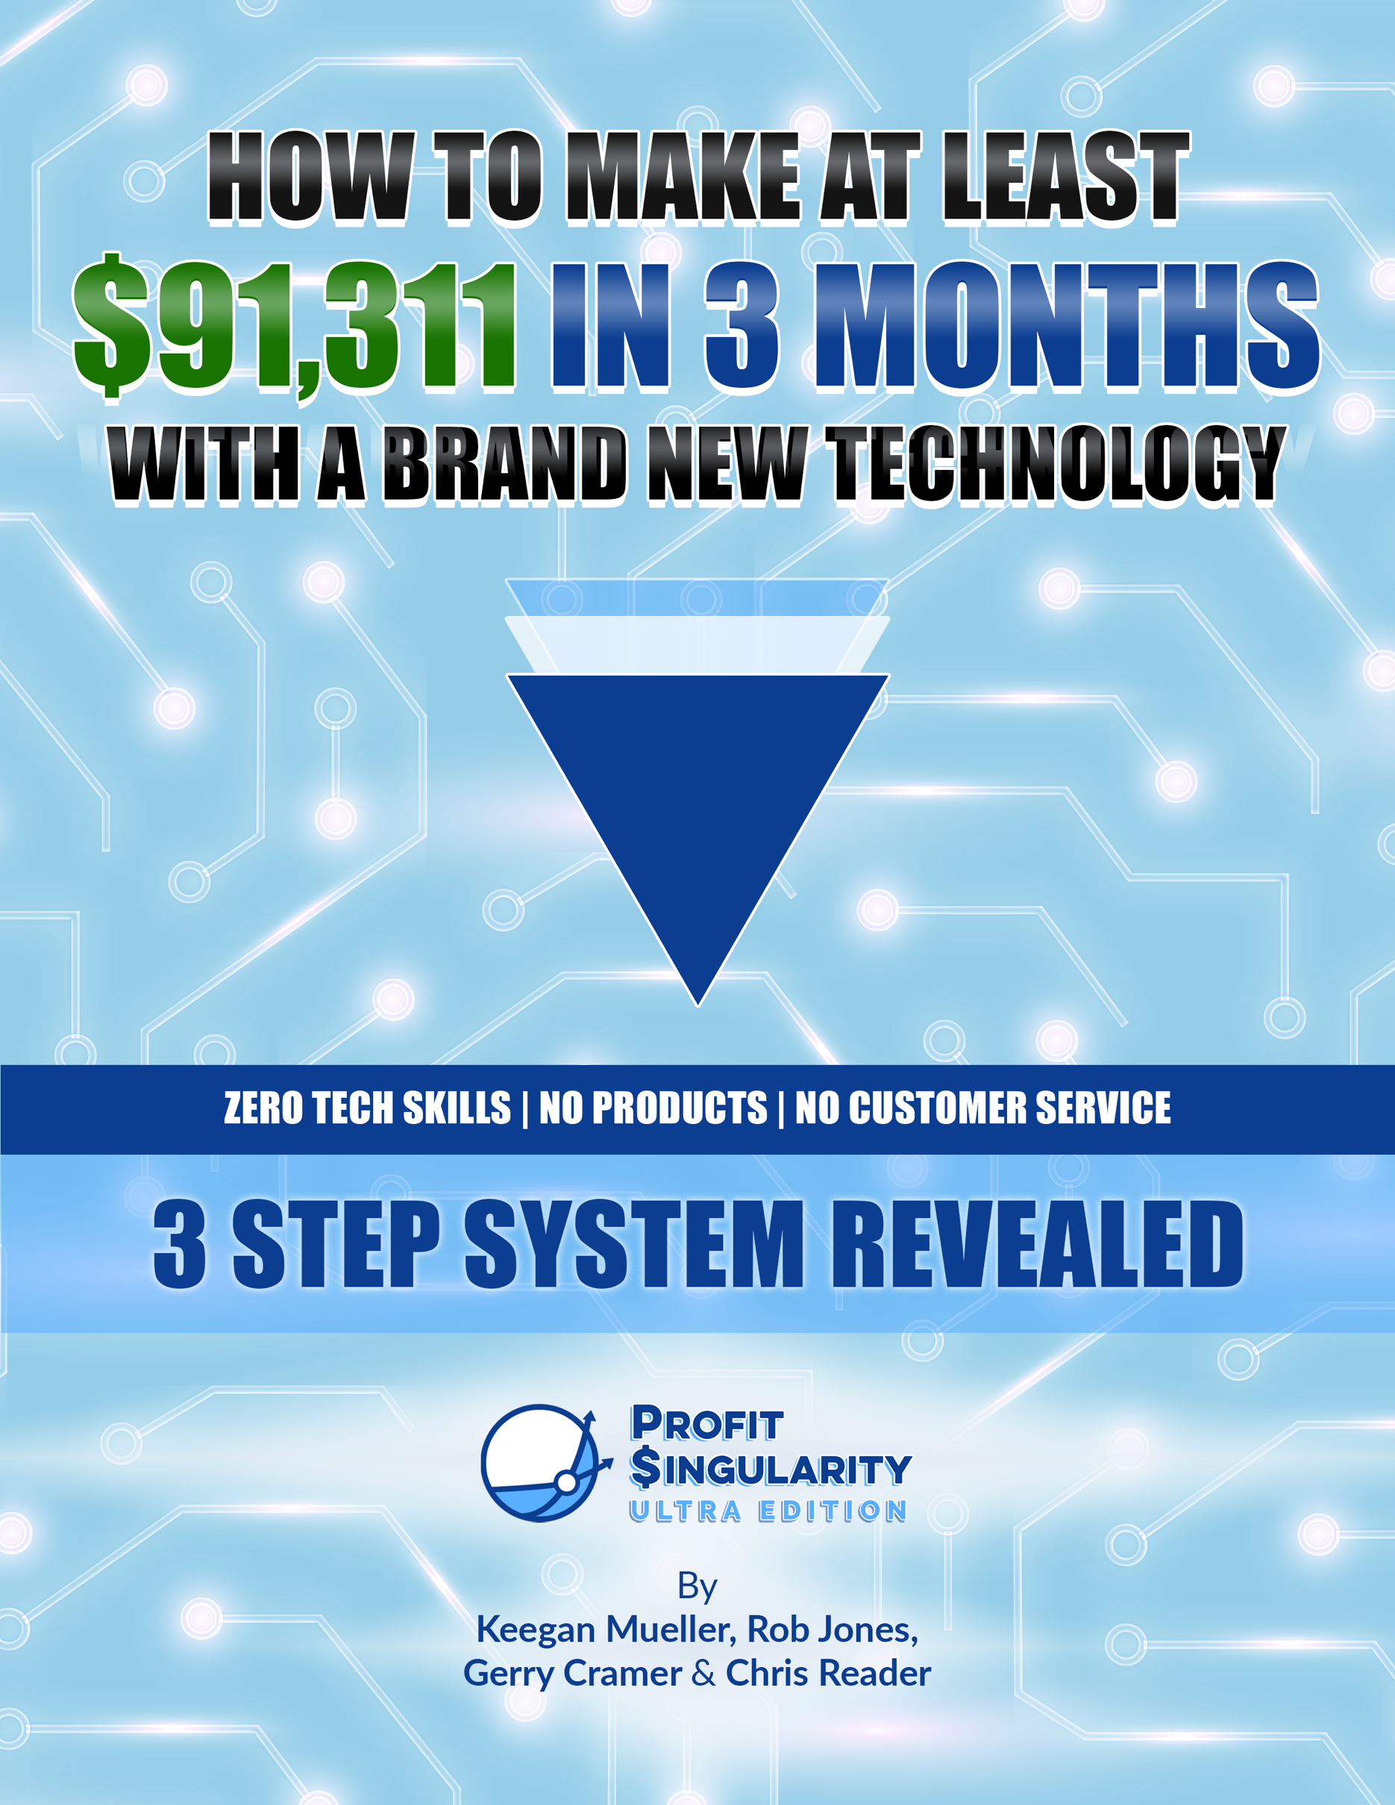

How a Small Group of Ordinary People
Made Up To $2.1 Million Each
In The Last 12 Months
Using a Brand-New Technology

…and how they did it WITHOUT any tech skills, WITHOUT Facebook or Amazon, WITHOUT creating products, WITHOUT customer support & WITHOUT spending a dime on inventory!

Hello, and thanks for signing up to get this case study!

IMPORTANT

Before reading one more word of this report, register to JOIN US on a LIVE
Online Coaching Session where we will walk you through this Never-Before-
Revealed simple 3-step system from start to finish and SHOW YOU our
$91k-in-3-Months-Blueprint (this is something anyone can replicate and scale),
in fact, everyone in our entire group of ‘beta testers’ was profitable, most
generating more than $1000 per day)!

Register for one of the live coaching sessions here:

http://GoProfit.AI/FreeTraining

NOTE: The webinar software we use limits us to 1000 session attendees. Each
session will be FULL TO CAPACITY, so make sure to log onto the call 20 minutes
early to avoid being locked out!

Did you notice the fine print above?

EVERY single person in our first small group of ‘beta testers’ made money with this never-before-seen system, including men and women from their early 20’s to their 60s from all over the world. In just 2 months, our small group of beta testers made millions of dollars with these 3 simple steps we’re going to reveal to you today!

And our second group of beta testers blew their numbers out of the water!

Now, we’re very excited to share this with you, and we hope you’ve signed up for one of our special online coaching sessions, because you do not want to miss out!

Now let’s get started!

The New Technology That Is Turning Ordinary People into Millionaires

In this special report, you’ll discover how to make at least $91,311 in 3 months using a brand-new technology that requires zero tech skills.

Most people overcomplicate the process of making money online, but THIS new system couldn’t possibly be any simpler:

- You do NOT need Facebook or Instagram
- You do NOT need to be a creative person
- You do NOT need an ounce of technical ability
- You do NOT need to create any products
- You do NOT need to have an online store
- You do NOT need an email list, followers or subscribers
- You do NOT need to work for months & months to see results
- And you do NOT need to worry about customer support or fulfillment

Does that sound too good to be true?

Well, it’s actually based on a proven business model that has made our students over $64 million in the last 5 years…with 1 primary difference…
90% of the work is done for you by a brand new technology!

…and you don’t even have to be Elon Musk to take advantage of it!

In fact, you don’t need to be technical at all!

This new approach means ALL the heavy lifting is done for you…isn’t technology great?

We Are The Only Ones Doing This…It Is A Wide-Open Blue Ocean Business Model!

There are 3 secrets that make this new strategy different than anything you’ve ever seen before:

- SECRET #1: A Simple, Accessible, Untapped & Mostly-Automated New Traffic Source Bigger Than Almost Any Other On The Planet!
- SECRET #2: An “Already-Optimized” Money Generating Machine That Anyone Can Quickly & Easily Tap Into!
- SECRET #3: An Ultra Simple Testing & Scaling Method That Anybody Can Do With No Prior Experience or Tech Skills!!

This is your opportunity to get in on the ground floor of something breathtakingly simple, powerful, and profitable!

This system, in a very short time, has already changed the lives of the few people who have been lucky enough to see it. So I urge you to read through this entire report and take it very seriously, because it has the power to change your life…

So, let’s jump in and see how it works!

The 30,000 Foot View…

To make sure we don’t overwhelm you, in this report we will be covering the 30,000-foot view of our never-before-seen system. This overview is going to be very powerful!

However, we will be going into more detail on our limited LIVE online coaching sessions, so I urge you to register for one of the limited seats right now:

Click here to register for one of our live coaching sessions

Here’s a sneak peak of the kind of results we are seeing:

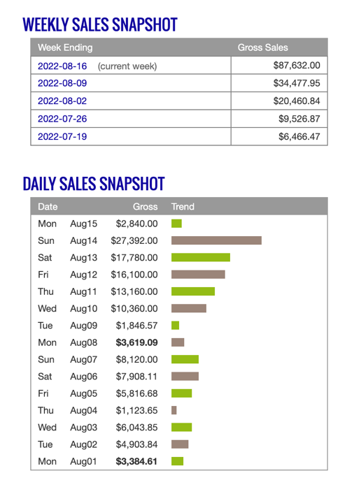
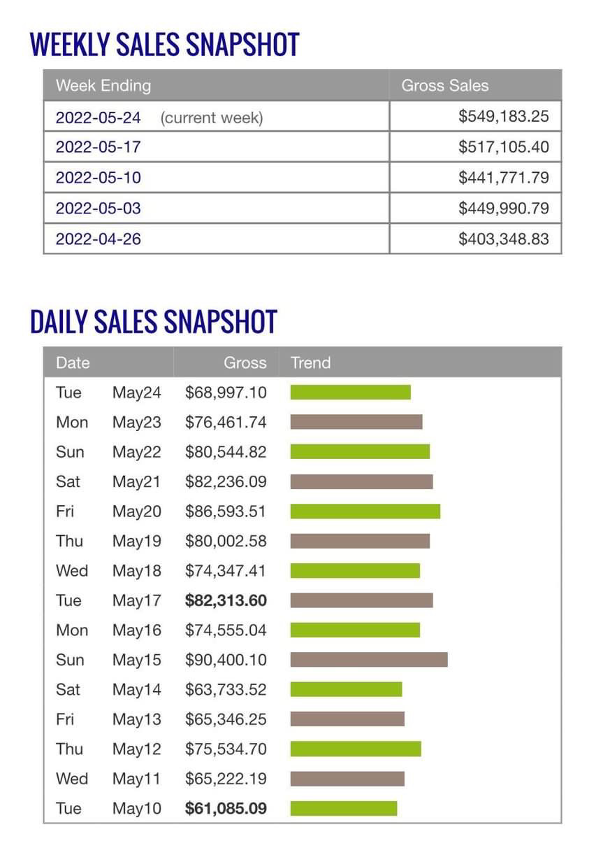
These are the results of just a few of our small group of ‘beta testers’…$90,400 and $27,392 days in a very short time!I should add these were complete beginners without any special skills or experience.

We’ll dive into the whole 3-step system soon, but first let me give you some background…
It All Started Back In 2015…

If you don’t know us already, my name is Rob Jones, and my business partner is Gerry Cramer. I’ve been lucky enough to make money online and enjoy that freedom for over a decade…and Gerry for more than 2 decades.

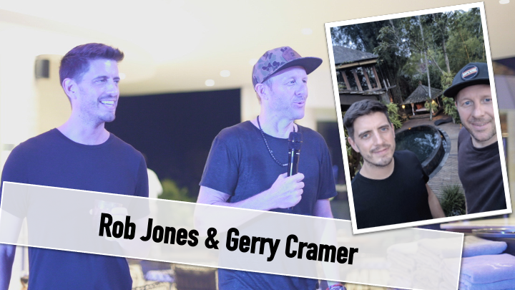

Back in 2015, Gerry discovered a simple system for making money online, and in 2016, we started teaching students how to do it too. It was an amazing success. Here we are with our students who were making $500 to $50,000 per day:

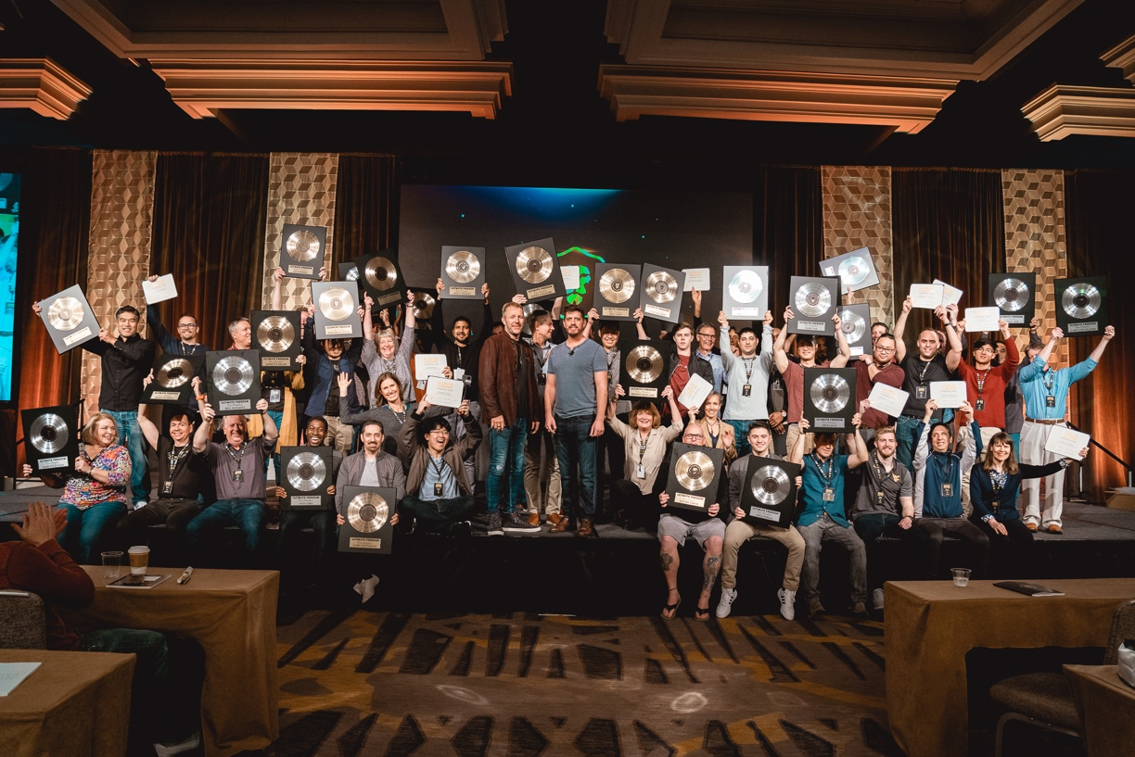
Here is a letter from one Clickbank, one network that we use to make money:

As you can see, the Vice President of Clickbank certified that our students have made over $64 million.

Better Than $64 Million?!?

The results of our students with Gerry’s system over the last few years have been astonishing, but I can honestly say this new system will blow these results out of the water.

It all started a few months ago when one of our most successful students, Chris Reader, reached out to us with some rather unbelievable news.

He told us about another one of our students, Keegan, who had adapted our system in a way that made it significantly easier and more powerful…all thanks to the power of a brand-new technology!

Thanks to this new technology, it suddenly became much easier for ordinary people to start making extraordinary profits right from the comfort of their homes with zero prior experience or tech skills required!

Who Is Keegan?

When we heard about Keegan’s results, we asked Chris to introduce us to Keegan.

Keegan is a young, soft spoken, clever guy from West Virginia. He’s also very kind and helpful.

Keegan had been using this brand new technology to make upwards of $30k per day.

And even better, he had not had a single negative day in over 6 months, as you can see from his impressive results…
Keegan at Stonehenge

When we met and spoke to Keegan, we hit it off immediately and after talking, we all decided we needed to see if this new method could be replicated by ordinary, everyday people.

So, we started to formulate a plan…

The Birth of the “Power Cell”

We had the idea of getting a group of ‘beta testers’ together to see if regular people could have the same kind of results as Keegan.

We called it our “Power Cell.”

We got together a small group of 15 volunteers, and kicked things off, and as you can see, everybody was excited to get started…

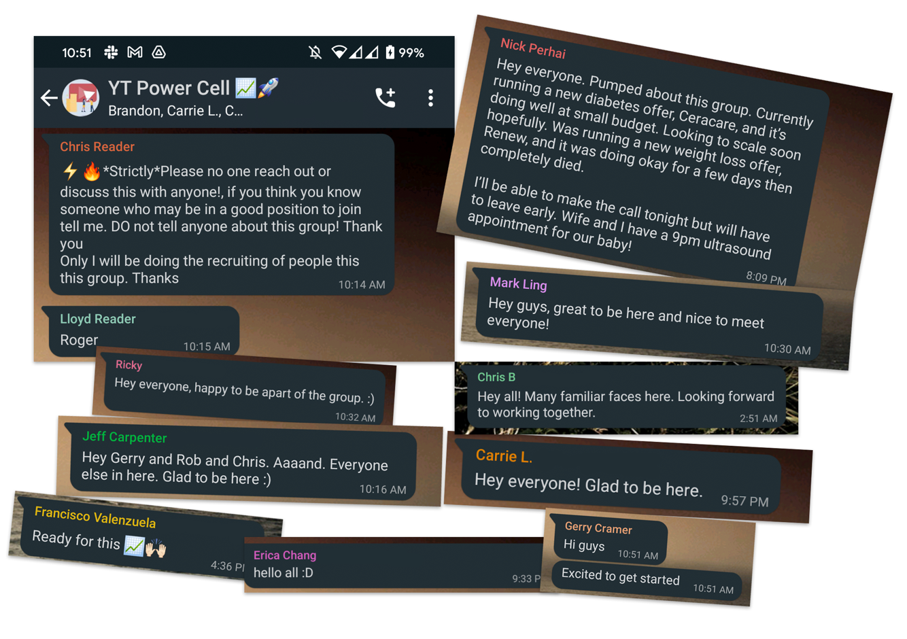

We were all excited for the possibilities, but we never could have imagined what would happen next.
Francisco’s Results - $15k Days!

Francisco lives in Venezuela where the average monthly income is $500. Even with limited cash, he got his first sales, and over 3 months got up to $15,000 days! Now he says he makes more than his parents’combined yearly income in one day!

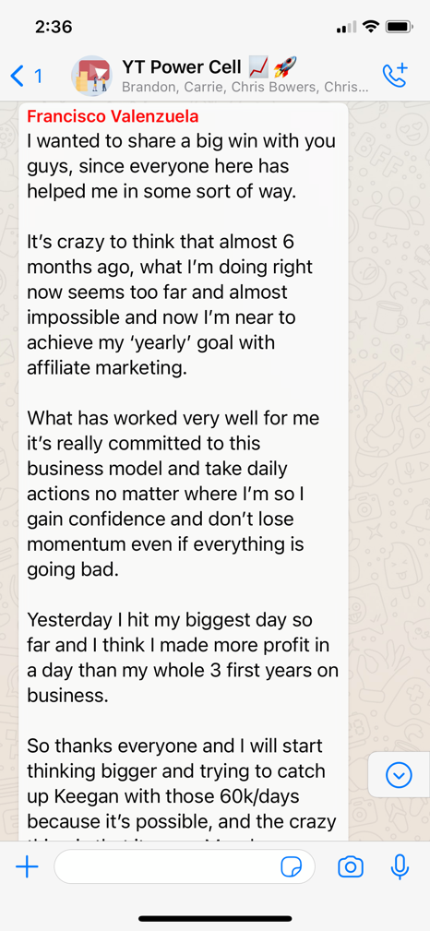
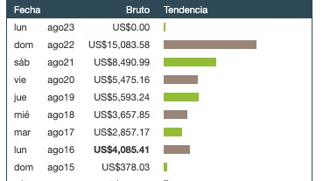
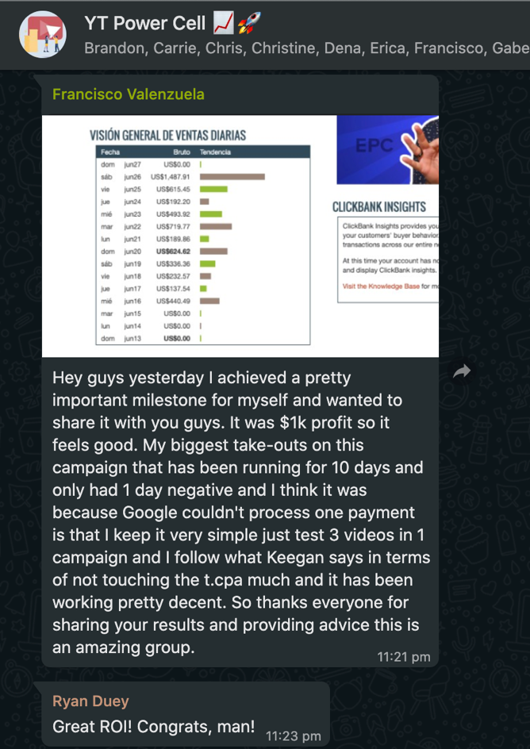
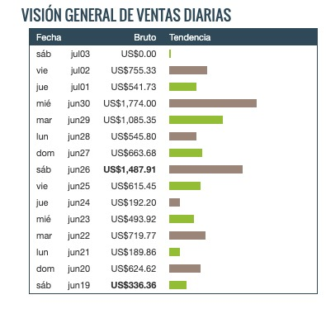
Dena’s Results

Dena is a mother of 2 daughters from Northern California, and her family was struggling to make ends meet financially.

Within just a few weeks of starting, Dena was making hundreds of dollars per day:

A few weeks later, Dena hit her first $1,000 profit day!

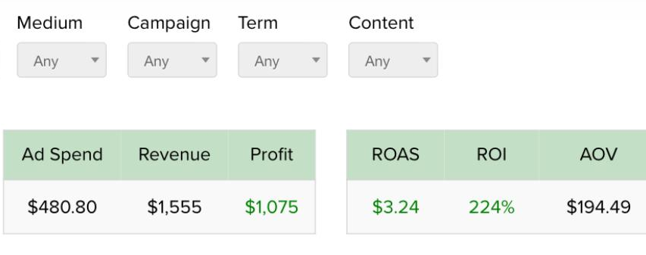

Now she can take care of her family and focus on the non-profit work she is passionate about!

Gabe’s Results

Gabe is a married father of 6 from Utah. The most important thing to him is his family.

Gabe struggled in the beginning with overcomplicating the system. But after making a few mistakes, he realized the most effective approach is Keegan’s proven simple method. When he finally gave into the simple method, his results skyrocketed.

Gabe hit his first $1,000+ profit day in August, and he was very excited to share his results:

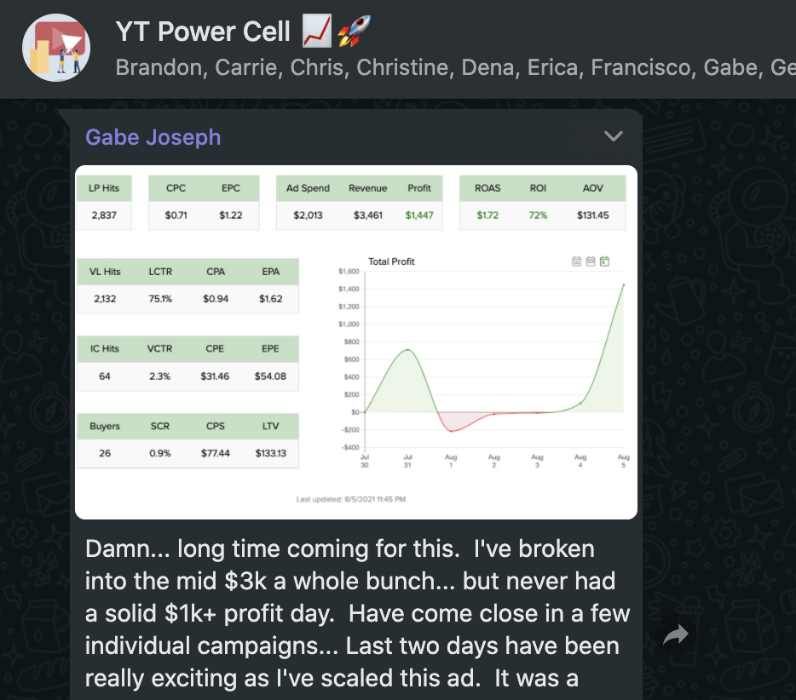

Just 4 days later, he hit it really big…

Imagine his excitement as he hit his first $15,000 day!

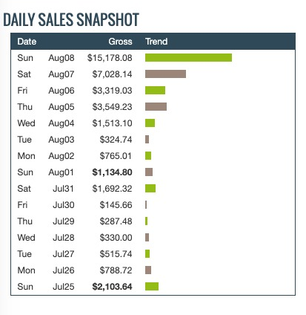

Nick’s Results

Nick is young and newly married. When the group started, he and his wife were expecting their first child:

Nick jumped in headfirst and didn’t hold back. Within a few short weeks, he had already gotten up to $15,000 days!

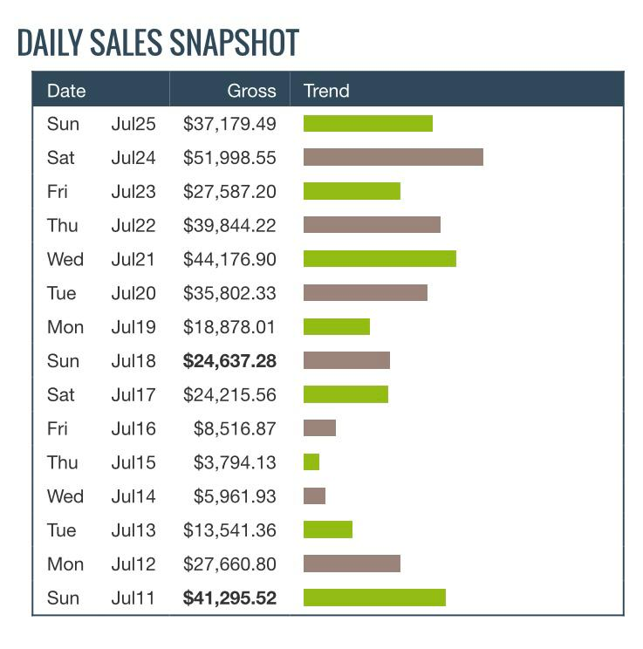
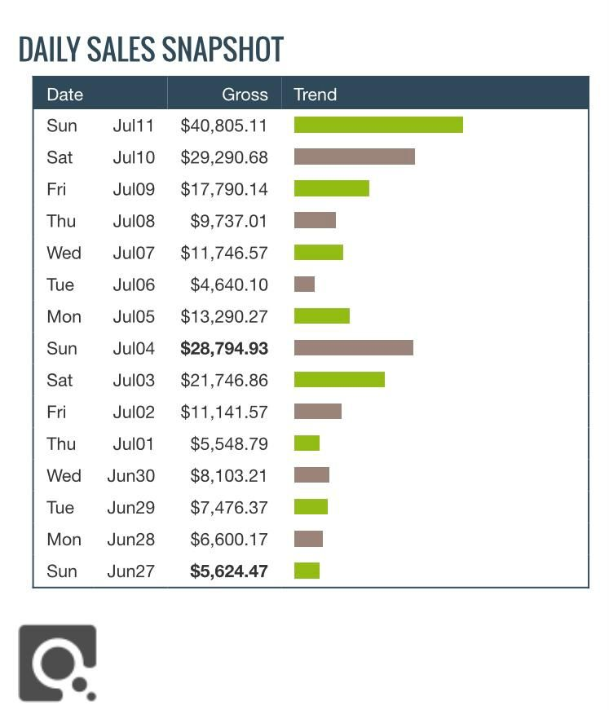

Less than a month later, Nick hit his first $40,000 day!

2 weeks later, Nick broke his first $200,000 week! Within 3 months, Nick had generated over $1.5 million!

In that time, his baby girl was born, and he was then able to take some time off to spend with new family, and he couldn’t be happier!

Greg’s Results

Greg is a 58-year-old father of 2 sons and 2 daughters from Australia. He’s a widower who lost his wife 3 years ago. He had been through some very difficult times financially as well over the past several years.

He also struggled with creativity, but he was able to quickly pick up Keegan’s system, and imagine his excitement as his first sales started to roll in and making hundreds in profit per day:

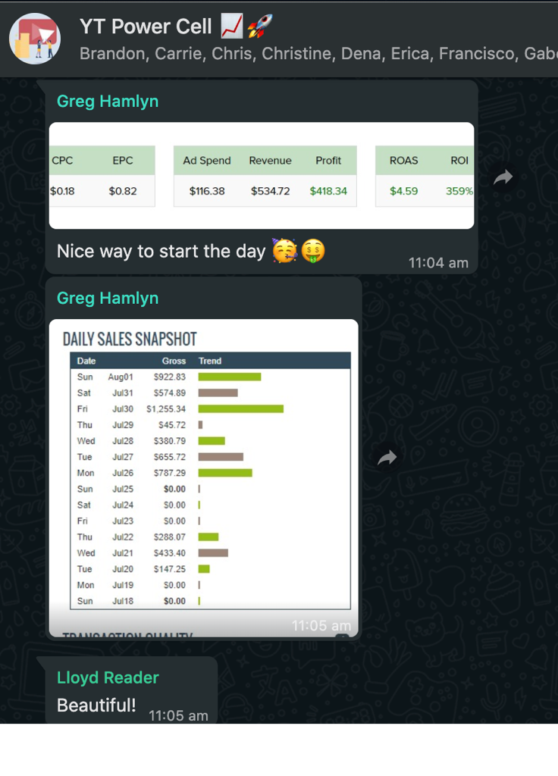

Just a few days later, Greg broke his first $1,000+ profit day.

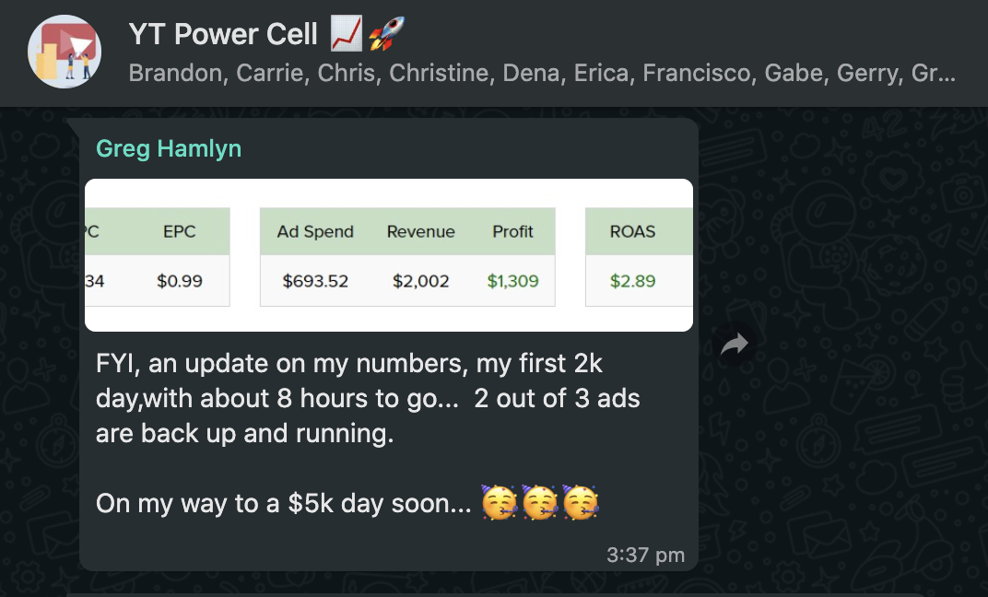

Greg was excited to reach his first $5k day soon, but he shot past it a few days later to hit his first $8,000+ day:

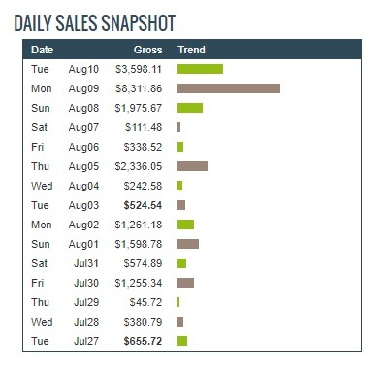

Now he says his success finally feels real…not just watching other people’s success stories anymore, and it has made a huge impact on his family’s life.
Unbelievable Results from EVERYBODY in Our Power Cell Group of “Beta Testers!”

I could add pages and pages of additional results from our first small group “beta testers,” but I think you get the picture.

In my 10+ years online, I had NEVER seen anything so effective as the results from the first small ‘beta tester’ group.

After just a short 3 months, EVERYBODY from our initial group of ‘beta testers’ who was running Keegan’s method was having amazing results.

Listen to these crazy, unbelievable results in just 3 months:

- All 15 beta testers made money.
- 100% of the group (15 out of 15 people) made over $10,000
- 13 out of 15 people made over $20,000
- 7 out of 15 people made over $50,000
- 4 out of 15 people made over $100,000
- 1 person made $1.5 million

NOTE – That’s excluding me, Gerry, Keegan, and Chris. We all made an awful lot of money too, but since we are a bit more experienced, I didn’t include our numbers in the totals.

Now those are gross numbers…what about profit?

Well, we asked everybody to share what their biggest profit day so far was and here were their results:

- Everybody got up to at least $500 PROFIT per day
- 13 out of 15 got to over $1,000 PROFIT per day
- 5 out of 15 people got to over $2,000 PROFIT per day
- 4 out of 15 people got to over $5,000 PROFIT per day
- 3 out of 15 people got to over $6,000 PROFIT per day
- 2 out of 15 people got to over $9,000 PROFIT per day
- 1 out of 15 people got to over $23,000 PROFIT per day

To put that in perspective:
- $500 profit per day puts you in the top 10% of income earners in America.
- $1,000 profit per day puts you in the top 5% of income earners in America.
- $2,000 profit per day puts you in the top 1% of income earners in America.
- $7,700 profit per day puts you in the top 0.1% of income earners in America.

EVERY single person in the group is now in the top 10% of income earners!

86% are now in the top 5% of income earners!

40% are now in the top 1% of income earners!

And 13% of our little group are now in the top 0.1% of income earners!

That is INSANE!

And after only 3 months!?!

I can barely believe it myself.

But that’s just the beginning…
Phase 2 – Our 2nd Beta Test Group

We were so amazed by the results of our initial small beta tester group that we decided to teach our method to a 2nd group of beta testers.

Around a year ago, we opened up our method to several hundred new beta testers…complete strangers from all over the world, men and women of all different ages and backgrounds.

We wanted to see if the results of our small group could be replicated by ordinary people.

But we never could have guessed what would happen next…

The Mind-Blowing, Amazing Results of Our 2nd Group of Beta Testers

Over the last year, we have been contacted by dozens of our beta testers sharing bigger results than we ever imagined possible, absolutely smashing our expectations.

Results like these…

Bryan’s Life Transforming Results

Bryan is a married father of 4, in his 50s, living in Missouri. He grew up in poverty, getting a degree in IT to try and escape the cycle. He struggled at a stressful job with long hours and always felt like something was missing.

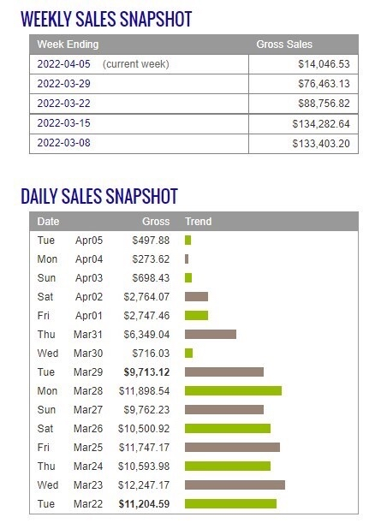
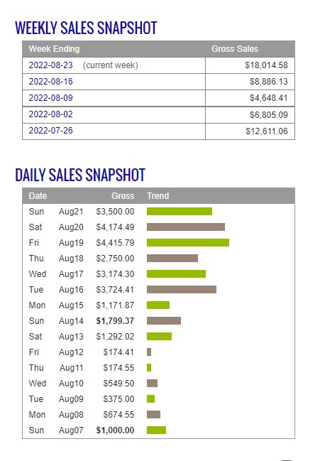

Since starting this new method, Bryan has reached regular 4 and 5-figure days and broken free of the restraints of his past career, achieving financial freedom and finally giving his family everything he hoped for.

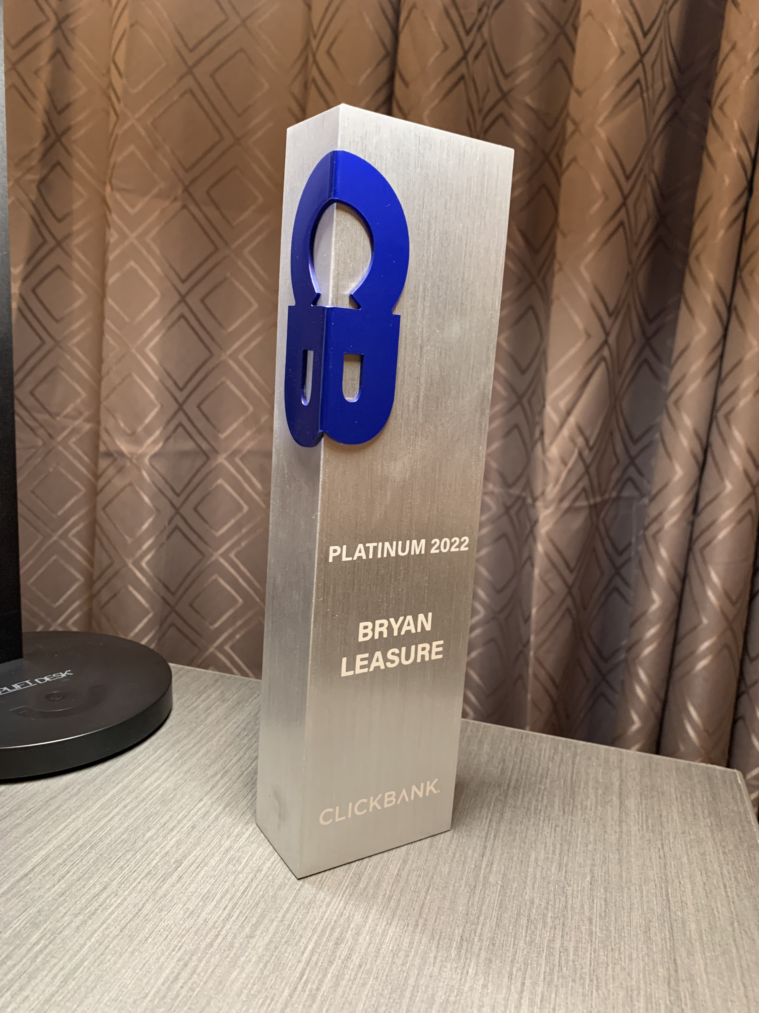
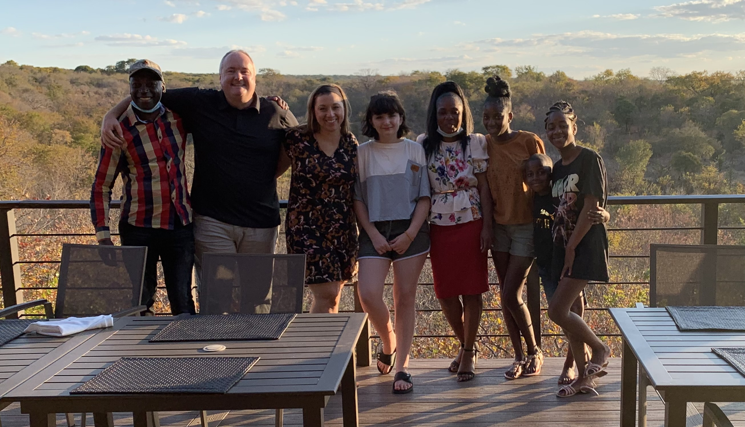
What’s even cooler is Bryan and his family have now sponsored a family in Africa to help them break free from the poverty cycle like he was able to.
Cole’s $500,000 Weeks with 1 Video

Cole is a 26-year old from Newport Beach, California. He was never a good student but he could play baseball. Unfortunately, he never realized his dreams of going pro, so he was stuck working difficult jobs…construction, hard labor, sales…

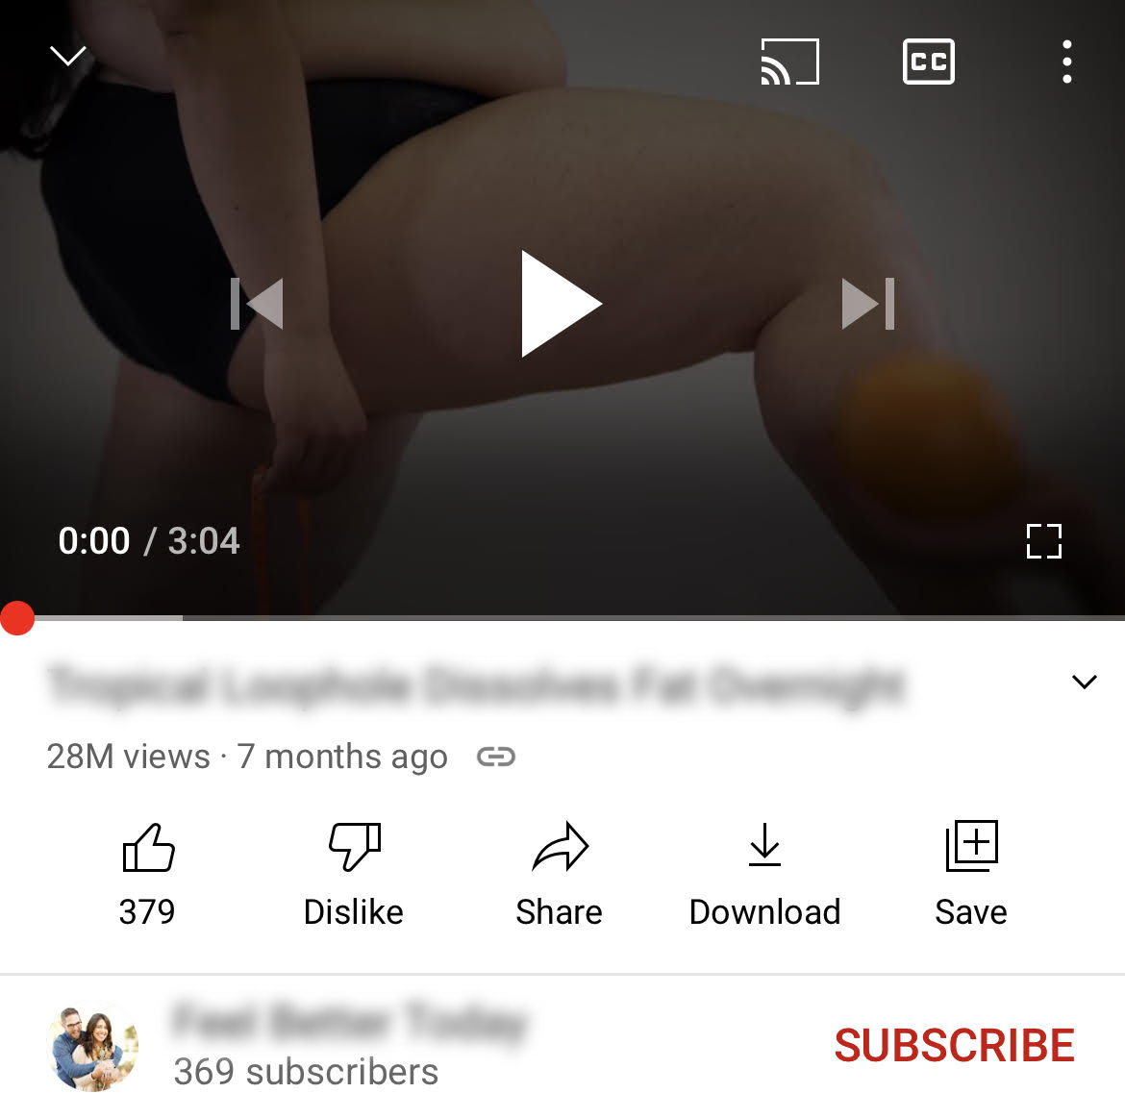
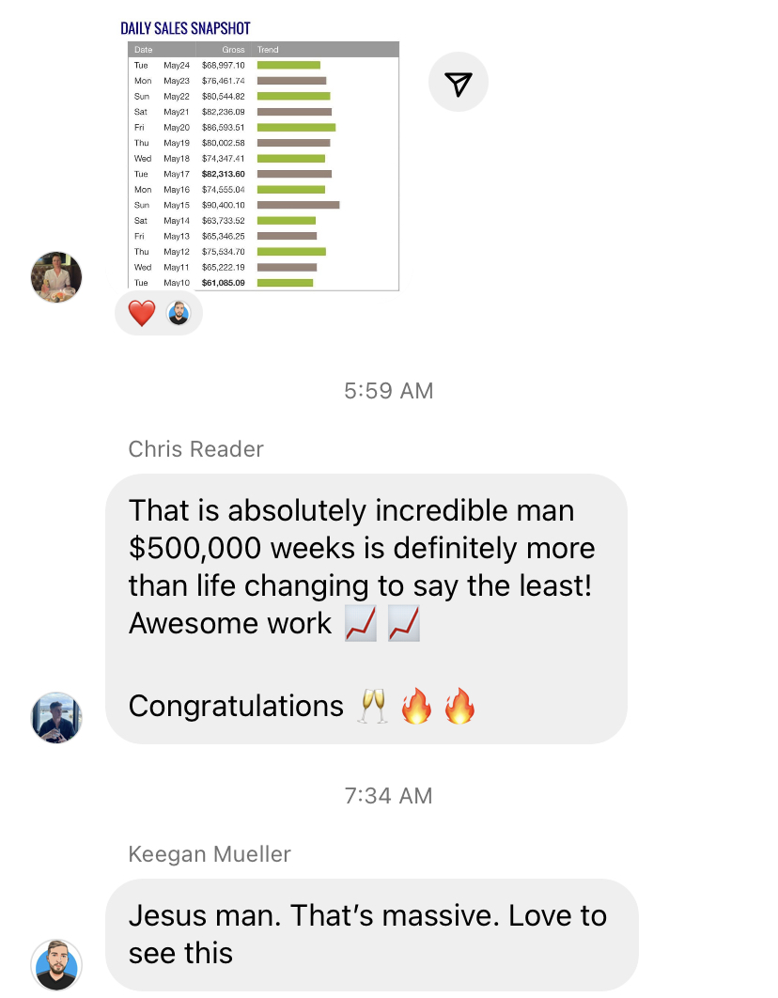
Everything changed after he found this new method. Once he found his winning video ad, he was able to make over $2.1 million in 7 months since joining our 2nd group of beta testers. Now his life is forever changed and he is an inspiration to us all of what is possible.
Jenn’s $60,000 Days From 1 Video

Jenn is a middle-aged, married mother of 4 living in Connecticut. She worked her entire life in the restaurant industry and is the primary breadwinner in her family. Unfortunately, the pandemic and a diagnosis of Multiple Sclerosis prevented her from managing a restaurant after many years, and her family was really struggling.

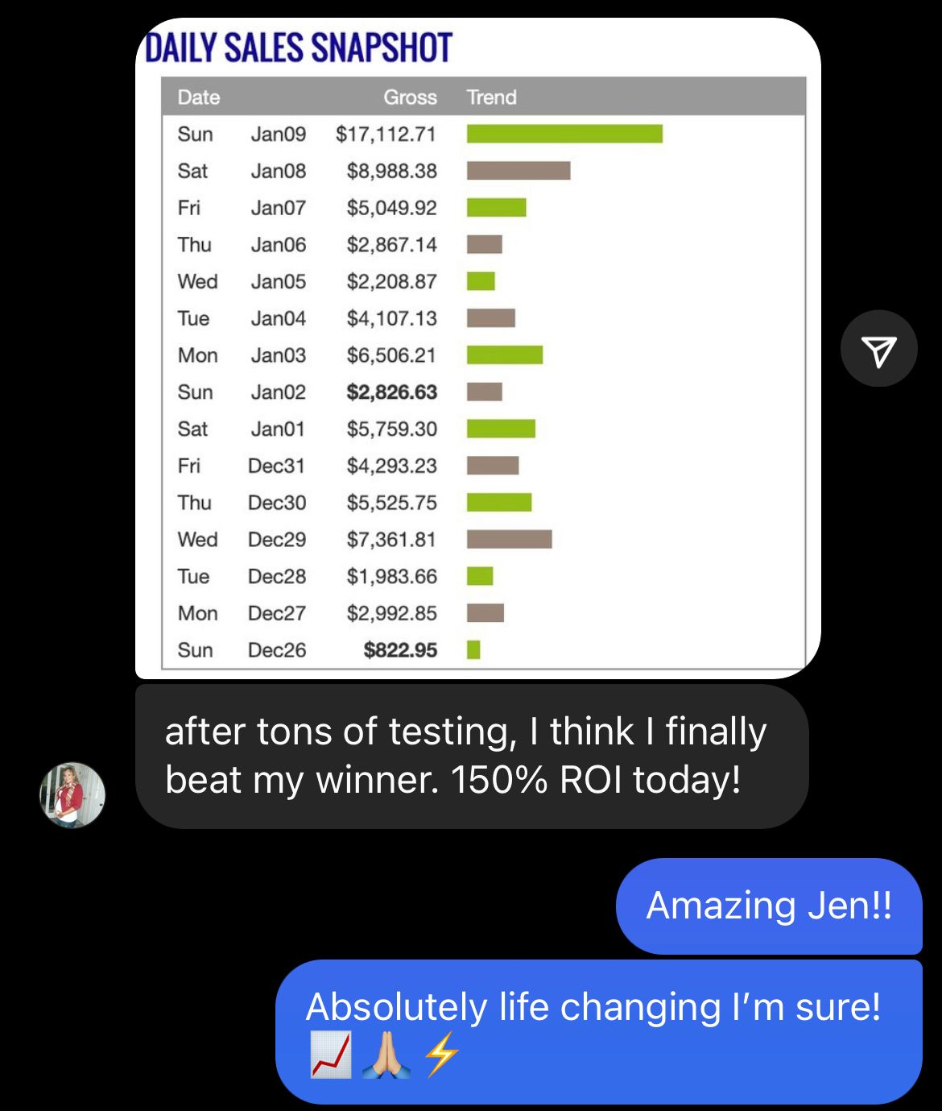
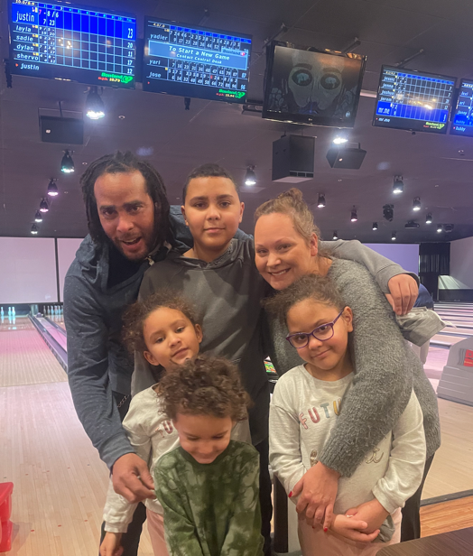
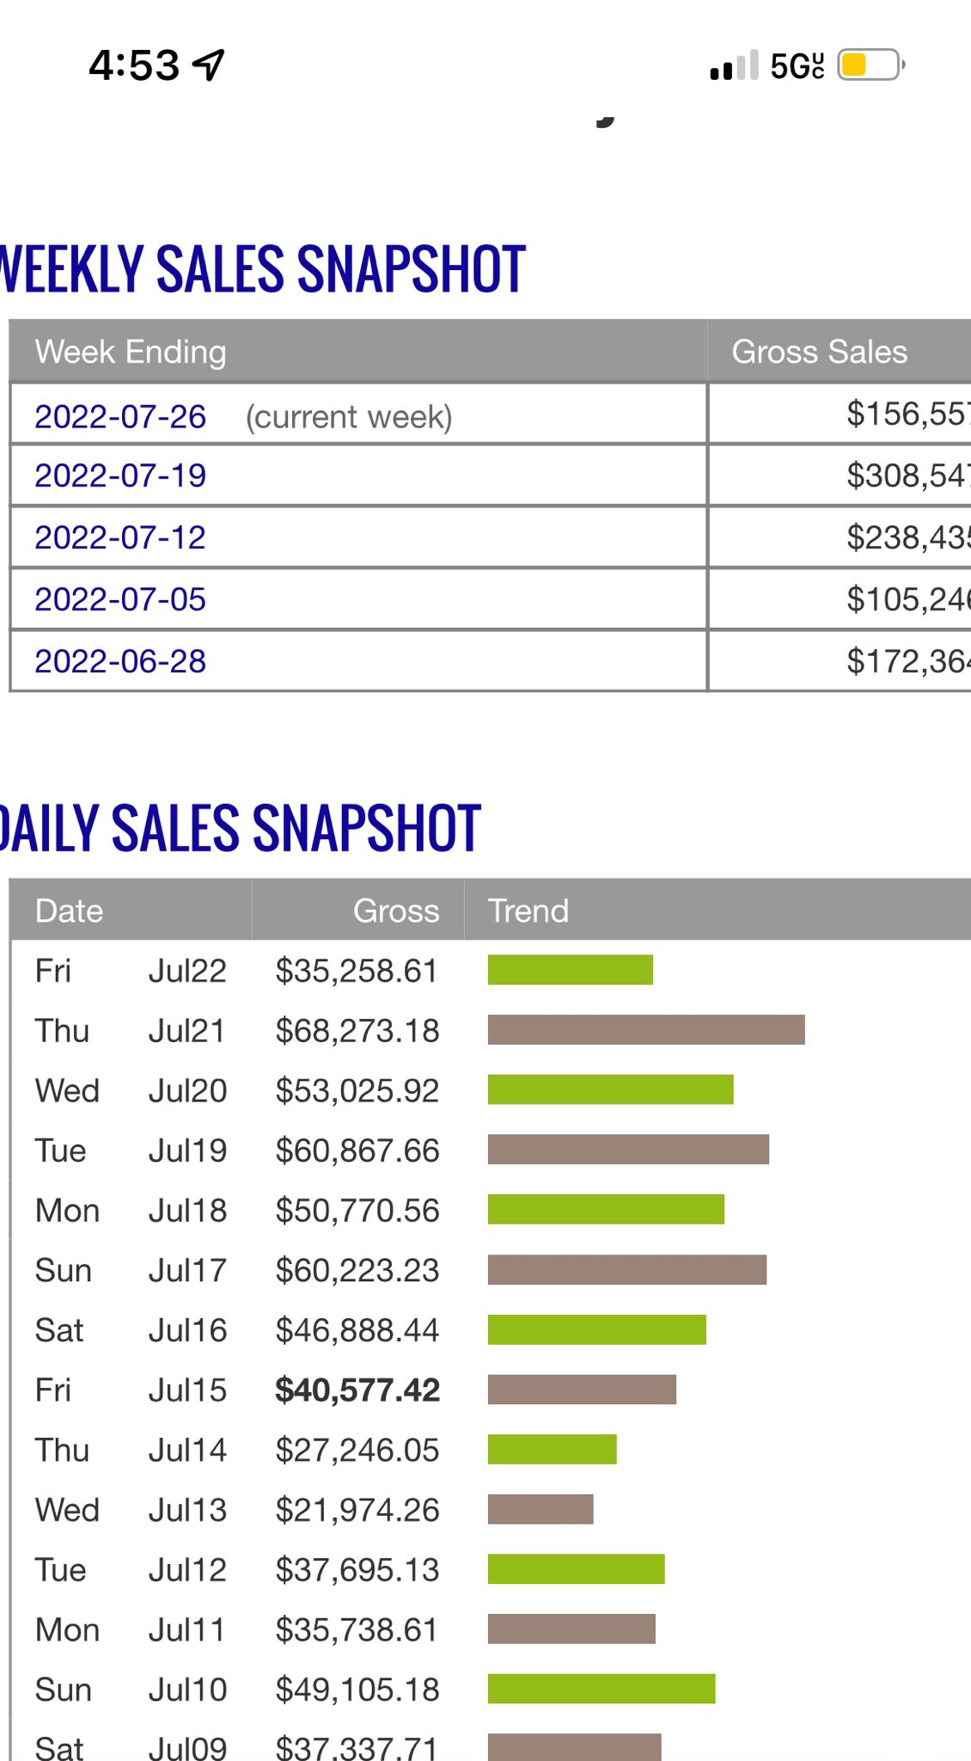
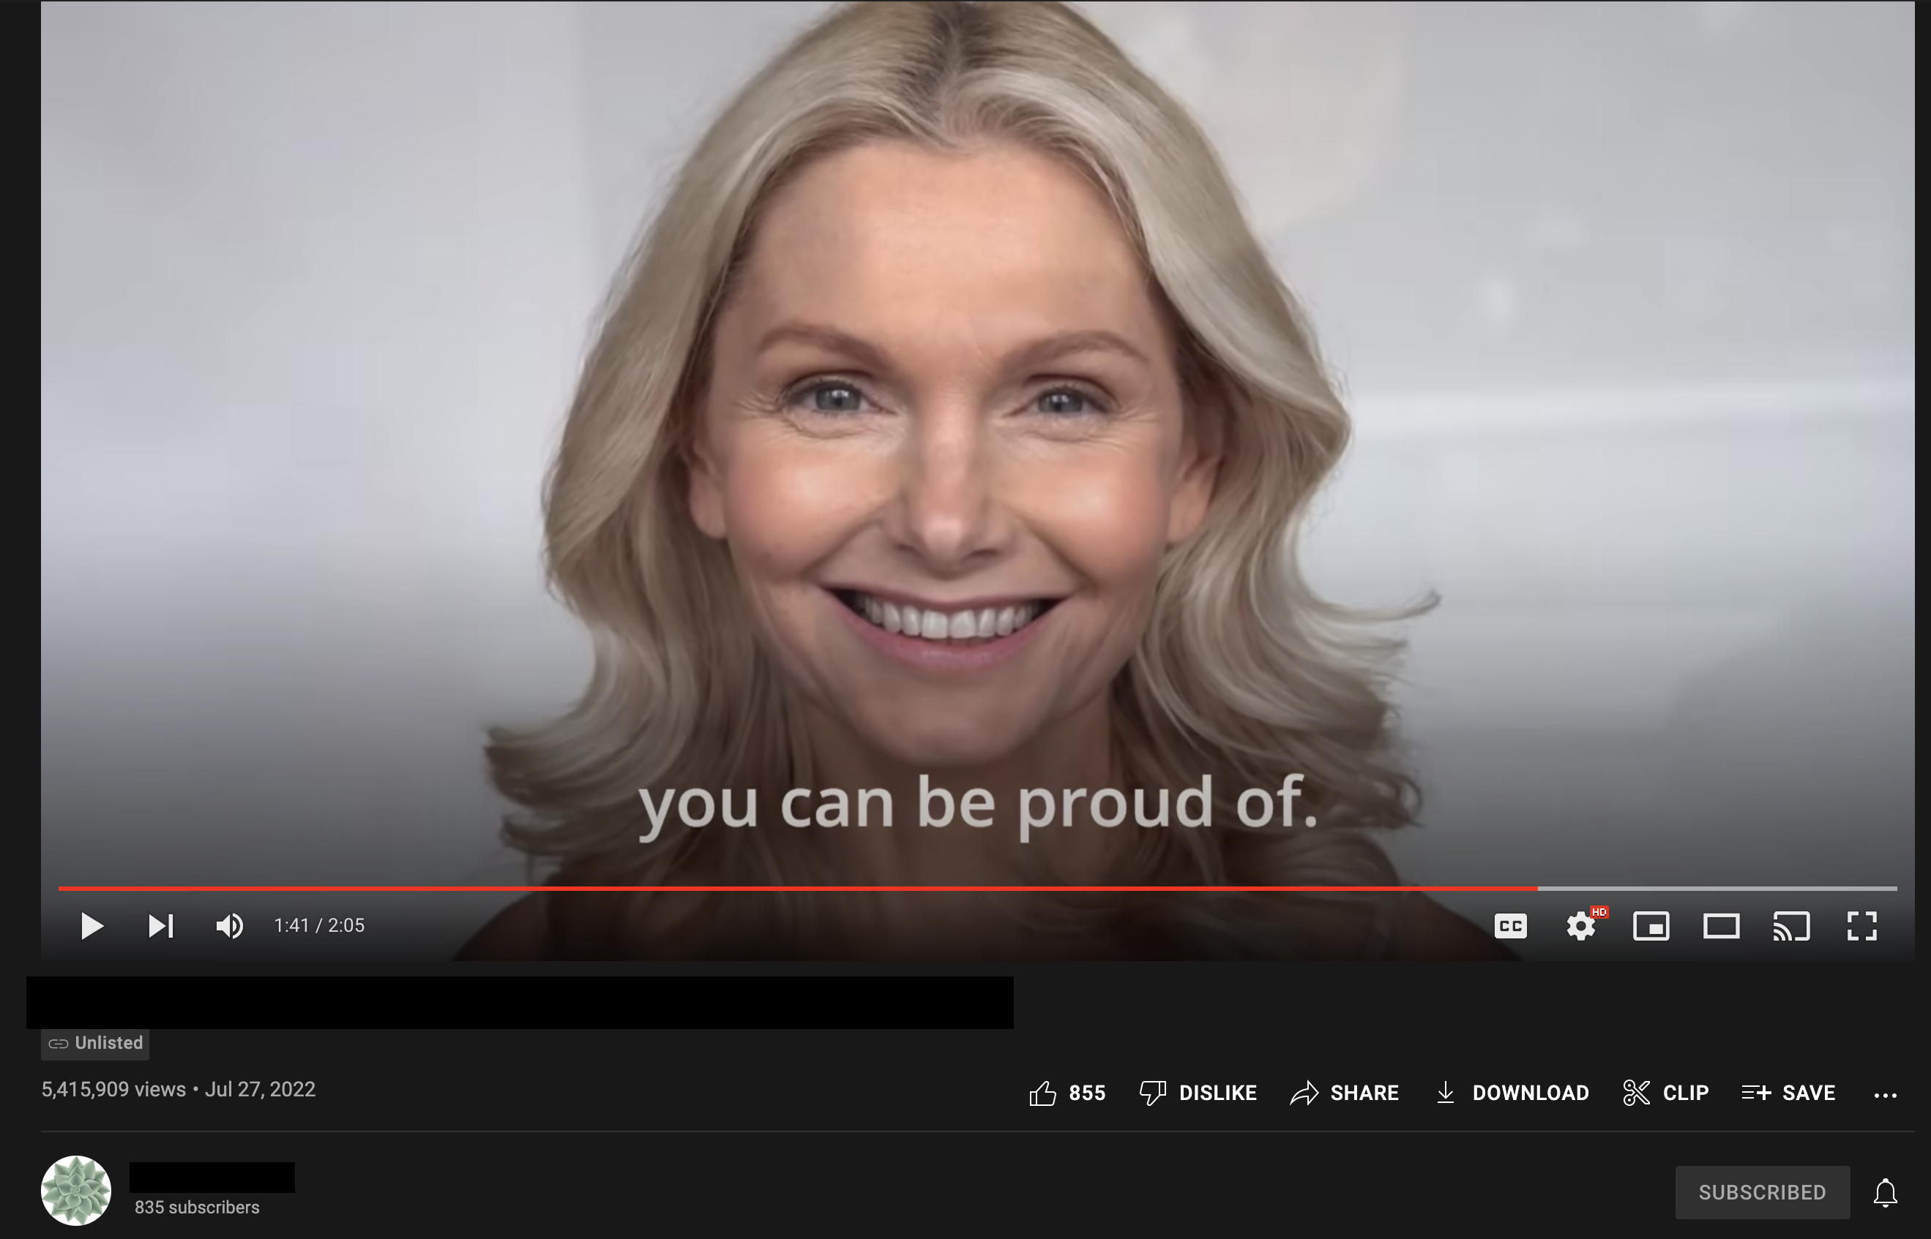
Once she found this method and her winning video ad, everything changed for her. She went Clickbank Platinum ($250,000) within 2 months and now is regularly doing 6 figure weeks. Now she is in full control of her family’s finances and future and she has amazed all of us with her ever increasing levels of success!
We Have Dozens & Dozens More Equally Impressive Results

This is just the tip of the iceberg. On our upcoming live coaching session, you’ll see even more examples of ordinary people who transformed their lives with this amazingly simple new method driven by a powerful new technology.

Now that you’re hopefully starting to get a small idea of what’s truly possible with this amazing new system, let’s jump into what it is and how you can get started.

How Does This New Technology Work?

As I mentioned before, there are 3 secrets that make this powerful new money making strategy different than anything you’ve ever seen before:

- SECRET #1: A Simple, Accessible, Untapped & Mostly-Automated New Traffic Source Bigger Than Almost Any Other On The Planet!
- SECRET #2: An “Already-Optimized” Money Generating Machine That Anyone Can Quickly & Easily Tap Into!
- SECRET #3: An Ultra Simple Testing & Scaling Method That Anybody Can Do With No Prior Experience or Tech Skills!

Now, I’m going to jump into each secret in just a moment and explain exactly how they work, but first let’s talk about…

7 Reasons This New Technology Is So Dang Powerful

- Reason #1: It has the best benefits of most online business models without all the bad stuff. You can be your own boss and set your own hours. You can work as much or as little as you like. You can be location independent. Yet, you don’t need to be a tech expert or build out a huge business. You have almost zero overhead expenses and the simplest business model we’ve ever seen.

- Reason #2: You can see results on your very first day. Time and time again our beta testers have shown that you can see immediate results within your first 24 hours. If you follow the steps closely, without changing them up or second guessing them, there is a very good chance you can start to see profit on your very first day…and if not on your first day, then within your first few days, because this new technology is so good at optimizing profit for you.

- Reason #3: You can get started “on the side” of whatever you’re currently doing. This is not a labor-intensive business model. It is not a big time commitment. Because the new technology systems do so much of the heavy lifting, you can get started in only an hour or two here and there and see results quickly. You don’t need to commit to a ton of time working on this business model to make it work. And then as the income starts to build, you can decide if you want to make this your primary source of income or just keep it as supplemental income.

- Reason #4: You can scale up fast when you find a winner. In many systems, there are limitations to how big or how fast you can scale up. That is not the case with this system. The sheer volume of profitable traffic and the method by which this powerful technology automatically selects the most profitable pockets of traffic for you at any scale, it’s as easy as turning a dial up when you find a winner. It’s literally just a few clicks of your mouse.

- Reason #5: You don’t need to be creative. With many systems, you need to be a good copywriter or designer or good with building out websites and systems. You don’t need any of that with this powerful new technology. Beta testers like Ryan, Gabe, and Greg and the others, who typically struggle with the creative aspects of online business, were able to experience huge success with this method because it didn’t require any creative ability in order to be successful.

- Reason #6: Saturation & competition don’t matter. With this system, there is more profitable traffic out there than you can even comprehend. This is one of the very biggest traffic sources on the Internet. And the powerful new technology working for you is the best in the world at optimizing that traffic. Plus, there are countless different offers that meet the criteria for this system, so you’ll never have to worry about saturation or competition.

- Reason #7: You don’t have to be technical. One of the absolute biggest reasons people fail online is because it’s just too damn technical. However, with this powerful new technology, all the technical stuff is done for you. It couldn’t be any simpler. If you can type and point a mouse and follow very simple, intuitive instructions, then you will be able to follow this system. You will never have to let tech issues stand in the way of your success again!

I hope you’re getting excited!

Before we jump into Secret #1 of this powerful new money-making system works, please make sure to take a moment to register for one of our upcoming LIVE online coaching workshops:

Claim Your Seat Now!

Register to JOIN US on a LIVE coaching workshop where we will take you
step-by-step through this incredible new system:
Register for one of the live coaching sessions here:

http://GoProfit.AI/FreeTraining

If you’re interested by what you’ve seen so far, you’ll LOVE what we have in
store for you on our LIVE coaching sessions!

Secret #1 – A Simple, Accessible, Untapped & Mostly-Automated New Traffic Source Bigger Than Almost Any Other on The Planet!

The lifeblood of any online business is traffic…you can’t make money online without traffic.

Traffic needs to fulfill 3 purposes:

- It needs to be profitable
- It needs to be available on demand
- It needs to be scalable

For these reasons, we pay for traffic. Any source of so called “free” traffic typically does not meet these requirements.

Paid traffic is available on demand. “Free” traffic is not.

So, we buy traffic.

And for 5 years, we almost exclusively bought traffic from Facebook. In prior years, Facebook always had the most profitable, scalable traffic.

But then it became increasingly difficult to buy profitable, scalable traffic on Facebook for numerous reasons…account shutdowns, competition, tracking difficulties (iOS 14 updates, etc).

You don’t really need to know all the technical details. The bottom line is it’s just a lot harder to get profitable, scalable traffic nowadays on Facebook.

But luckily there’s a new hope…

The BIGGEST Untapped Traffic Source

There is one subdivision at Google that is so massive and still untapped when it comes to advertising…

That’s right…YouTube.

YouTube is the #2 website on the planet. The only website bigger is Google, and Google OWNS YouTube.

Now in the past, we never looked too closely at YouTube advertising for 2 reasons:

- Videos were too hard to make
- Google was hard to advertise on

But ALL of that has changed.
I’ll get into why videos are a million times easier to make now in Secret #2.

For now, let me explain to you why Google (and more specifically YouTube) is infinitely easier to buy profitable, scalable traffic now.

There are 5 reasons:

- Ad targeting is brain dead simple. On YouTube ads, the most profitable ads only require you to choose a topic or simply advertise to the broad audience. It requires basically zero skill to figure out ad targeting now, and it takes about 30 seconds to set up, if you know the right settings.
- Google does all the work for you of finding the profitable traffic. Google is about as set-and-forget as you can get it. Google’s machine learning automatically optimizes your traffic so insanely fast, we have often been able to be consistently be profitable right from day 1 on our winning campaigns. And every day that we run ads, Google’s extremely advanced A.I. machine learning algorithm optimizes automatically and gets more and more profitable.
- You can advertise all kinds of stuff that you never could on other networks. Most traffic networks have so many limitations on weight loss, dating, and tons of different profitable industries. Google lets you advertise practically any industry you can imagine…most importantly the most profitable ones! And it’s SOOOO FAST & EASY!
- The setup is so simple a monkey could do it. With YouTube ads, starting a new campaign requires just a few dead simple settings, and you’re good to go. Even my grandmother could do this!
- You can scale up as fast as you could ever possibly want to at the flip of a switch. With a lot of traffic networks, you have to jump through hoops with crazy methods like horizontal scaling…spreading out over multiple ad accounts…daily spend limits…and all kinds of crazy hoops to jump through just to scale up. With YouTube ads, Google actually recommends you raise your budget practically every day! When I’m running $20k per day budget, Google actually recommends that I raise it to $60k per day budget! That is practically impossible to do on other networks.

There is no faster & easier traffic network to buy profitable, scalable untapped traffic right now than YouTube ads on the Google ad network.

ANYBODY can do it, and it’s so insanely simple it will blow your mind when we show you on the live training session.

SECRET #2: An “Already-Optimized” Money Generating Machine That Anyone Can Quickly & Easily Tap Into!

Traffic is not enough to make money online. You also need a method to turn that traffic into CASH in your pocket.

That’s where the 3-Step “Already-Optimized” Profit Machines come into play.

And it’s so simple, you’ll be amazed!

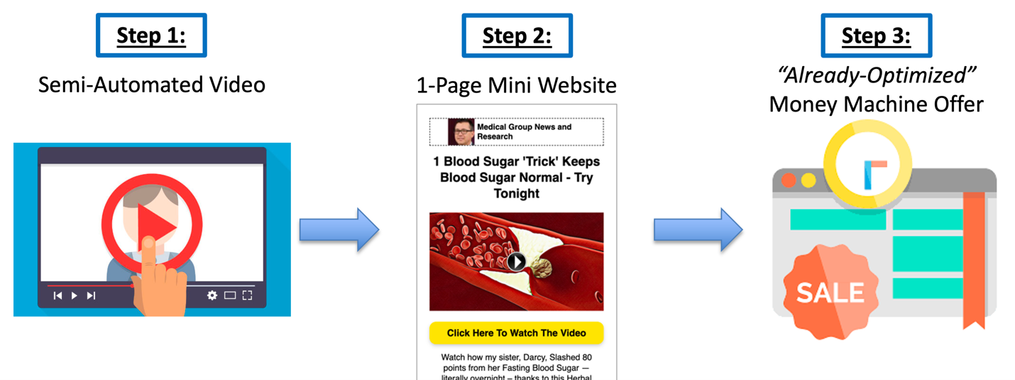

The 3 steps are a semi-automated video, a 1-page mini website and an “Already-Optimized” money machine offer you can instantly tap into.

I’m going to go through each step and show you how amazingly simple and easy they are, thanks to brand new technology and a few other tricks we have up our sleeves.

Step #1 – The Semi-Automated Video

Videos used to be difficult & time consuming to make. You needed to be creative. You needed to know how to use video software. You needed production skills, copywriting skills and a host of other things.

Not anymore. All of that has changed.

Thanks to the magic of new technology that we will share on the live training session (be sure to register now), videos can now be generated in minutes with a few clicks of your mouse.

All you need is a written script, and we have proven templates for that.

The new technology will do all the other difficult tasks of creating videos for you.

Listen to this:

- You don’t need a camera
- You don’t need a microphone
- You don’t need any video software on your computer
- You don’t need any production skills
- You don’t need to be in your videos at all

A.I. Robots can now create voiceovers on videos that you can barely tell aren’t human.

New technology picks out video clips for your video to play in the background for the voiceover that was created for you.

There is also natural language processing that automatically syncs up the voice with captions in the video and the voiceover script.

95% of the work is done for you. Literally all you have to do is copy and paste a video script into the semi-automated video creator and it does nearly all the heavy lifting for you.

And just a few manual tweaks after that to make sure everything looks good, and you press a button, and you have a video!

Again, all you need is a video script. That is the big key.

To find out how we quickly & easily create our scripts that are responsible for the insane profits you’ve seen from our 2 ‘beta tester’ groups, make sure to register for one of our upcoming LIVE coaching sessions at:

http://GoProfit.AI/FreeTraining
.

Step #2 – The 1-Page Mini Website

The 1-page mini website needs to include proper sales & persuasion tactics, but this is actually super easy, because we use the same templates for every 1-page mini website.

It’s simply a checklist we go down to make sure our 1-page mini website checks all the boxes.

You don’t need any tech skills or special abilities to create a perfect 1-page mini website. It takes about 10 minutes if you can follow simple instructions…pointing and clicking.

If you follow the same templates we use, your 1-page mini website will work perfectly.

Then it all just comes down to the video script.

The way we do it, if you are able to copy and paste, then you are capable of generating a perfect 1-page mini website in about 10 minutes with no tech skills whatsoever.

Step #3 – The “Already-Optimized” Money Machine Offer
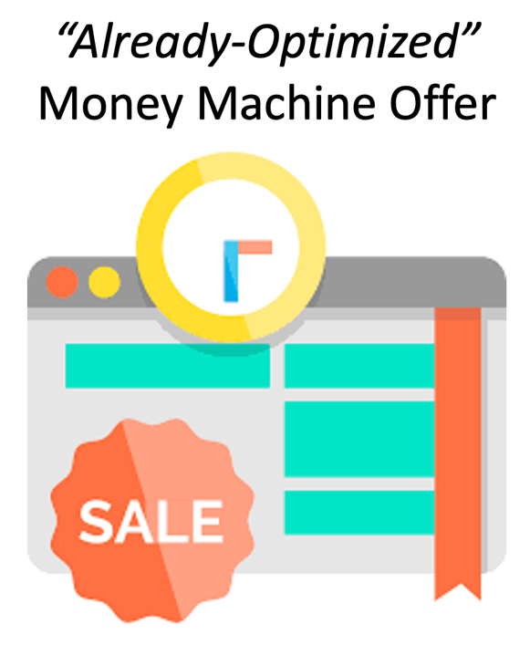
It’s important to choose the right money machine offers to promote, because they will do all the hard work of turning your traffic into HARD CASH in your pocket.

The best thing you can do is know someone who knows which offers are the most profitable right now.

Because if you promote bad offers, you just won’t make any money. But if you promote the right offers, you’ll make a small fortune…and possibly a large one.

Come to our LIVE coaching session and you’ll see exactly how you can quickly & easily find the best money making offers out there that will stuff your bank account with profits!

And that’s it! That’s how simple the 3-Step Profit Machine is!

Even the most tech challenged buffoon can crank out a Profit Machine in under an hour!

SECRET #3: An Ultra Simple Testing & Scaling Method That Anybody Can Do with No Prior Experience!

Alright, so you’ve got your Profit Machine set up, and you’re running traffic to it.

The next step is optimizing your campaigns and scaling up.

In the past, this was very difficult and technical. However, with advances in A.I. Machine Learning, Google makes this insanely easy.

There are basically 9 steps:

- Choose an “Already Optimized” Money Machine Offer to promote
- Generate a 1-page mini website using a proven copy-paste template
- Generate several semi-automated video variations to test (this process is mostly automated and can be repeated very quickly with no camera, no microphone and no downloadable software required)
- Run $20 traffic tests to see if your initial stats are good enough
- Turn off the campaigns that don’t meet the early minimum stats, and let Google automatically optimize the remaining campaigns to find the profitable campaigns
- Turn off non-profitable campaigns early to minimize costs
- Raise the budget on profitable campaigns
- If the campaigns remain profitable, continue turn up the budget more
- Continue to repeat steps 3-8 to generate more & more profitable campaigns and scale up your profits

That’s the entire process of optimizing and scaling.

There are a few important rules that we follow to make it extremely effective, which we’ll cover on the upcoming LIVE coaching sessions, so make sure to register for your spot now! Remember, seating is limited, be sure to show up 20 minutes early to make sure you get a spot!

Problems You Might Face If You Try to Figure This Out on Your Own

This is an amazingly simple and effective system, but the truth is it’s simple because Keegan has already figured out the simplest, most effective way to streamline profits.

If you were to try and figure this out on your own, here are a few problems you might run into:

- You might overcomplicate the traffic process. Google has a million options for ways to advertise on their massive network. Keegan has discovered the most effective settings, and we use them every time. If you were to try and figure out the settings yourself, chances are you would waste countless hours and money on ineffective ad campaigns.
- You would waste time & money on ineffective videos. Keegan’s techniques for creating videos are streamlined and simple to follow. And through months of testing, he has determined exactly what works best and what not to waste time on.
- You could overcomplicate the 1-page mini website or create ineffective versions. The templates we use have been tested like crazy to find out what works and what doesn’t. It would cost hundreds of thousands of dollars of advertising and trial and error to find out what Keegan has already discovered works the best with the least amount of effort.
- You might choose offers that don’t make you money. One of the big keys to success is promoting the offers that effectively turn your traffic into a mountain of cash. If you promote the wrong offers, you will struggle to make money. But if you promote the right offers, you’ll amazed at how much easier it is to generate consistent, scalable profits.
- You might overcomplicate the testing/scaling process. There are a few key indicators to know when your campaigns are ready to scale up. If you try to scale too soon, your profit will go in the toilet. However, if you know what to look for, you’ll be able to scale up and maintain profit as you increase your budget, so you continue to make more and more money each time.

These are just a few of the pitfalls you might run into if you tried to figure this out on your own.

Or You Could Take a BIG Shortcut

Gerry and I have over 30 years of combined business experience. Our students have generated over $64 million. We know what it takes to help complete newbies to succeed online.

Keegan and Chris have had tremendous success with this new method and bring an amazing amount of insight and real-world experience to help you succeed.

Chances are, it would take you months or years of trial and error to try and a lot of luck to be able to replicate this kind of success, and it would be so much more difficult on your own.

Sure, you could try to go at it alone, but wouldn’t you rather skip all the hassle and headaches and let us take you by the hand and gently guide you to experience your own success breakthrough?

This is your chance. The opportunity and timing will never be any better than it is right now.

We are holding out a helping hand to you…it’s right in front of you…all you have to do is take the first step and reach out and grab it!

If this sounds like the opportunity of a lifetime, then you’re going to absolutely love what we’re going to share with you.

I urge you to register right now for one of our upcoming LIVE coaching workshops to get more information on how you can start using A.I. Powered Funnels today:

http://GoProfit.AI/FreeTraining
.

Who Will Get the Most Out of Profit Singularity?

I believe almost anyone could have success with this system, however there are 2 types of people who I believe will really have the best chance to benefit the most from the Profit Singularity system:

Type #1 – The Investor: You have some money to spend (cash or credit) on a proven business model where you know your money will go to work making more money for you.

Type #2 – The Hustler: You may not have a ton of cash to start with, but you have enough hustle and heart to work your way through and make it work anyway.

Which one of these types are you?

Make 2022 Your Breakthrough Year!

We are already practically through 2022…yet regardless of where you’re at in your business, you still have time to make this your breakthrough year!

All you need to do right now is set aside time out of your schedule to attend one of our exclusive online LIVE coaching workshops.

On our live coaching workshops, you’ll get ALL your questions answered:

- We’ll walk you step by step through every detail of the process of creating 3-Step Money Machines
- You’ll find out the key details you need to make them succeed as quickly as possible
- You’ll see the amazing results of other students who started from scratch
- And you’ll see how quickly & easily you can get started building a lucrative income in no time!

Come join us on our next LIVE call…just register now to reserve your seat:

http://GoProfit.AI/FreeTraining

Thanks for reading, and here’s to changing your life for the better this year!

Rob Jones, Gerry Cramer, Keegan Mueller, and Chris Reader

