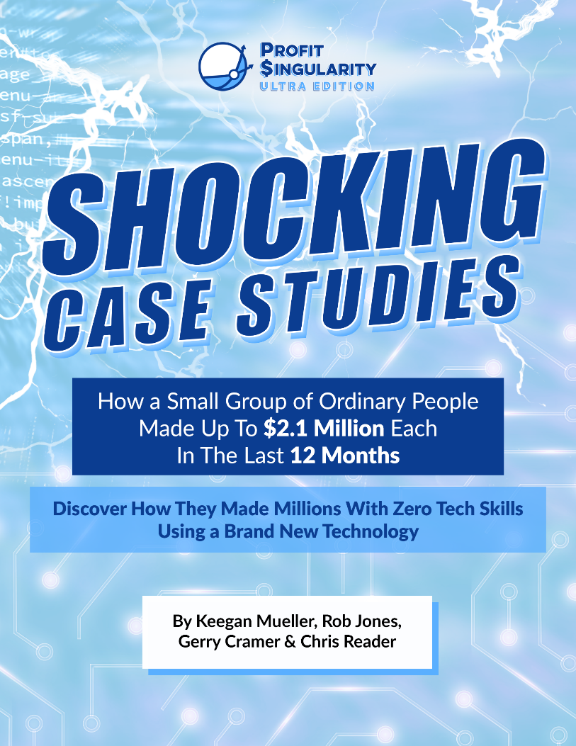

CASE STUDY #1

COLE DANIELSON

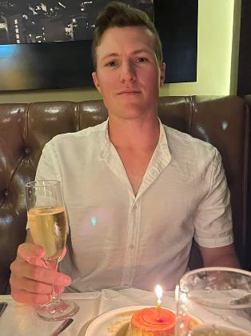
BACKGROUND

I’m Cole from Palm Springs, CA. I grew up playing sports and moved to the Midwest to play college baseball at a high level trying to pursue my dream of playing at the professional level. Unfortunately, due to an injury, that dream ended abruptly since I could no longer play the game.

Since I was a kid, being a professional athlete was all I ever dreamed about so when I got hurt, I was lost and didn’t know what to do from there. My entire life plan was over at 21.

I worked a bunch of odd jobs to pay bills, but nothing that I was interested in making a career out of. My worst job was selling internet services outside a local Walmart. It was commission only so some weeks were okay, while others left me with nothing after paying rent, gas, groceries, and my cell phone.

Standing outside all day, especially during the cold winters, trying to talk with strangers on their way to shopping felt like being a door to door salesman. I finally quit when I only made $45 for the entire week. That’s when I told myself I needed to figure out a new plan for the future.

Not knowing what to do next, I Googled “How To Make Money Online” which can take you down a rabbit hole of videos and courses which I tried a few, but they didn’t get me very far.

When I discovered this model, I knew it was completely different than anything I had previously seen.

The only thing holding me back was that I didn’t have much cash or credit at the time. I had about $2,000 for my ad spend, but thought I’ll figure it out along the way.

Eight months later, I’m living my dream life in Newport Beach, CA which is one of the best beach towns anywhere in the U.S. It was my goal to live here one day and thought it would take me until 40 to be able to afford it. I’m only 26. I still can’t believe it!

HIS RESULTS

I was optimistic that if I found that ONE WINNING VIDEO AD that it would take me to where I wanted to go. I never dreamed I would be at this level in less than a year running ads for the first time in my life.

With 1 Ad, 1 Video, and 1 Offer I’ve made over $2m in Commissions in 1 Month and $1.5m in Profit! And it all came from that $2,000 I had when I started reinvesting my weekly profits.

My one video has 28 million views to date and keeps growing!

This model makes money every week of the month, but I only have to spend one week’s worth of ad spend over and over to generate four weeks of Profits!
I was able to secure an AMEX credit card after a few months running ads which really helped. After one month, they lifted my $5k credit limit to no limit and I turned them into my free bank to help me scale quickly.

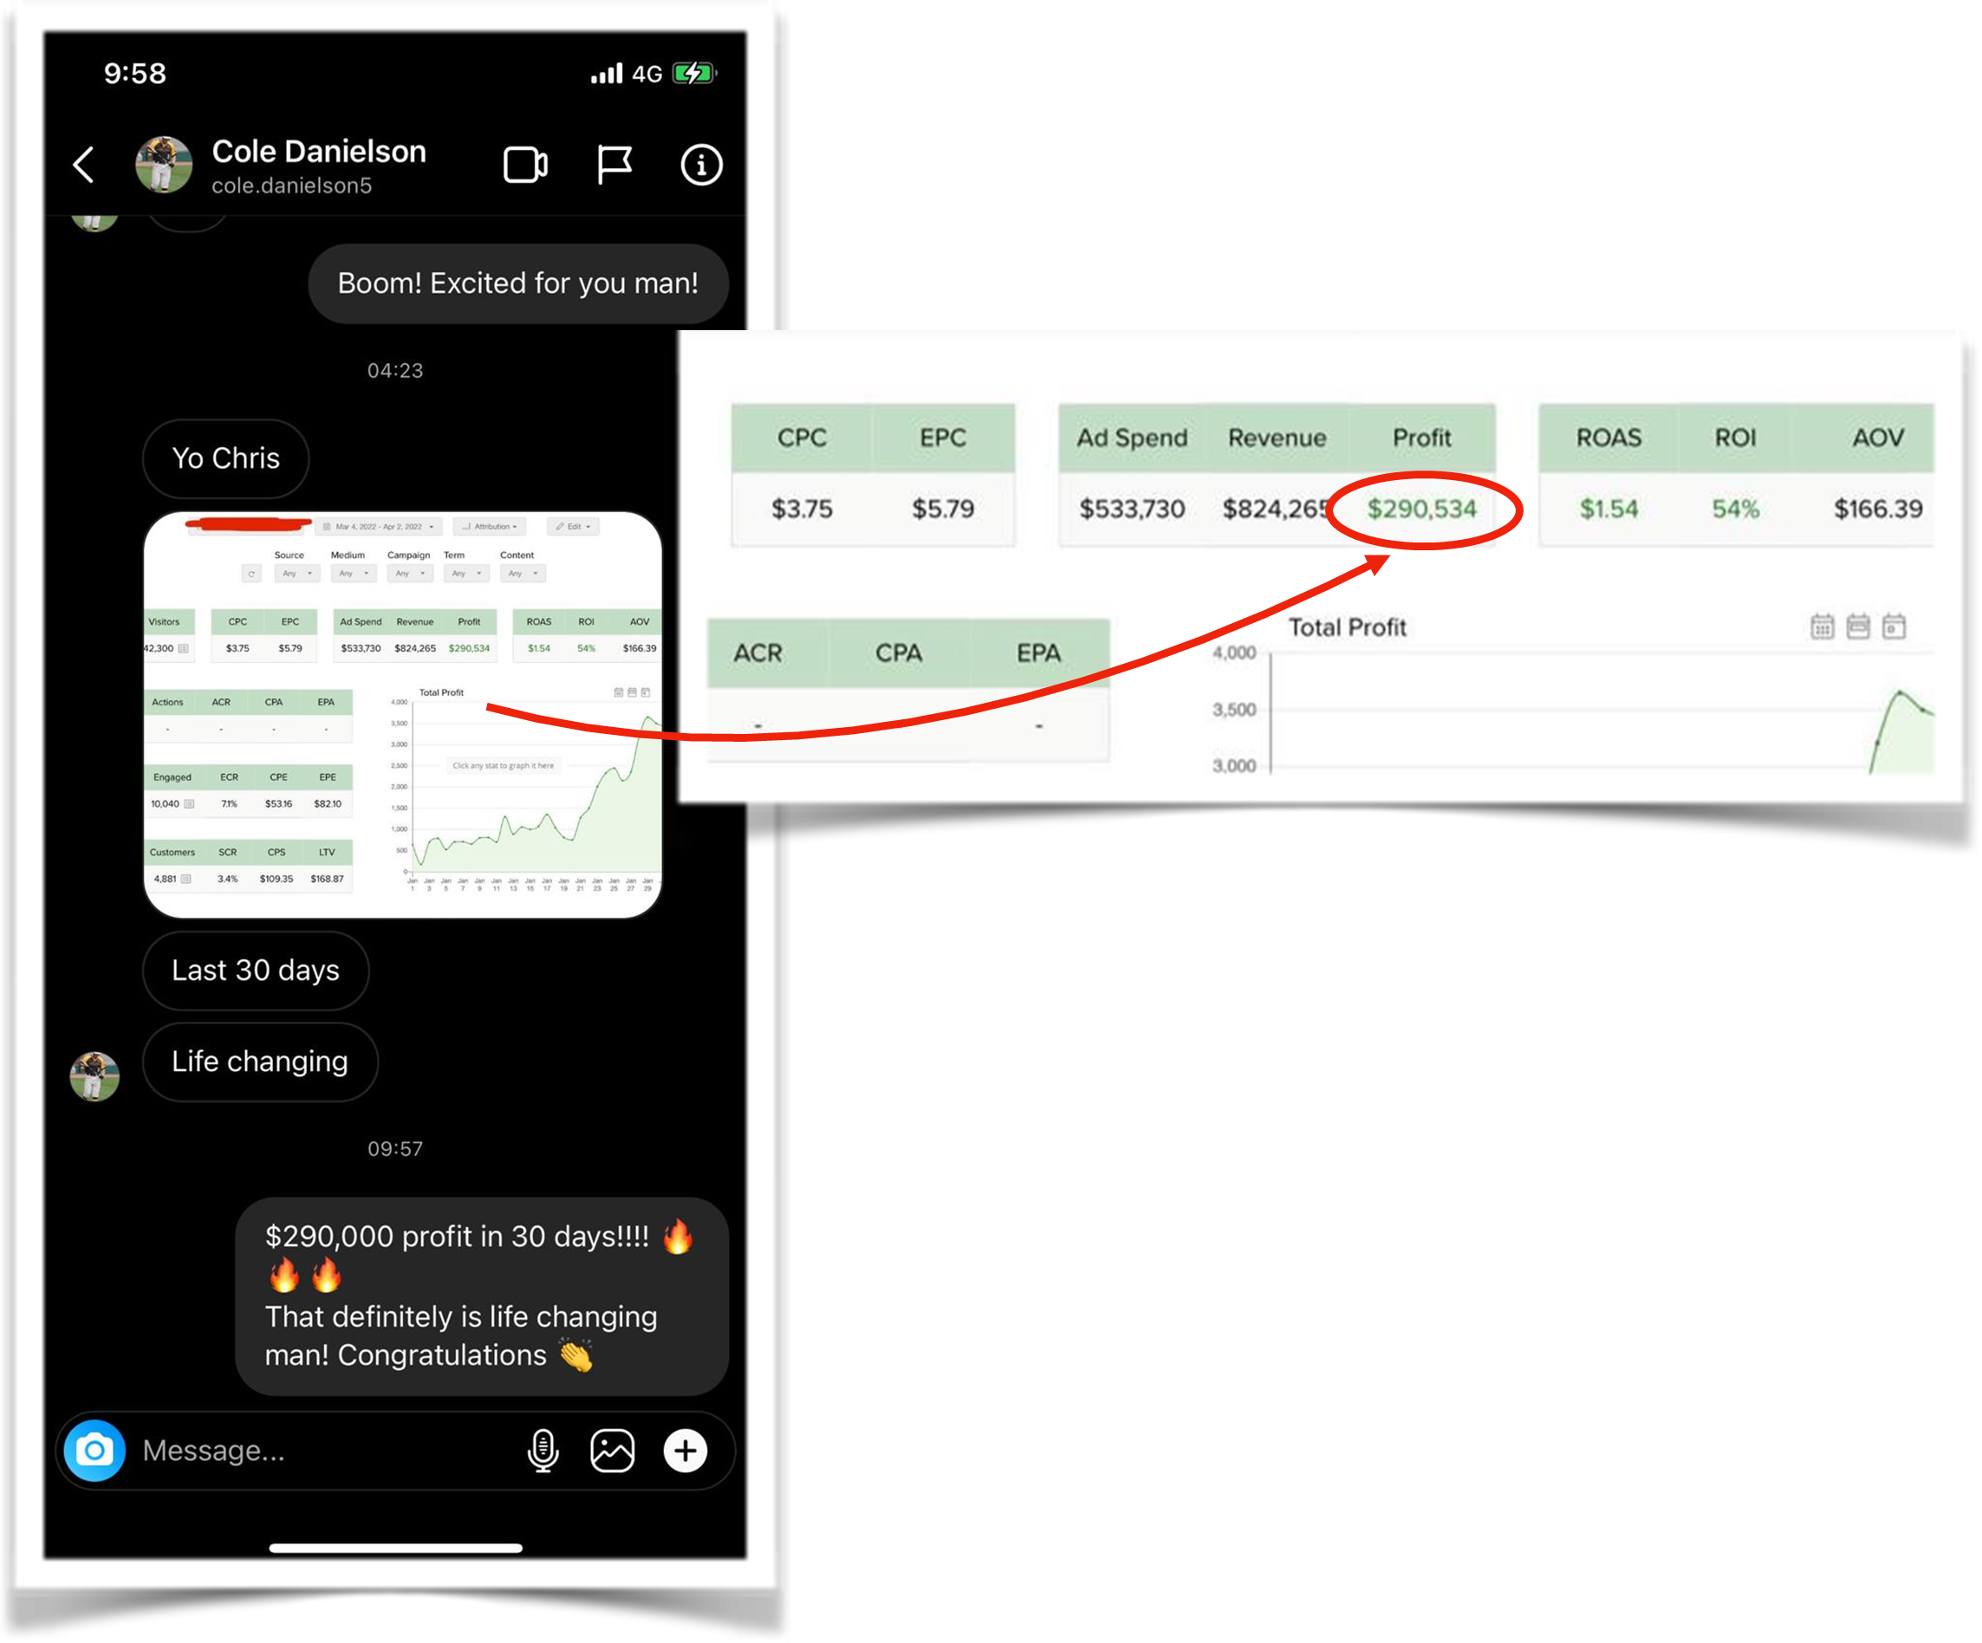
When they see multiple Google charges, they know it’s for ad spend and really worked with me to keep upping my credit seeing my commissions coming in daily. I highly recommend a business credit card to help with scaling needs.

$824,265 Revenue for $290,534 Profit from March 4 until April 2
`

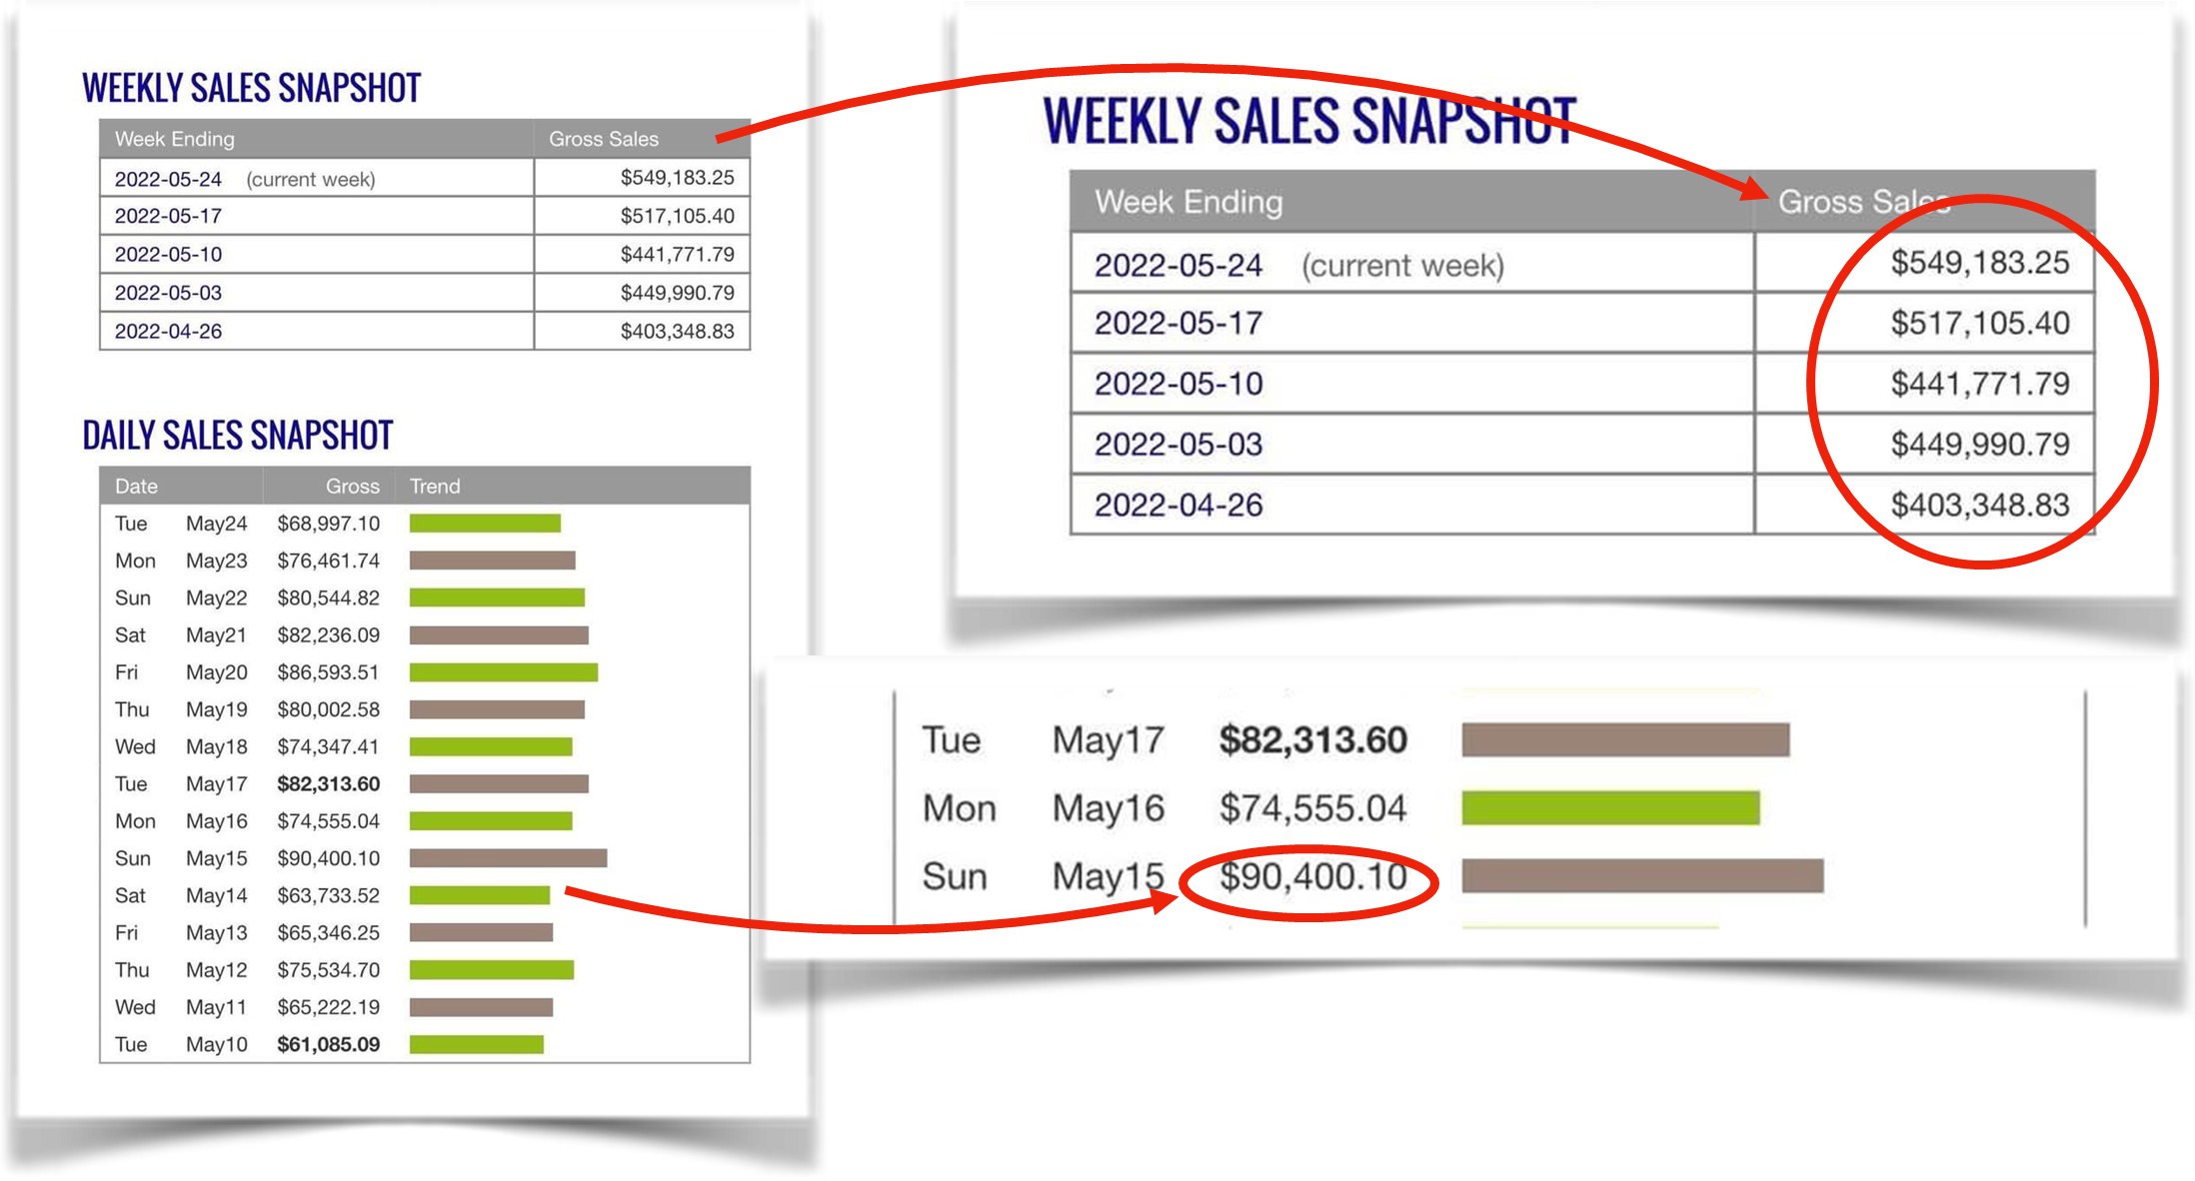
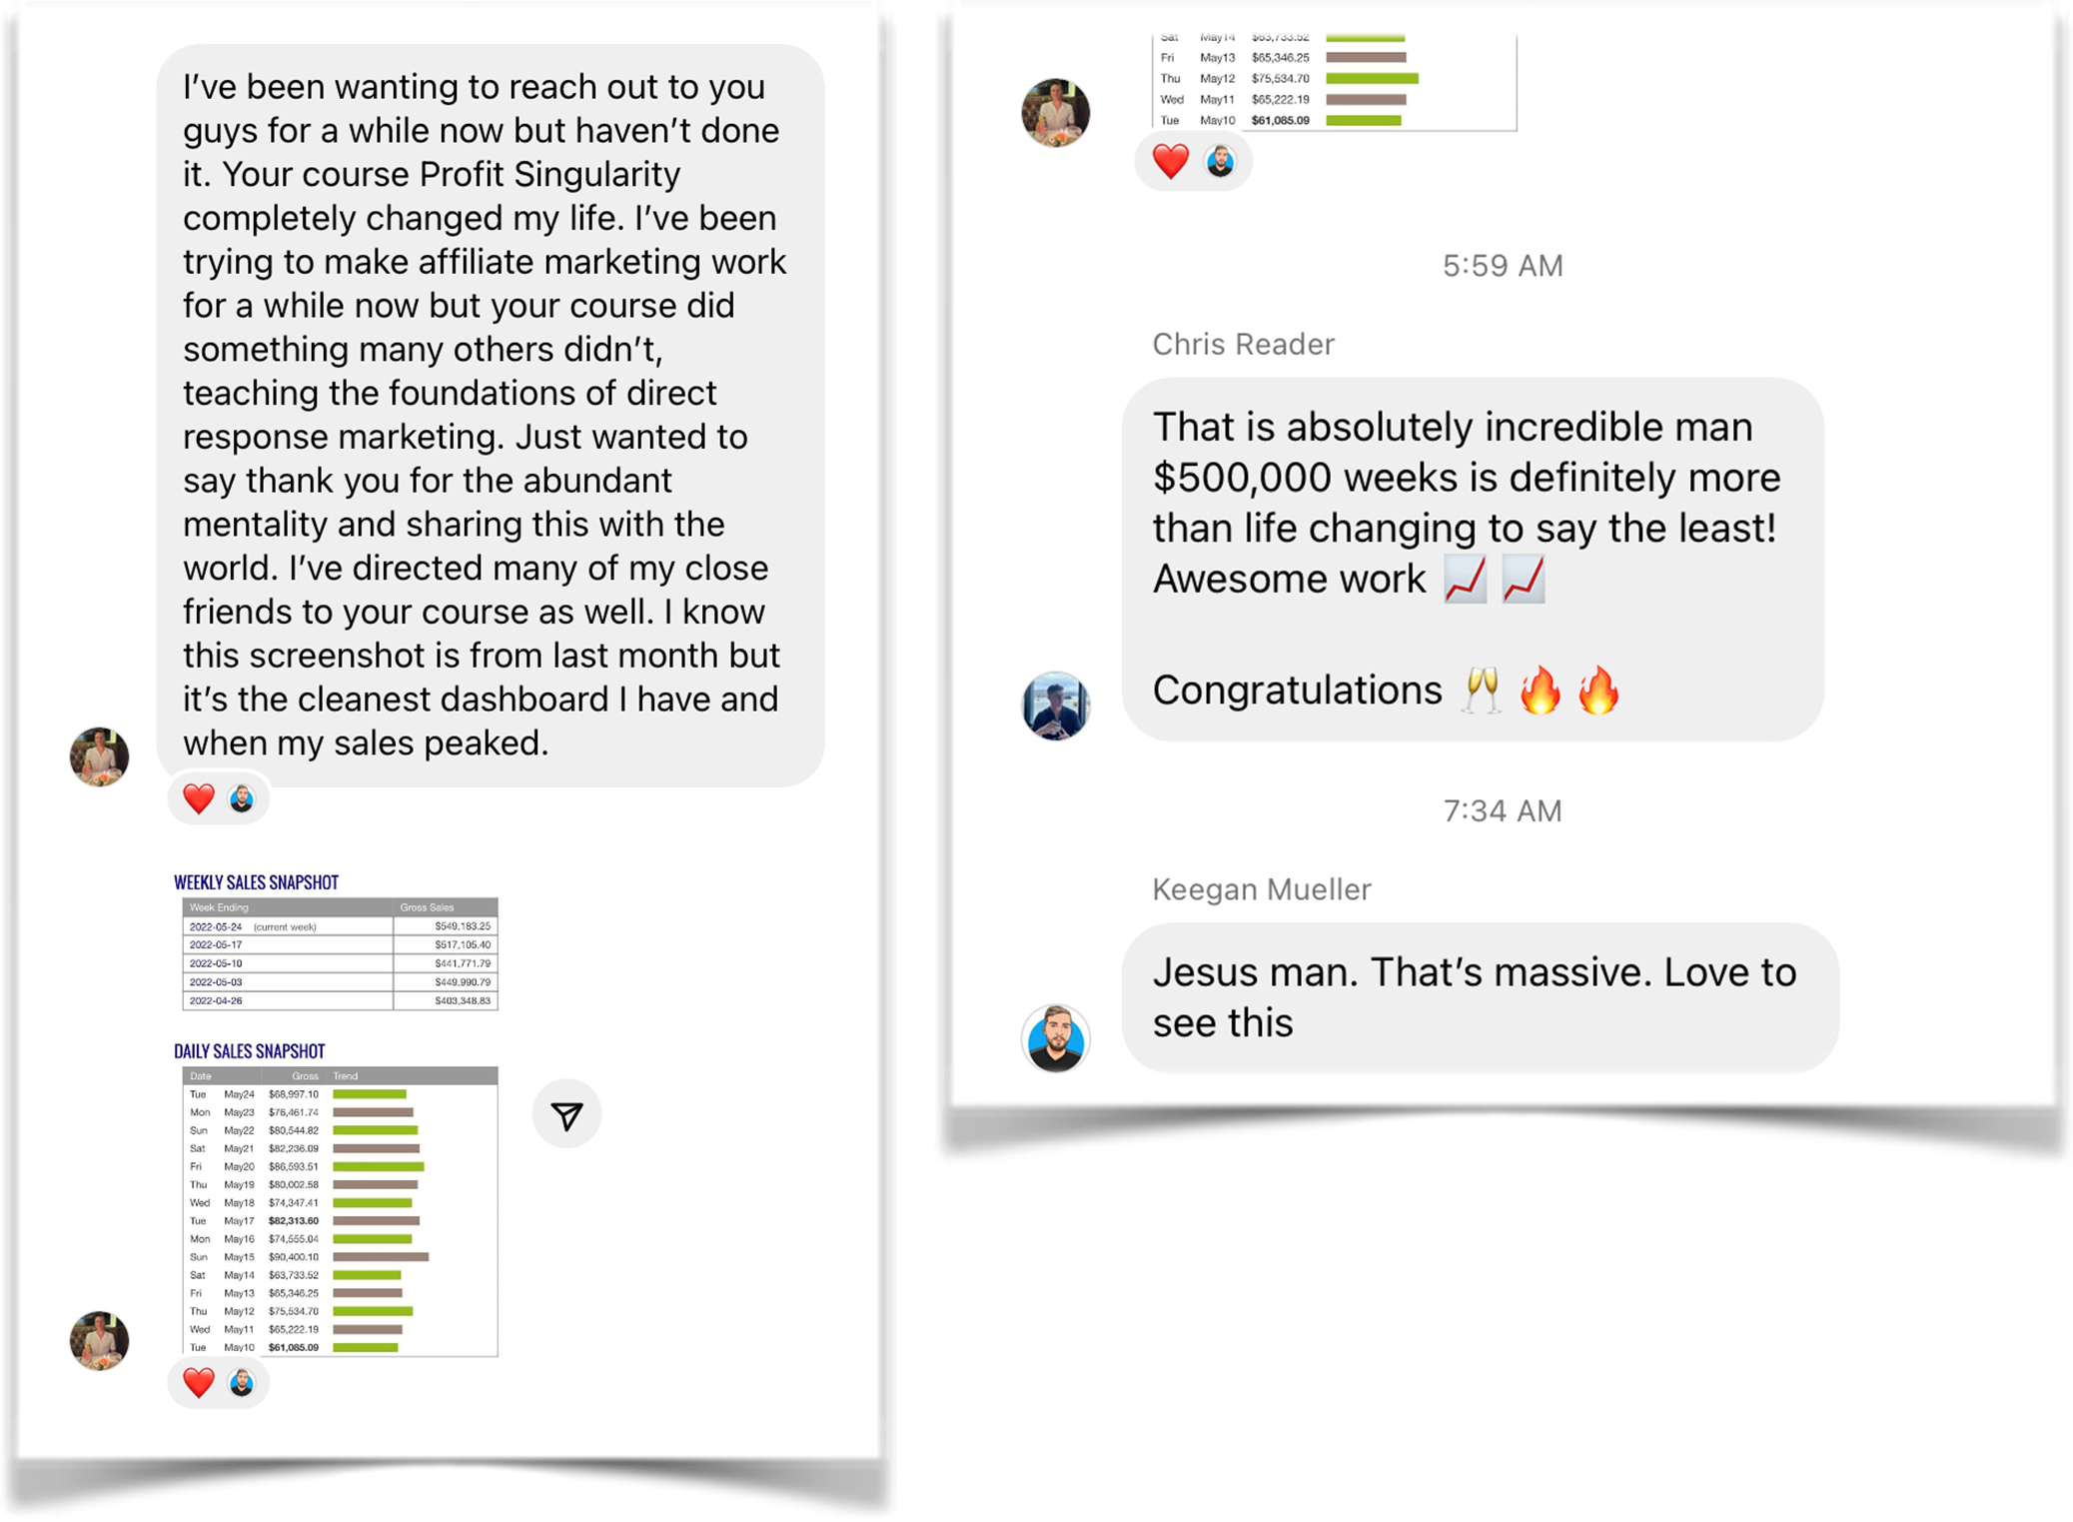
$90,400 Best Single Day on May 15 and started hitting my $500k + Weeks!
COLE'S BEST DAY - $90,400
COLE’S BEST WEEK - $549,183
COLE'S BEST MONTH - $1,958,050

It felt great getting some Love from the Course Creators

MY BEST ADVICE

“DO WHAT IS TAUGHT IN THE COURSE AND NOTHING ELSE!”

I came in with the mindset “This IS going to work” and then went ALL IN.

I kept it simple and did EXACTLY what I was taught. I got sales on my first day running an ad. And I haven’t lost money since my first campaign! I may break even or have low profit on a new campaign sometimes, but that doesn’t matter to me because I know once I find a winning campaign, it’s so much easier to scale.

Resist the temptation to keep touching your campaigns. Being a hard worker, that’s the most difficult part...to sit there and let machine learning do its thing. Patience is not my strongest skill set.

But I can tell you that after spending over $4.5m in just the last 8 months...it’s the absolute BEST way to run your campaigns.

If you want this badly enough, then don’t let anything get in your way. Sure, it’s a learning curve and not everything is going to go your way in the beginning.

But I promise if you put your faith in this method and keep moving forward, it’s only a matter of time before you start seeing results.

When you’re learning from 4 SUPER AFFILIATES and follow their training exactly, I don’t know how you DON’T win if you keep going!

IMPORTANT
To learn more about this all new system our students are using right now to earn $1000's in daily profits, join one of our free live training workshops (details are at the link below):

https://goprofit.AI/FreeTraining

During the workshop you will learn about the entire business model and discover how you can deploy it into your own business immediately. We will also be taking your live questions on the call.

CASE STUDY #2

JENN L.

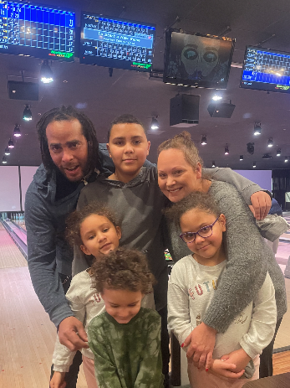
BACKGROUND

I’m Jenn and I live with my husband and four beautiful kids in Connecticut.

I’ve been working in the restaurant and food industry since I was in college. I always enjoyed meeting people and it felt great getting paid out daily rather than my friends in the corporate world who got paid their salaries once or twice a month.

I was managing a restaurant working crazy hours until the Pandemic hit, closing us down like everywhere else in the world. Our industry was one of the worst hit and nothing was open for almost two years.

I was able to live on state unemployment and also the US Government had an emergency program that helped out for awhile. When it was close to running out, I knew I needed to continue bringing in an income.

After being off for so long, the thought of having to go back to standing on my feet all day and not being at home with my kids was not something I wanted to do anymore.

The problem was that I’ve always been the breadwinner of my household. The pressure of making money for the family always fueled me to find the right opportunity that had the potential of scalability.

After the fear and panic of being unemployed for so long wore off, I realized that it was actually a blessing and opportunity to have my time back to focus on making money with my computer so I could be around more at home.

HER RESULTS

I couldn’t believe how FAST my results were happening right after I finished the set up period. I was able to go through the lessons and started getting traction pretty quickly. I got my first $1,000 day and $2,000 day on the SAME day!

Within five days after that, I achieved my first $5,000 and $10,000 day.

And within two months from starting, I was able to generate $250,000 and even won some awards for top performance in a few contests. My family was ecstatic. And it couldn’t have come at a better time after living on unemployment.

My profits allowed us to have a very Merry Christmas and we just got back from a long road trip. It’s the first time I can remember where we didn’t even think about the costs like gas, hotels, or the kids activities we went on every day. We could relax and have fun together.

My husband was able to quit his job to help with the kids so I can give more time to our new, thriving online business. I now like to say that I’m home by choice and “Successfully Unemployed”.

Like working in the food service industry, I’m still getting paid daily which feels amazing… except now there’s several zeros added to the payout.

What’s even more amazing is that’s only the beginning of my story. Today, I’m doing 300-500% more than I was just four months ago! And it’s still that one WINNING VIDEO.

First $17,112 Best Day in January
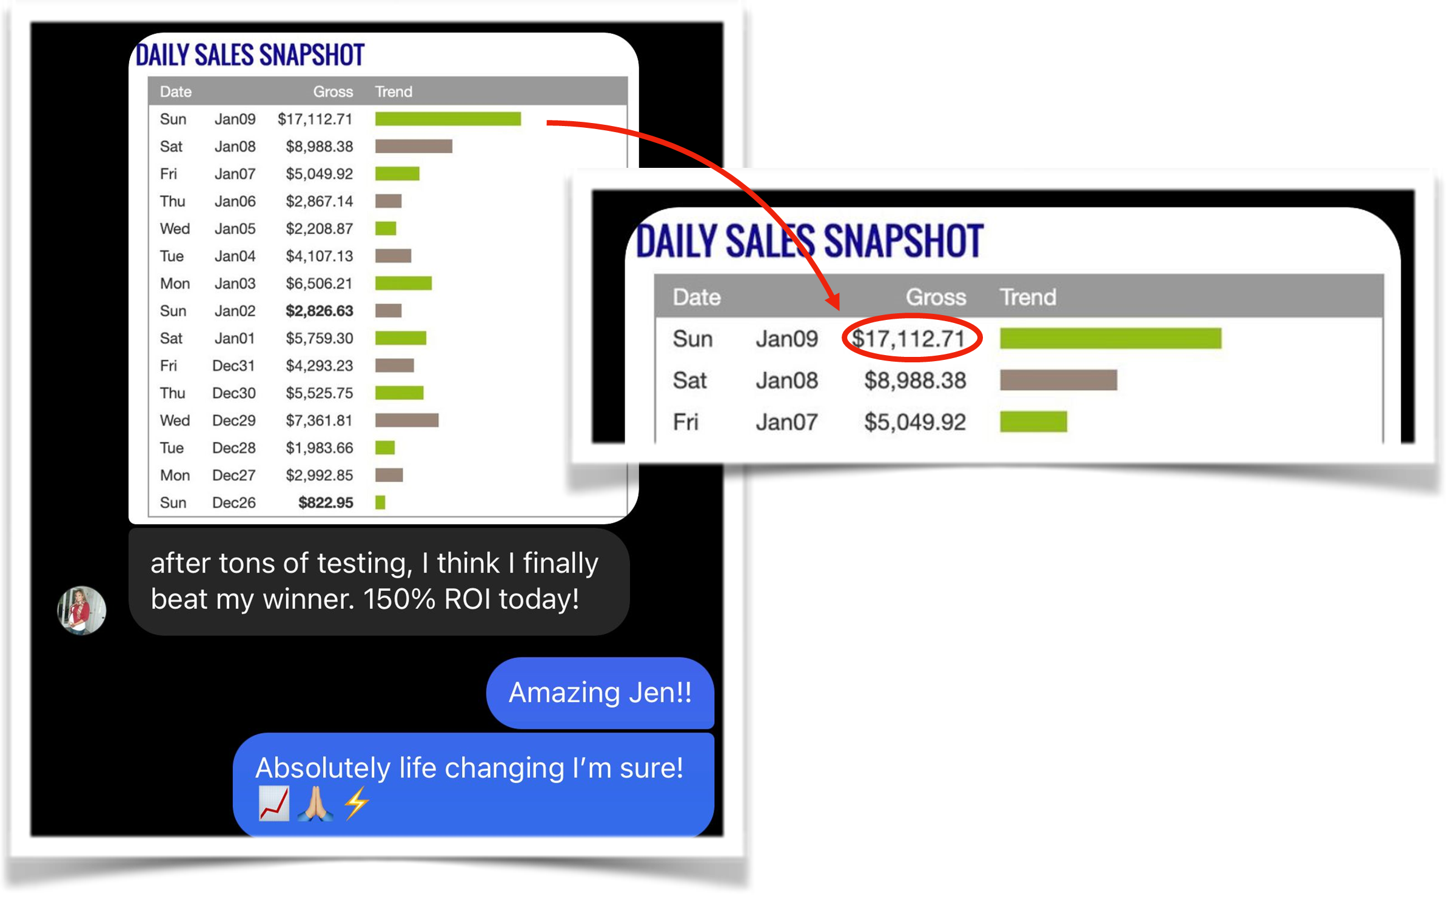

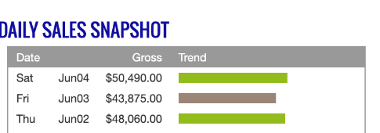
Did it again in early June with a New Campaign quickly going from $43,875 t0 $60,210 in just a few back-to-back days

JENN'S BEST DAY - $68,273
JENN’S BEST WEEK - $308,541
JENN'S BEST MONTH - $808,773

A few weeks later achieved these stats below
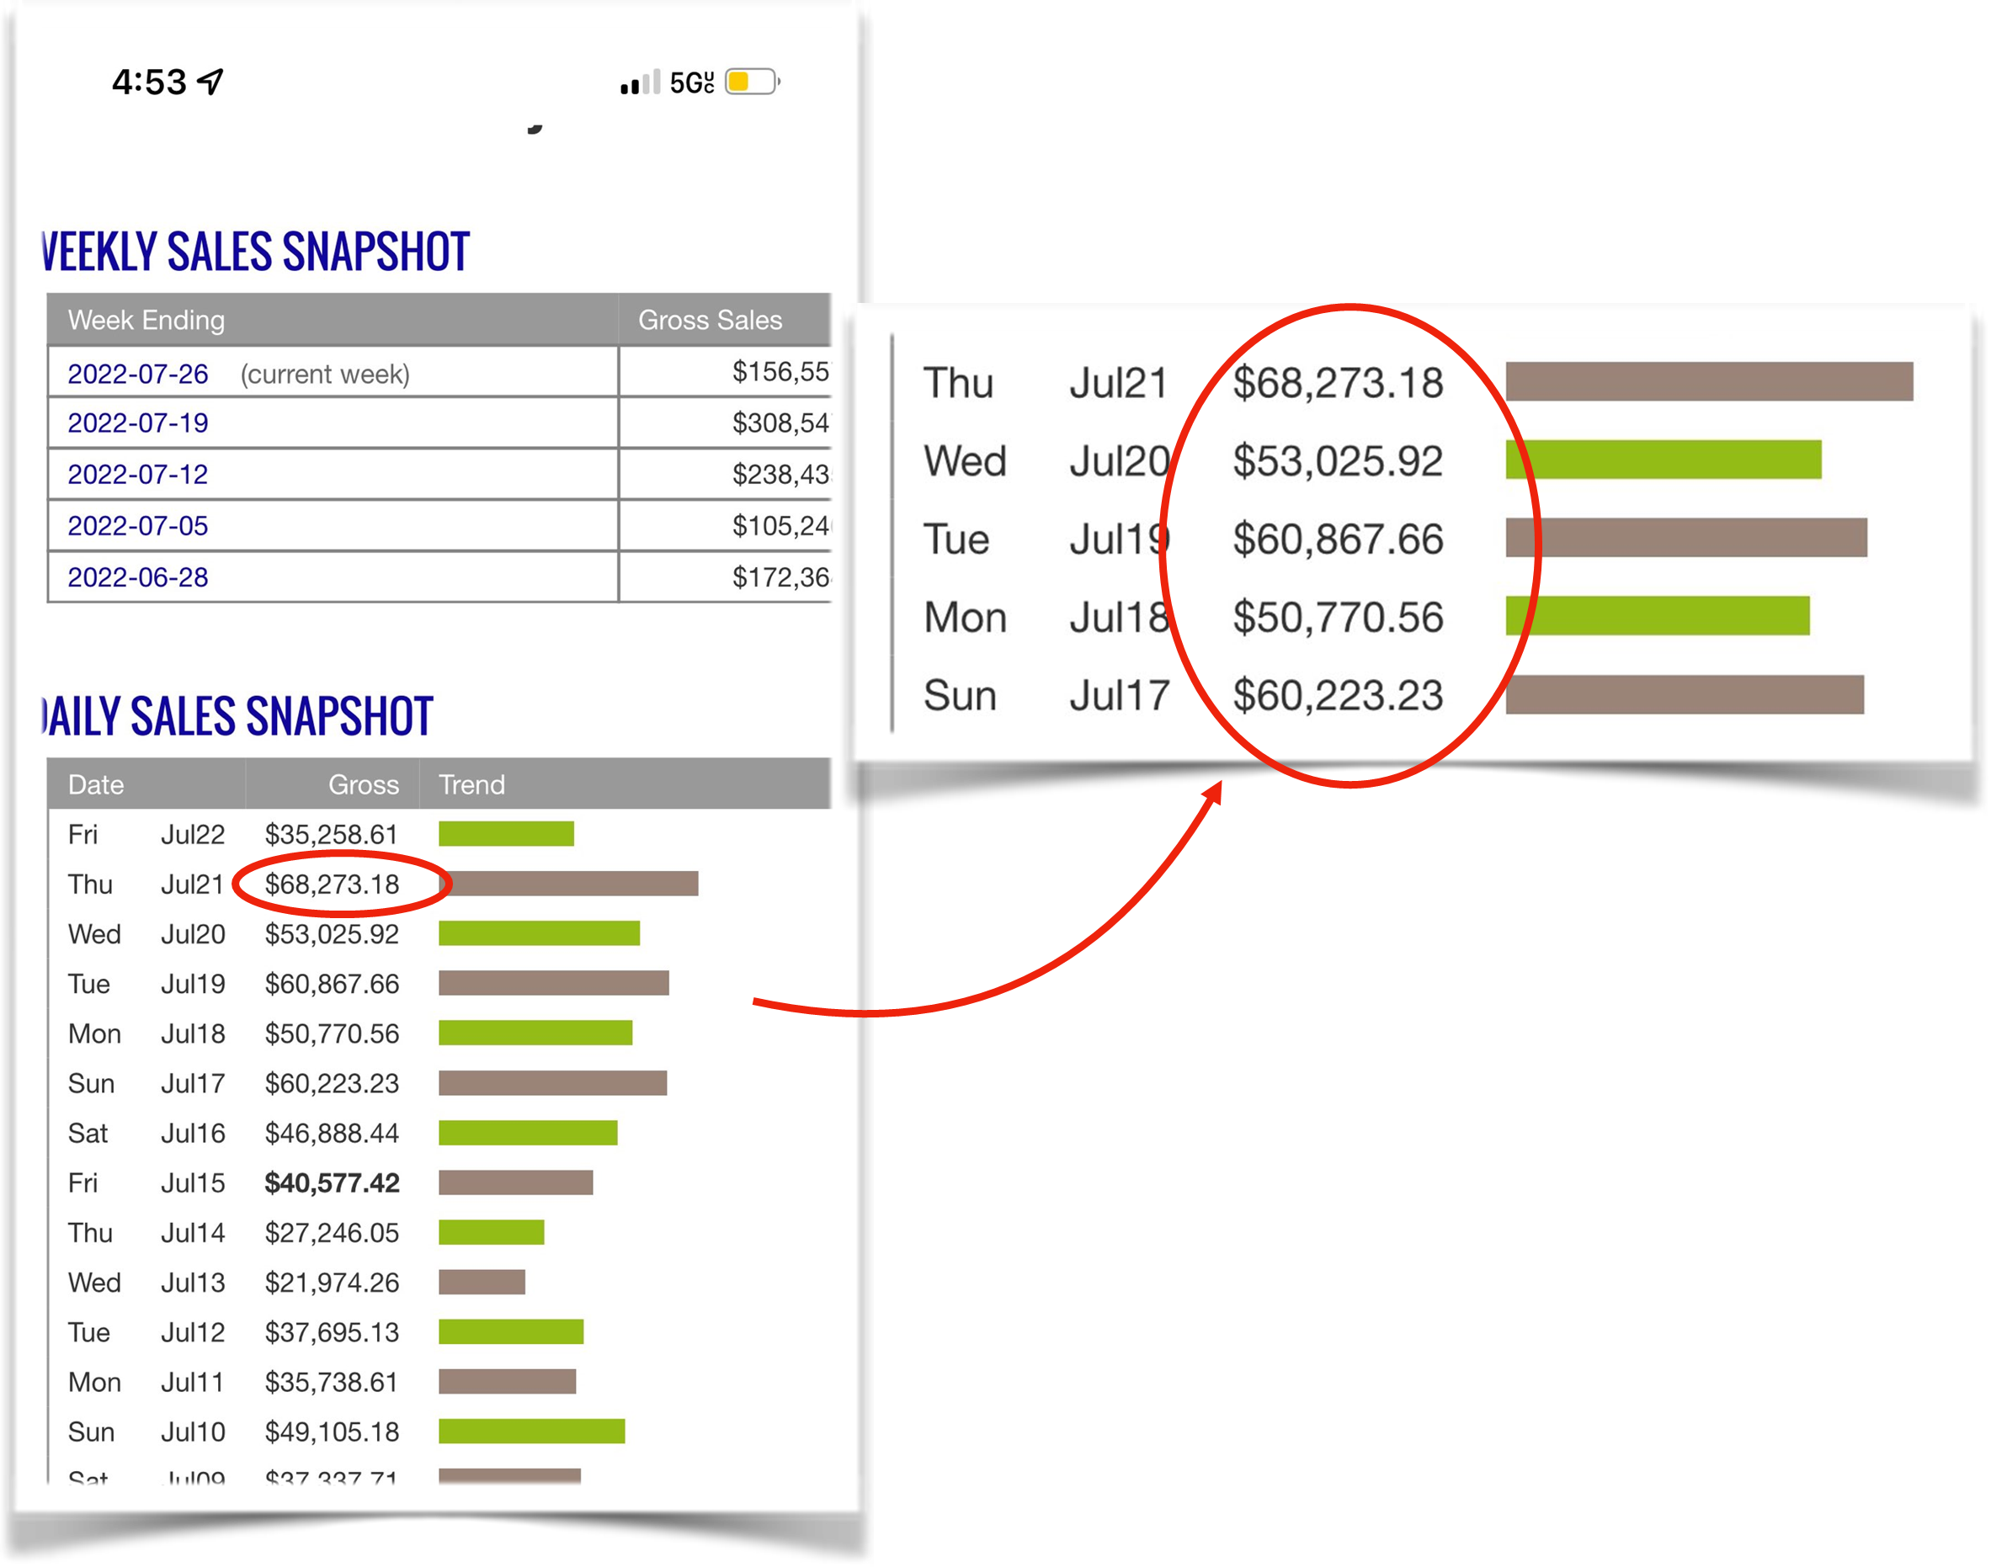

MY BEST ADVICE

Before you even begin, my best advice is to check your thoughts and mindset because they’re so powerful. You can learn all the tools and strategies needed to thrive, but you must master your mind and your emotions.

You MUST believe it’s not a matter of IF, but WHEN you will succeed.

Even though I was given all of the examples needed to make something good, I found that originality goes a long way when I put my own spin on things. I loved the templates and they were a good guide, but my numbers really took off when I spent a little extra time asking myself, “What’s another creative way to say this so it doesn’t look like everyone else?”

If the stats aren’t there, then let it go and move on. In the beginning, I kept trying to make things work when the feedback was clear and the audience wasn’t responding.

Keegan reminded me that losers don’t turn into winners and go back to try something else. Don’t get too attached to anything and be more flexible. That was the best piece of advice.

Going from living off of unemployment checks to spending $30,000 a day on ads sounds crazy, but it’s also mind boggling how quickly you can get used to it. I never had fear spending that kind of money because there’s no doubt in my mind it’s coming back once you find that winning ad.

Unlike so many other things out there, this is the furthest thing from gambling because I’m always in control of my skills and investment.

Last piece of advice…Get Going!

IMPORTANT
To learn more about this all new system our students are using right now to earn $1000's in daily profits, join one of our free live training workshops (details are at the link below):

https://goprofit.AI/FreeTraining

During the workshop you will learn about the entire business model and discover how you can deploy it into your own business immediately. We will also be taking your live questions on the call.

CASE STUDY #3

BRYAN LEASURE

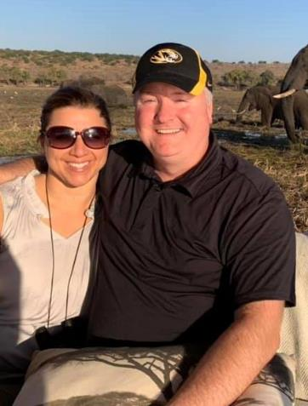
BACKGROUND

Hi, I’m Bryan from Missouri. I’m married with 4 kids.

I’m an IT guy because I love all the techy stuff. The company I work for helps businesses manage their servers and resolve issues.

I’m one of the lucky ones who actually likes his job and am close friends with the owner. The real problem is that making his clients happy is a lot more than 9-5 leaving me limited hours with my family except on the weekends. It’s a lucrative industry making my boss a lot of money.

However, I’m stuck in a salaried position that only goes up a few percentage points each year so basically I’m capped out after doing this for 30 years.

My wife has been encouraging me to start my own business where my efforts can bring in limitless potential. Finding time is always a challenge with long hours and kids so finding something I could do online at night and on the weekends was the only thing I believed would work with my schedule and responsibilities.

I originally studied IT in college because I knew it was the only way out of the extreme poverty I was raised in. Our parents loved us, but it was always a struggle for them. Growing up, survival was very difficult.

I played sports when I was young. Coaches would have to pay for me to go anywhere with the team. The thing that got me the most was when I heard people say all the time: “Poor Bryan…” That really bothered me.

The hardest time was college because I had to survive on $5 to feed myself an entire week. It was many years ago, but $5 didn’t go that far back then either. You can imagine the types of food I was relegated to eat.

I’m one of those serial course takers that’s been trying for many years to create an online income. I finish everything I start and it was getting to a point where I had a sinking feeling the course I just bought wasn’t going to work as advertised before I even started.

I can honestly say that this is the FIRST TIME I was truly surprised how well it was taught and most importantly that it WORKS because it’s still early for this platform. Finally, I was one of the people at the front of the line instead of the back!

HIS RESULTS

As soon as I watched the training videos, I could clearly see all the potential and possibilities.

I’m not the kind of person who needs hand holding, but just some general direction and Best Practices and I’ll do the rest.

I felt confident with all of the technical setup steps since I’ve been doing it professionally for decades. I’m comfortable knowing how to follow directions.

It was the opposite problem for me that I wasn’t the most creative person around. I can write a script, no problem. But I was nervous about how to make it great quality with all the elements I see other videos getting a lot of views from.

But when I saw the brilliant script template format, it was like a light bulb went off and I could see exactly what to do and when.

I’m just blown away at how smart the A.I. is at dialing in my campaigns. It does most of the hunting for you FASTER than all the things I learned how to isolate and individually test. It finds more and more buyers as fast as you throw money at the A.I. Now, I achieve in days what would have taken me months to slowly scale using other platforms.

Within a few months, I had my first $1k/day, $3k/day, and then a $5,800/day.

I’ve been averaging $2k-$5k days for the past five months and it’s turned into something steady I can count on…and best of all, it all comes from the One Winning Ad video I easily created in about 30 minutes.

I’m finally close to having that business I’m in full control of that my wife always knew I could. By the end of this year, I will need to have an uncomfortable conversation with my boss and friend that it’s time for me to resign.

These days, it really feels like I’m the luckiest guy in the world!

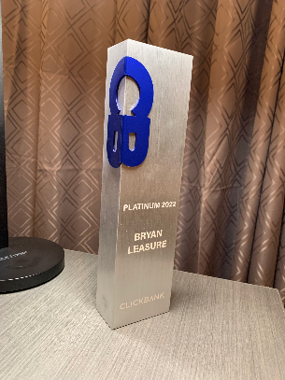
Here’s my Clickbank Platinum Award for reaching $250,000

From December 8 until February 19, I generated $726,485 with one campaign

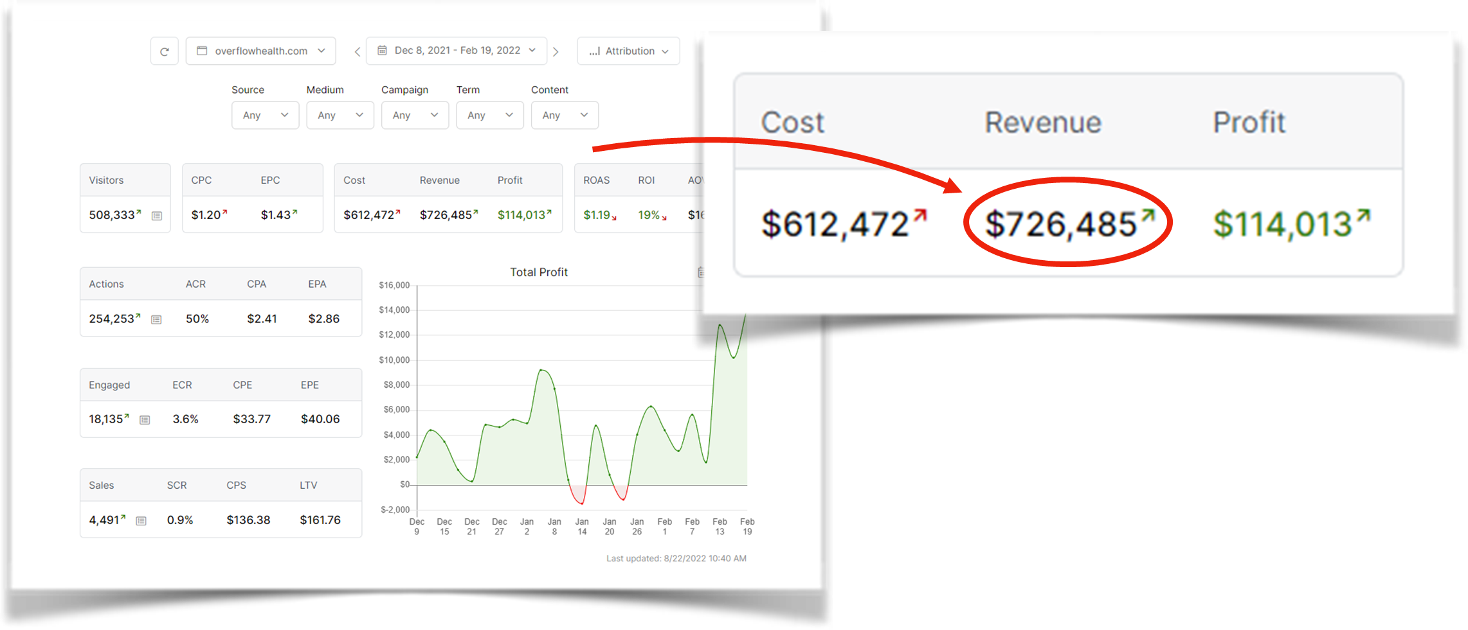

In 2022, I’ve generated over $1.4m!
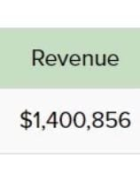

BRYAN'S BEST DAY - $12,247

BRYAN'S BACK TO BACK WEEKS - $133,403 & $134,282

BRYAN’S 2022 TOTAL REVENUE - $1,400,856

back to back $133k & $134k weeks.

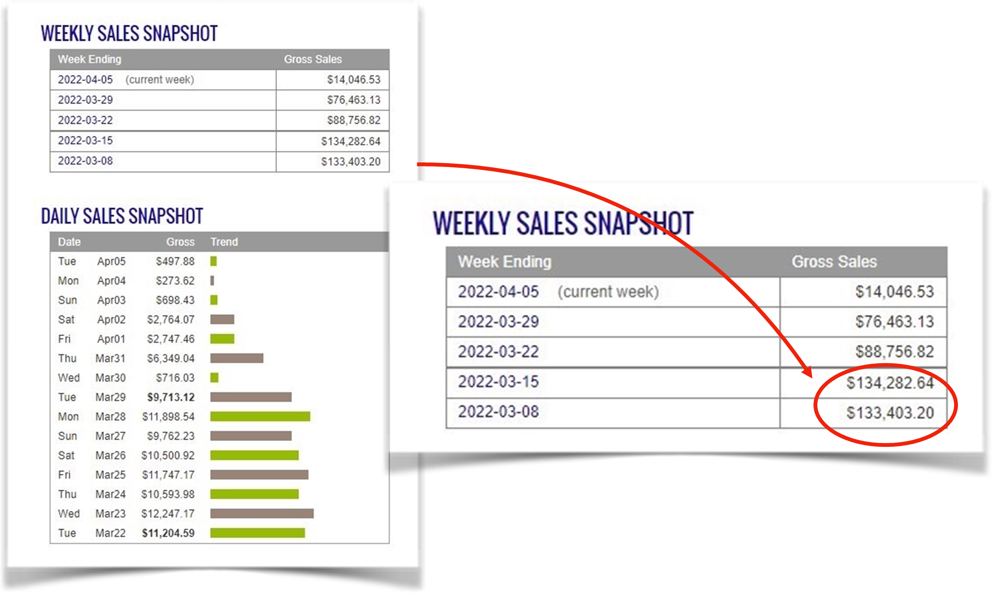

MY BEST ADVICE

Here’s my best advice for anyone thinking of following in my footsteps and adopting this business model. Believe me, I did it in the long run, but you don’t have to…

- Don’t be scared, pull the trigger!
- Focus on the metrics to make next decision
- Don’t let a losing campaign stop you from trying again with adjustments. If you fall off the horse, get back on.

DON’T GIVE UP: I’ve seen too many people give up, especially too soon. I promised myself I wouldn’t be like that and would keep going until I figured it out so, don’t give up!

MINDSET: You need to have an Abundance Mindset versus a “Couponer’s Mindset” always trying to save money. You need to flip it to “I don’t care what it costs because I concentrate on making more money”. Now, my family is in awe of my ability to spend money comfortably.

I’m not looking for coupons or discounts like I used to. I don’t look at life that way anymore and trained myself hard to view situations as abundance rather than scarcity. I’m so much calmer these days and finally overcame all that pain from my childhood. I didn’t expect an emotional breakthrough when I got my financial one.

IMPORTANT
To learn more about this all new system our students are using right now to earn $1000's in daily profits, join one of our free live training workshops (details are at the link below):

https://goprofit.AI/FreeTraining

During the workshop you will learn about the entire business model and discover how you can deploy it into your own business immediately. We will also be taking your live questions on the call.

CASE STUDY #4

EVA WERTHMANN

BACKGROUND

My name is Eva and I’m from Germany.

I work for a marketing agency with clients in real estate and physical therapy. I do all of their social media and lead generation. I was familiar with being online, but had never run an ad before.

Due to the pandemic, my boss had to cut the staff when our clients greatly scaled back on their budgets.

I was fortunate to keep my job, but that meant I had to do the work of 3 people so my 9-5 became an 8-8!

When I was learning this new system, my biggest challenge was TIME. I had so little spare time that I had to be smarter and more efficient setting everything up.

And watching so many of my co-workers being laid off not only did I not have a lot of money to invest, but I was scared to spend the money I did have on ads. When I first started publishing my own ads, I had this fearful voice in the back of my head wondering if I was going to lose my job at some point, too.

What made it easier for me to let go of that fear was the fact that I didn’t like my job so trying to get out of that pain motivated me to make time to go through the course. I had a vision board in my room of the Freedom I was seeking and the ability to travel the world with my boyfriend once it happened.

Once I knew why I was pursuing this path, I worked mostly late at night and on my weekends. I was completely focused and dedicated during my study time. I wanted it so badly that most nights I fell asleep listening to the trainings thinking it would sink into my subconscious.

The thing that kept me going was watching so many others succeed doing the same thing I was doing. It gave me the inspiration and confidence that if they could do it, then why not me?

HER RESULTS

I never felt like I was on my own because there’s steps laid out in a precise order and all the materials I was provided were easy to follow. I found the group to be really supportive, abundance minded, people cheering you on along the way. My win was theirs, and theirs mine.

Best of all, I find it so much easier to test an ad to quickly find a winner. Plus, the algorithm is so smart and is extremely quick to take your videos out to the marketplace and show you what’s working best. Keegan taught me the data that’s most important to measure to know I’m on the right track.

There’s really not that much tech setup required and creating the video ads actually was fun.

Google and YouTube are stable platforms and very friendly to newbie marketers.

You can do it without putting your face on camera. I’m a really private person and the thought of putting myself out into the universe was not appealing at all so this strategy is great for me.

This model is a simple testing process to find a winner and then it’s so easy to scale when you do find a winner!

I worked hard and was holding between $1k-$2k days, but once you really nail that one Winning Ad it can really take off!

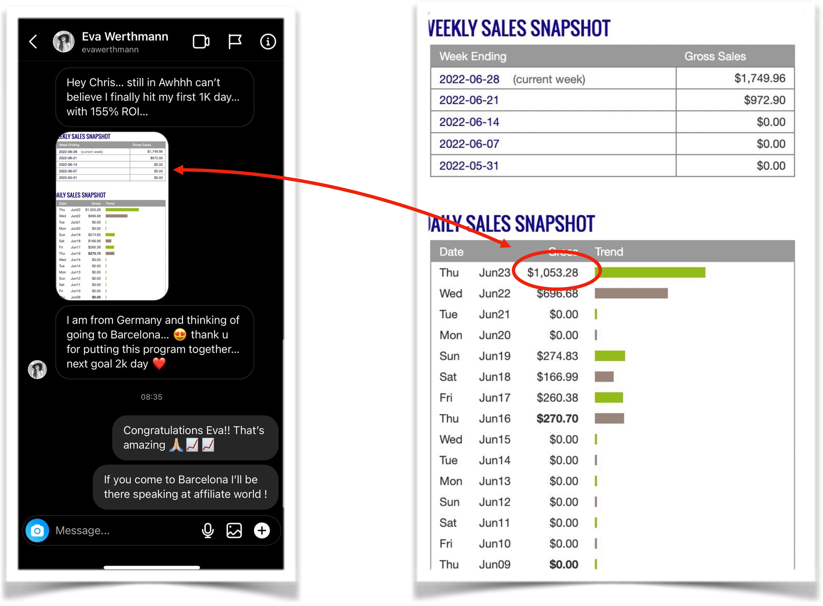
$1k Best Day on June 23

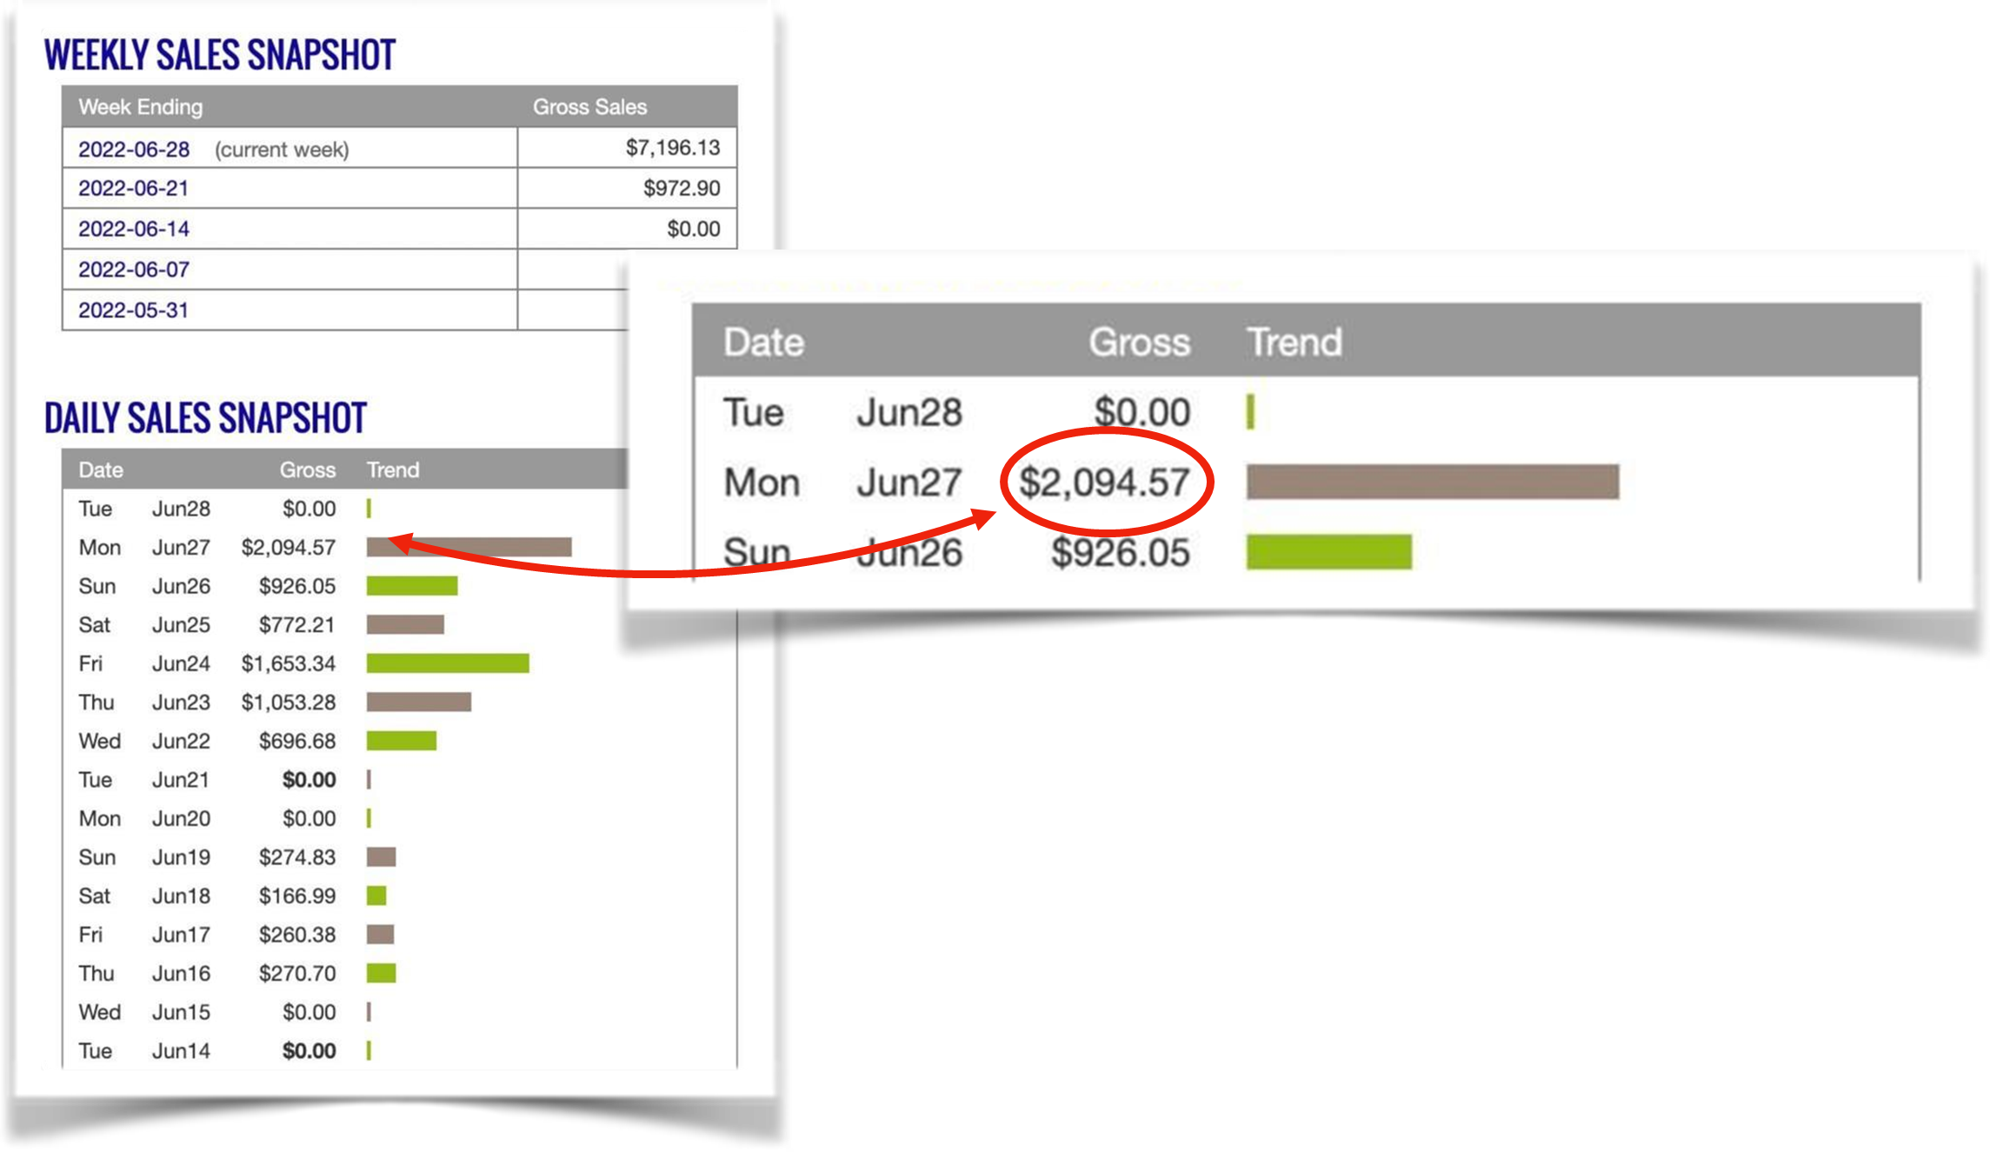
$2k Best Day on June 27

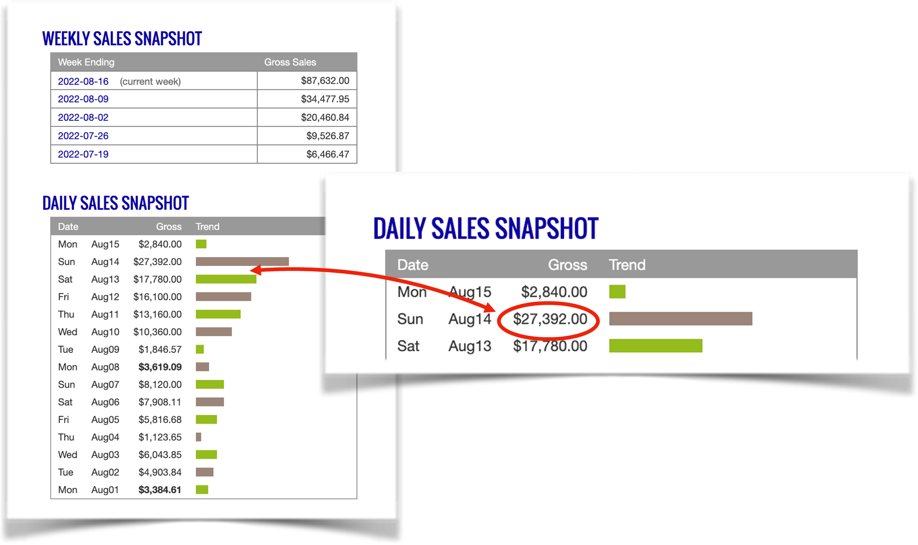
$27k Best Day on August 14

$36k Best Day & $175k Week on August 22

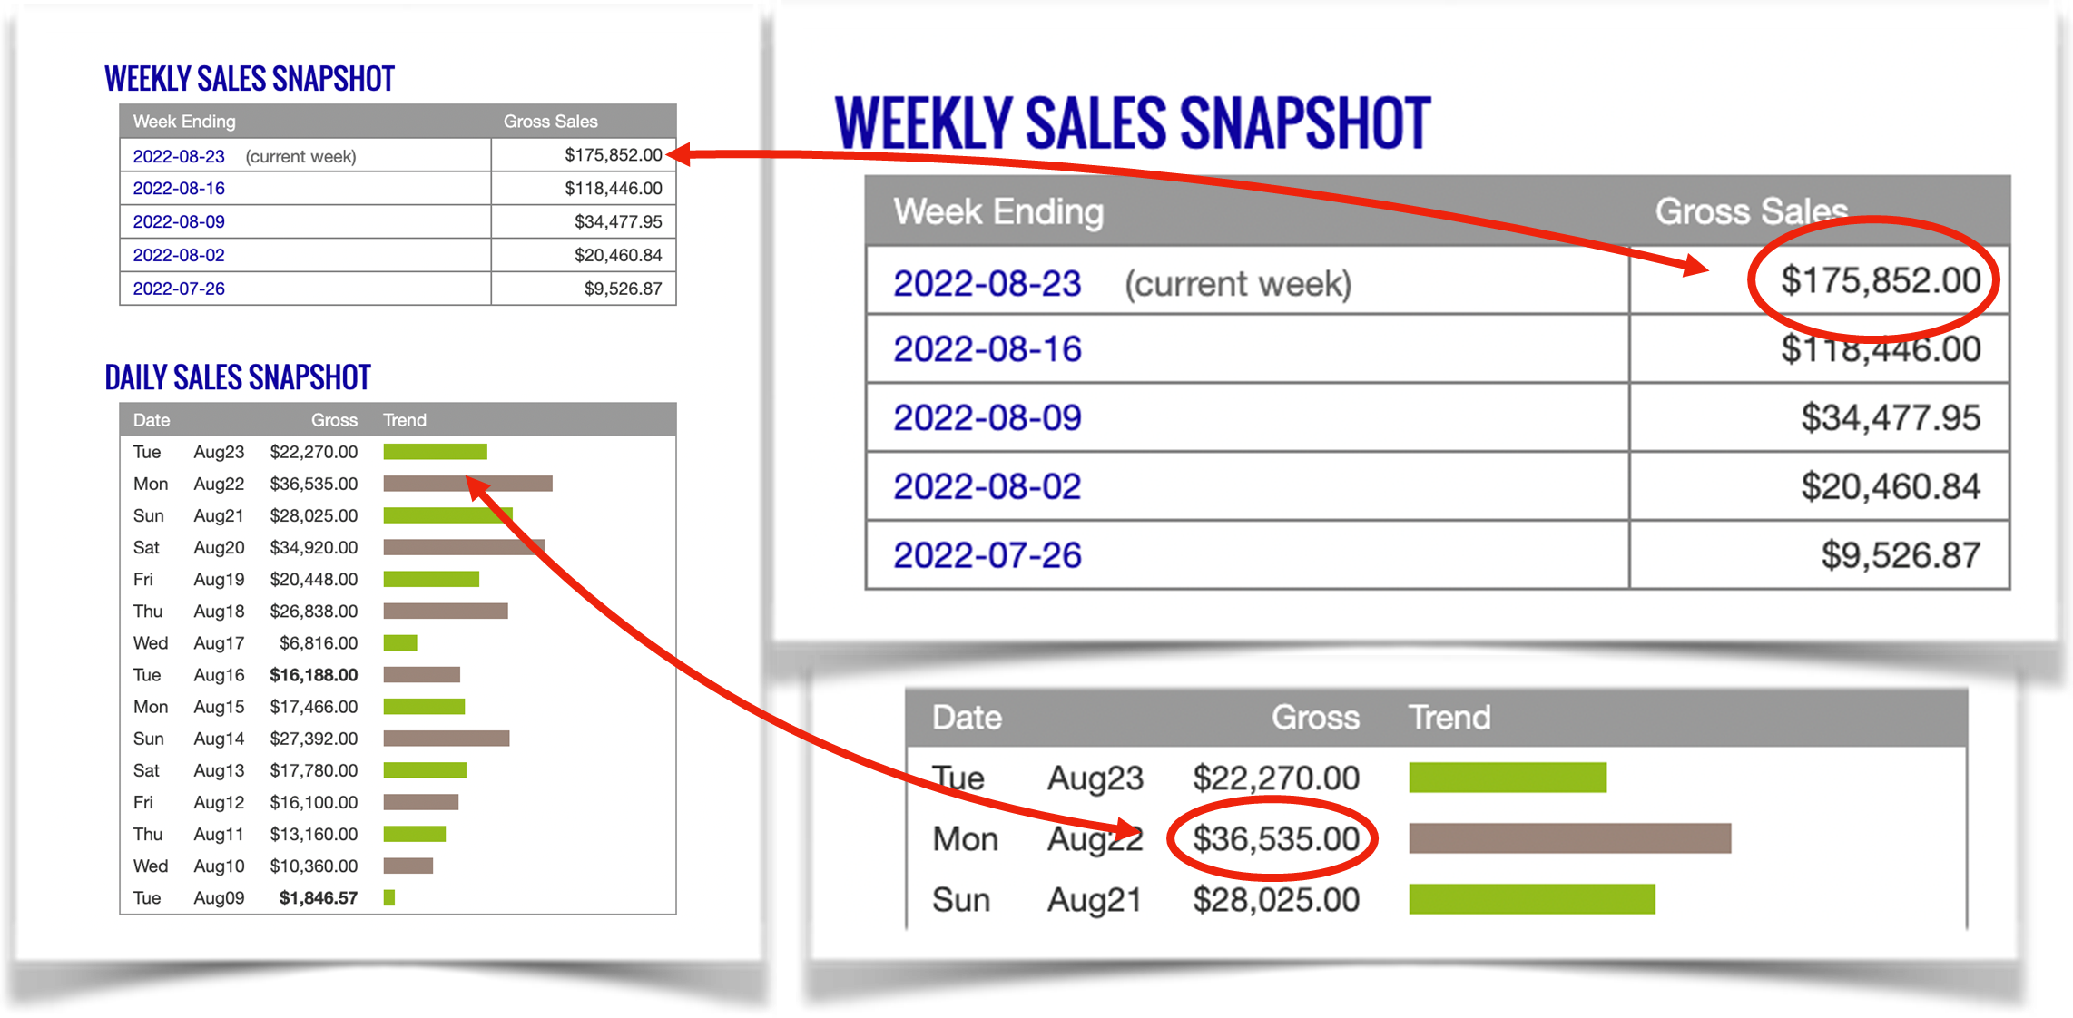

Eva went from $0 to $250k in 9 weeks!

If things continue to progress as quickly as they have in the last few months,
I should be quitting my job by Christmas and will finally be living
INSIDE my Vision Board!

MY BEST ADVICE
EVA'S BEST DAY - $36,535
EVA’S BEST WEEK - $175,852
EVA'S BEST MONTH - $352,235

You cannot give up…I almost did in April when my first video started to die out. But I’m so glad I didn’t because all my successes you’re seeing would’ve never happened.

Seeing other people’s successes & Chris’ posts on IG kept pushing me especially during tough times Rob and Gerry say, “Don’t give up and it will work out. “You must have faith” and they’re right.

A lot of people can achieve similar results to mine, but give up too early.

I loved looking at my Vision Board to remind myself what I was working towards. For you, it may be a journal or writing down your goals. Have something you can go back to reminding yourself why you’re on this path.

My biggest piece of advice is keep looking at the data to make the right decision. And don’t worry because they give you all things to look out for to know exactly WHAT and WHEN to do something.

As someone who does her share of worrying all day…trust me when I tell you that successes take you from Hope & Wishing to KNOWING & CONFIDENT!

The platform we use is the easiest way I’ve ever tried to make money online. It’s user friendly and very forgiving. You get results back on the same day so you can make decisions quickly and protect how much you invest each day.

IMPORTANT
To learn more about this all new system our students are using right now to earn $1000's in daily profits, join one of our free live training workshops (details are at the link below):

https://goprofit.AI/FreeTraining

During the workshop you will learn about the entire business model and discover how you can deploy it into your own business immediately. We will also be taking your live questions on the call.

CASE STUDY #5

MATT BARAN
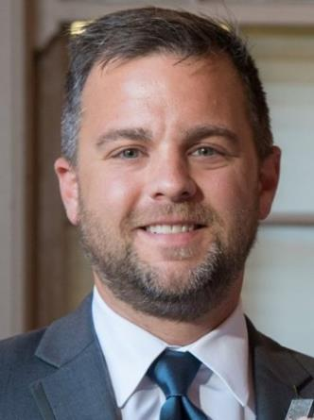

BACKGROUND

I’m Matt from Chicago, Illinois.

I’ve been selling insurance for 20 years. I first got into it because I saw it as a stable job being drawn to the idea that if I signed up a new client that I still would be paid another commission every year they renewed their policy.

Unfortunately, I could never get past making $75,000 a year. Five years ago, I felt stuck and my income was capped.

I can’t tell you how many mornings driving into work feeling so angry and frustrated (dare I say depressed) that I was trapped in a career and company that I gave so many years to and the idea of leaving felt like I was starting over as a middle aged guy.

I was in deep credit card and college loan debts that I accumulated and had been making monthly payments on for 20 years and felt like I’d never be done.

Like millions of other people out there, I hated my job and my place in life and wanted out NOW! Yet I couldn't quit because I was so deep in debt and my other monthly bills had to get paid.

I’d been trying to build an online income for 7 years, but nothing seemed to work. I always felt late to the game with everything I previously tried. Never got that big win.

When I joined this one I told myself I was going ALL IN because it’s the last one I’m going to try before moving onto another idea.

HIS RESULTS

This is the part that I can barely even believe in myself. My initial goal was to hopefully hit $1,000/day within 90 days. I smashed that goal within the first two weeks.

Eight weeks later, I had tallied $177,722 in affiliate earnings and over $83,000 in profit. I have never made money like this in my whole life. I don’t think I could have seen this coming.

Some days it seriously feels like I'm printing money. I get paid three times per week and each time I look at my bank account there's more money in it than the last time I looked.

It’s crazy.

I admit that when it comes to online courses, I have a tendency to overcomplicate things thinking I have to put my own “spin” on it. I tried that route with other courses. When Keegan advised me to follow his formula and templates to make it simple for myself, a lightbulb went off and I started seeing my results immediately...and they came quickly after that!

I found a winning campaign and scaled it in only 5 days – hit my $1k/day.

You can throw up a campaign and in 1-2 days you know if it’s a winner so you don’t waste weeks or months like on other ad platforms.

I loved being able to ask questions and everyone was so open and transparent of what was working for them. I would implement the advice and Bam...it would work for me like a charm!

Within a few weeks, I hit my first 5-figure day! I’ve never had this much success and at such a rapid pace before. I’ve been at it for only a few months. It’s so incredible to wake up each morning checking my stats and feeling I’m finally on track like I was back in my real estate days.

Within 7 months of starting, I was able to pay off ALL OF MY DEBTS and QUIT MY JOB!

$177k Revenue for a $83k Profit in January
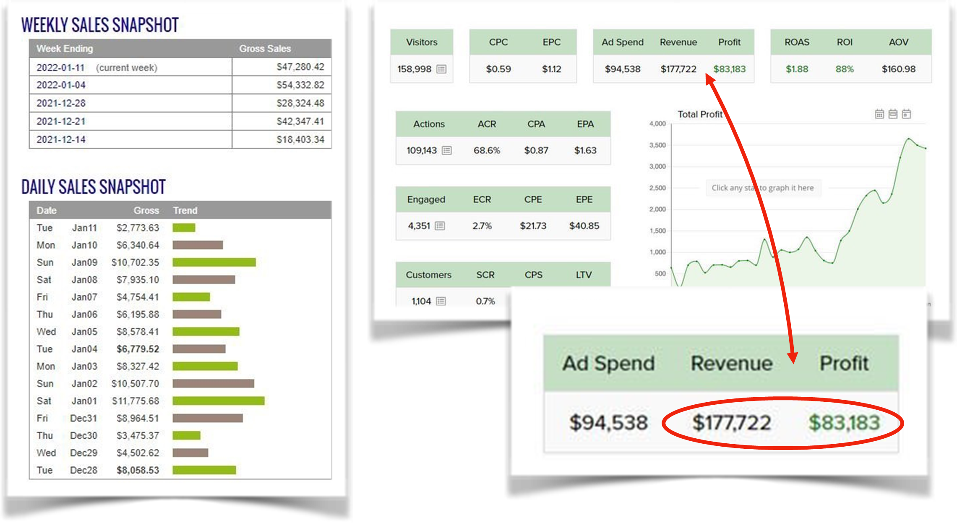

$22,470 - Best Day in April

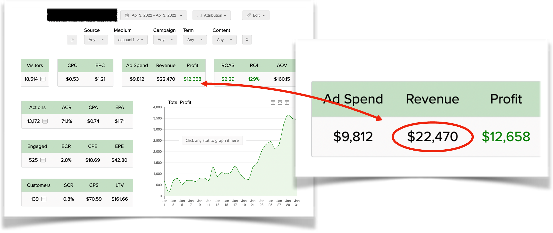
$179,793 for $81k Profit - First 3 weeks of April

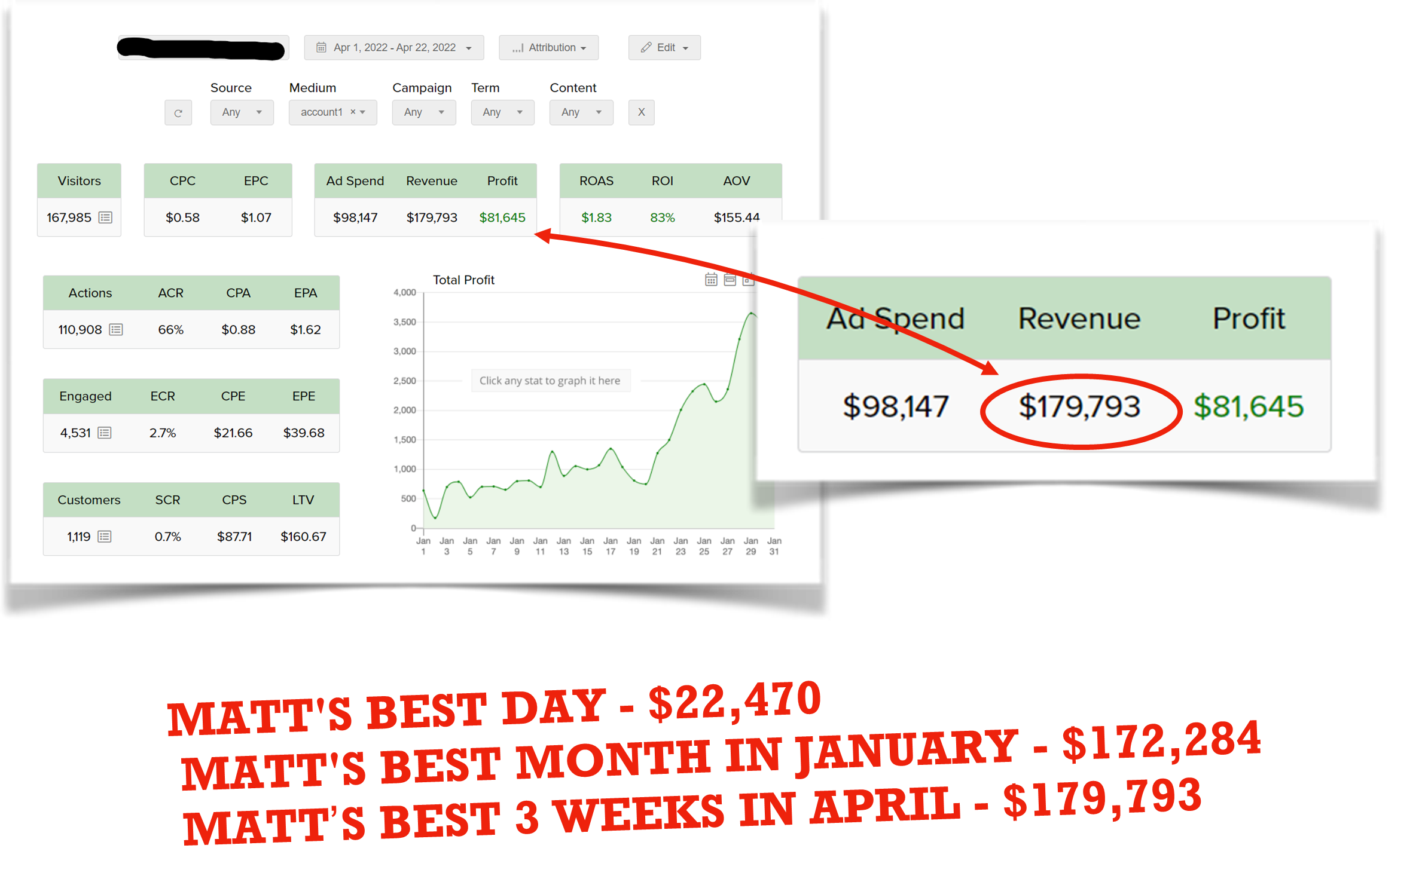

MY BEST ADVICE

Trust the fact that you’re only one of a very small group of people in the world running this specific model. All of the biggest success stories come from those who get in first before the world finds out about this model. We just have a few years to take advantage of once in a lifetime opportunity.

Most courses feel like a lot of work and it’s going to take forever to get to the end. Here, I was finally having fun going through the course so enjoy the journey.

Learn from your mistakes. Borrow from the success of others. Time and money are two things you can’t afford to waste.

Find a fast path to success. Follow a roadmap. Don’t do it on your own.

Success is a choice. It just takes focus and consistency. Avoid excuses and distractions. Take action and jump in with both feet..

You hold the power and you are in control of your financial destiny.

You can't get back lost time, but you can make up for it by taking control of your future, right now. Experience is the best teacher. You learn pretty quickly what works and what doesn’t.

After all those years of failing online, I finally believe I can do it. And there wasn’t anything special about other successful people that I didn’t have. I learned the MAGIC TRICK.

I’m so grateful and joyful that I’m debt free. I took out $500 in $20’s and gave them out to Homeless people in Chicago and it was the best feeling helping others in a tough spot to hopefully brighten their day.

IMPORTANT
To learn more about this all new system our students are using right now to earn $1000's in daily profits, join one of our free live training workshops (details are at the link below):

https://goprofit.AI/FreeTraining

During the workshop you will learn about the entire business model and discover how you can deploy it into your own business immediately. We will also be taking your live questions on the call.

CASE STUDY #6

RICH BELL

BACKGROUND
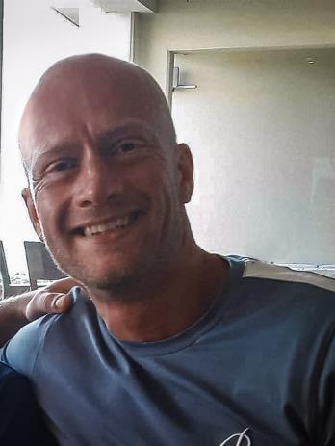

My name is Rich from the UK. I’m married with 3 teenage daughters.

For a long time I had a government job helping people with all the paperwork to receive their benefits. It felt good, but no one goes into public service to make big money.

I started a local paper to charge companies to advertise looking for new customers. It was the year before the pandemic happened and I lost everything when the world shut down.

Like everyone else, I was home all day and knew people were making money online. I kept thinking, “How do I turn my desktop computer into an ATM machine?”

At first, I tried setting up an eCom store and then dropshipping, but it was hard work and honestly, I was annoyed by angry customers when it wasn’t my fault that the shippers would delay or screw up their orders.

Managing an online store, tracking shipments, dealing with high merchant account fees, and dozens of other things leads to burnout. And once you get to a certain level in sales, it requires hiring people to help run the business and then I had to manage all of these people and their personalities which is a responsibility I didn’t want for myself.

With eCom stores, you only hear about big revenue claims. The profit margins were terrible after all your costs are paid out.

The idea of a model where you never talked to a customer or dealt with suppliers or shipping all over the world was exciting.

I had a bad credit history so I couldn't get a credit card. I knew I had to start slowly and was relieved to learn that there’s a low budget strategy as I built up my resources.

I’ve been following Rob & Gerry online for years and now Keegan & Chris so when this opportunity came out, I knew I had to try it.

HIS RESULTS

I started with 100 British Pounds a day for my ad budget and put all of the profits back in to build up my reserves. It’s incredible how quickly it grows in only 3-6 months.

Now I’m up to 9,000 pounds a day in ad spend. I've never really seen that much money in my bank account before and it happened in such a short period of time. Even just thinking about that, there is just so much weight off of my shoulders now.
It's literally the best feeling in the world making money online.

I actually feel free for the first time in my life because I have money to do whatever I want. And even more importantly, I can choose how I spend every minute of my day.

Seeing I’ve had 3.5 million views on just one winning video is mindblowing. My girls say that means I’ve gone viral! And I only have 33 subscribers and have never shown my face.

It’s been great having my wife and daughters cheer me on as I achieve higher results along the way.

One of the coolest things that happened recently is that I only spent 10 min a day on my ads while on vacation in Portugal. By the time we were ready to head home, my profits had paid for the entire trip!

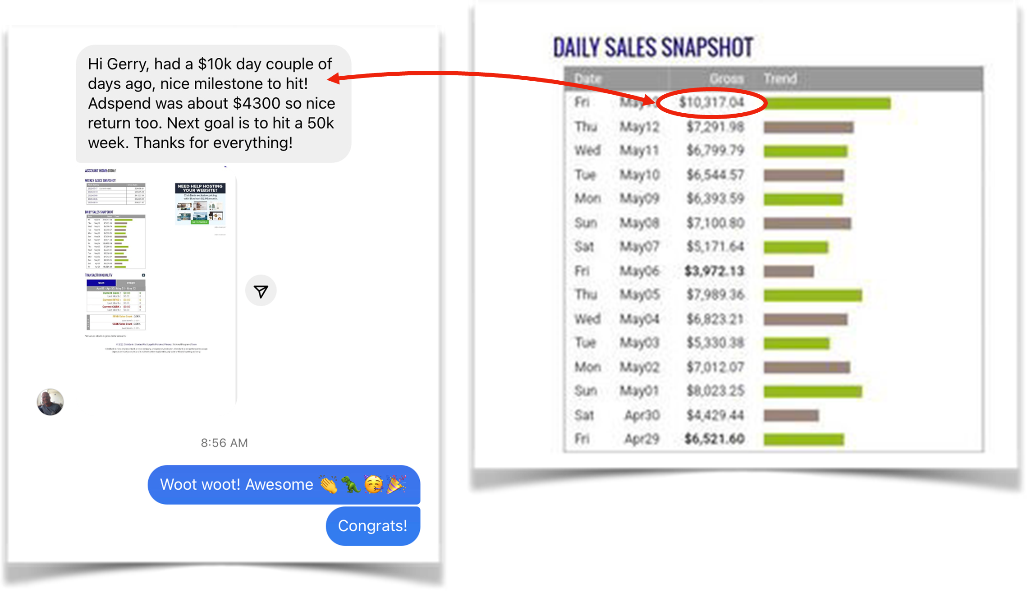
First $10k Day in May

First $20k Day & $100k Week & $367k Month in July

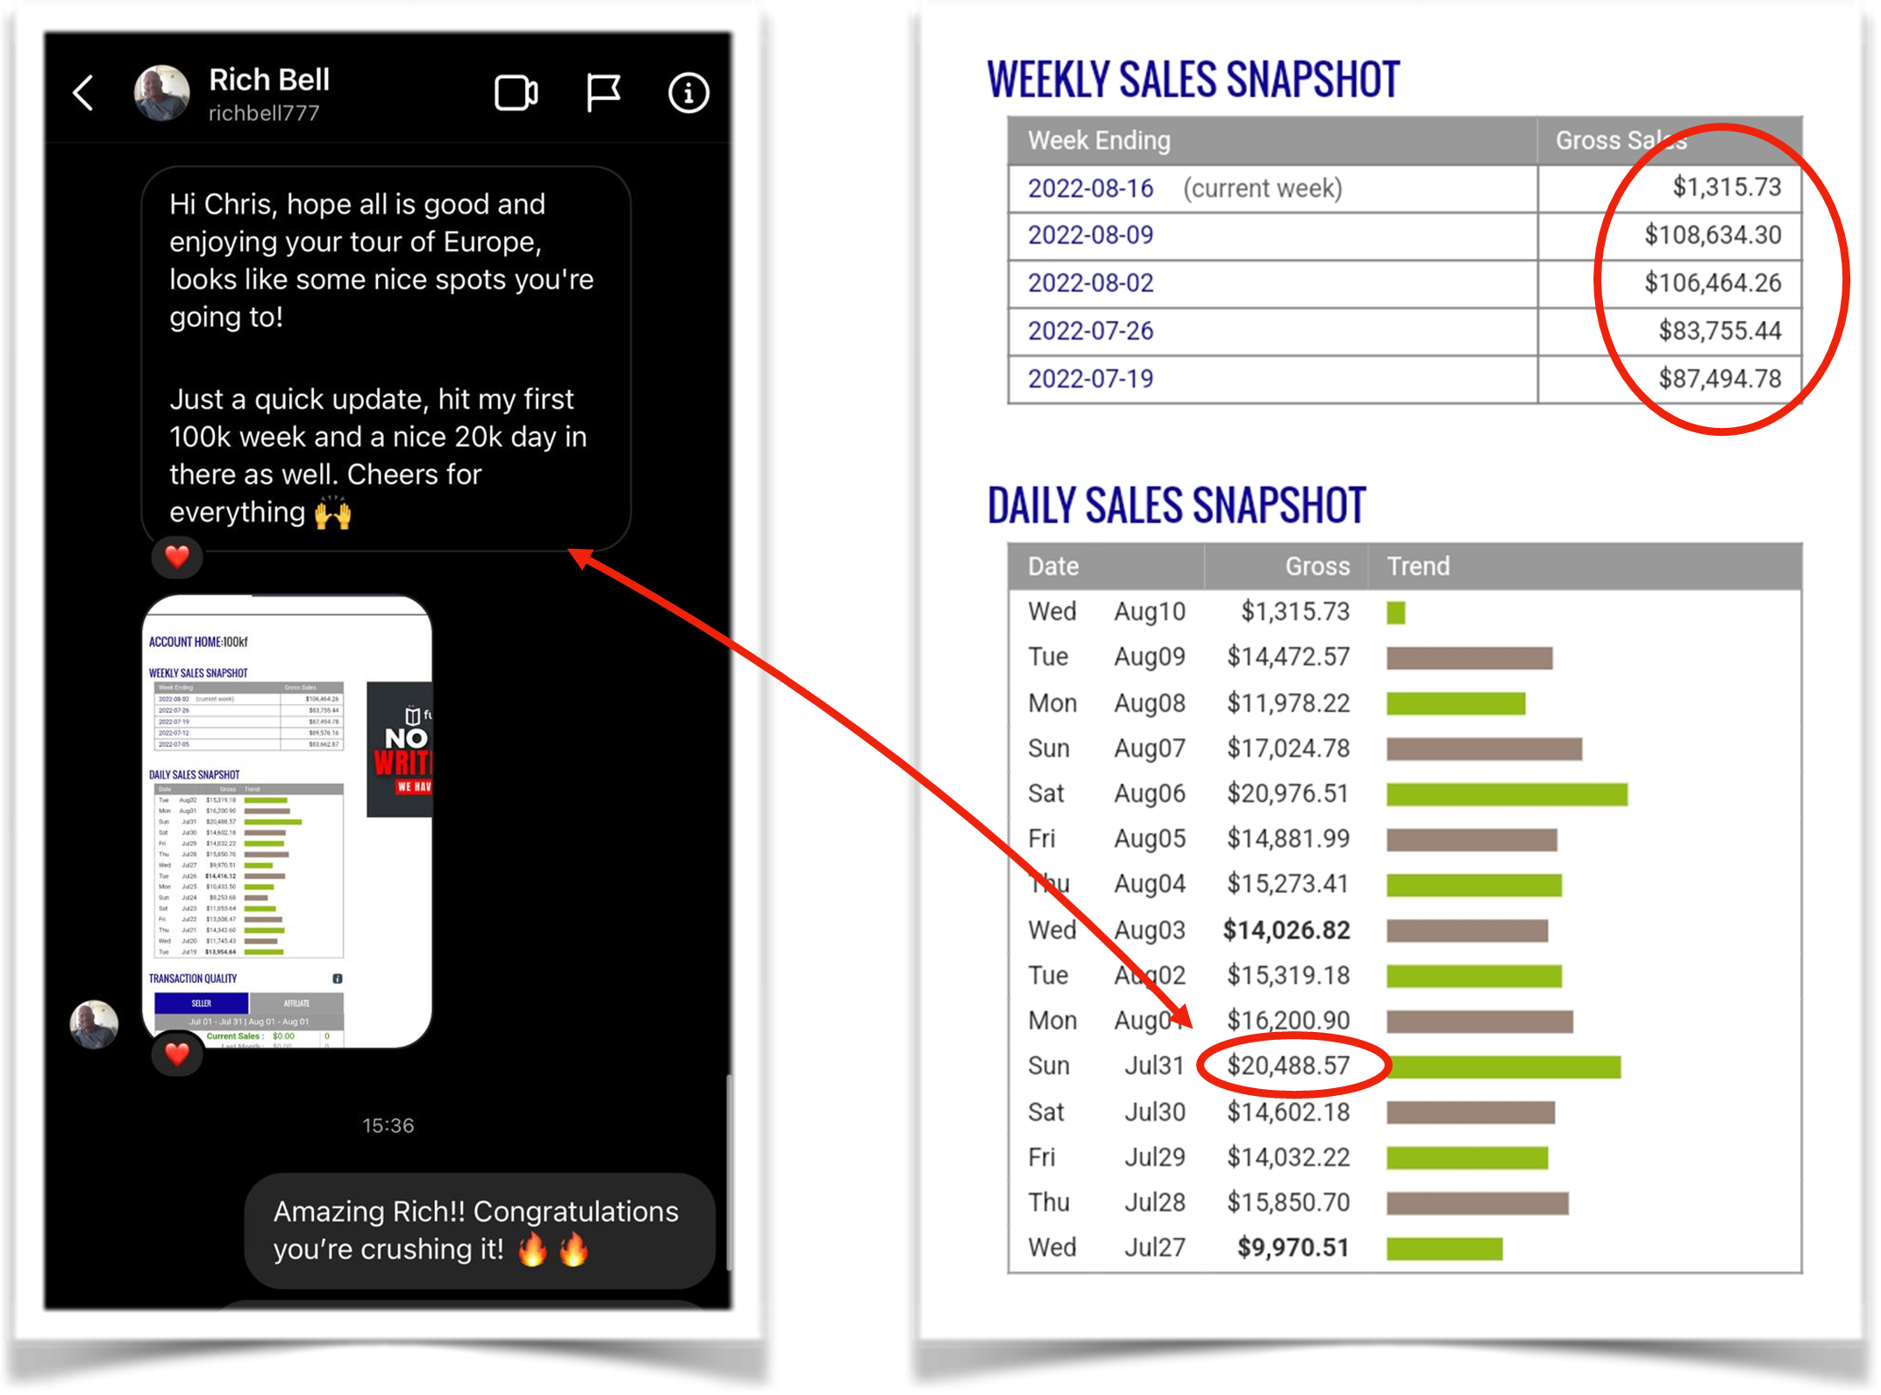
Two weeks later had Three Consecutive $100k + Weeks and his highest $21,763 Day
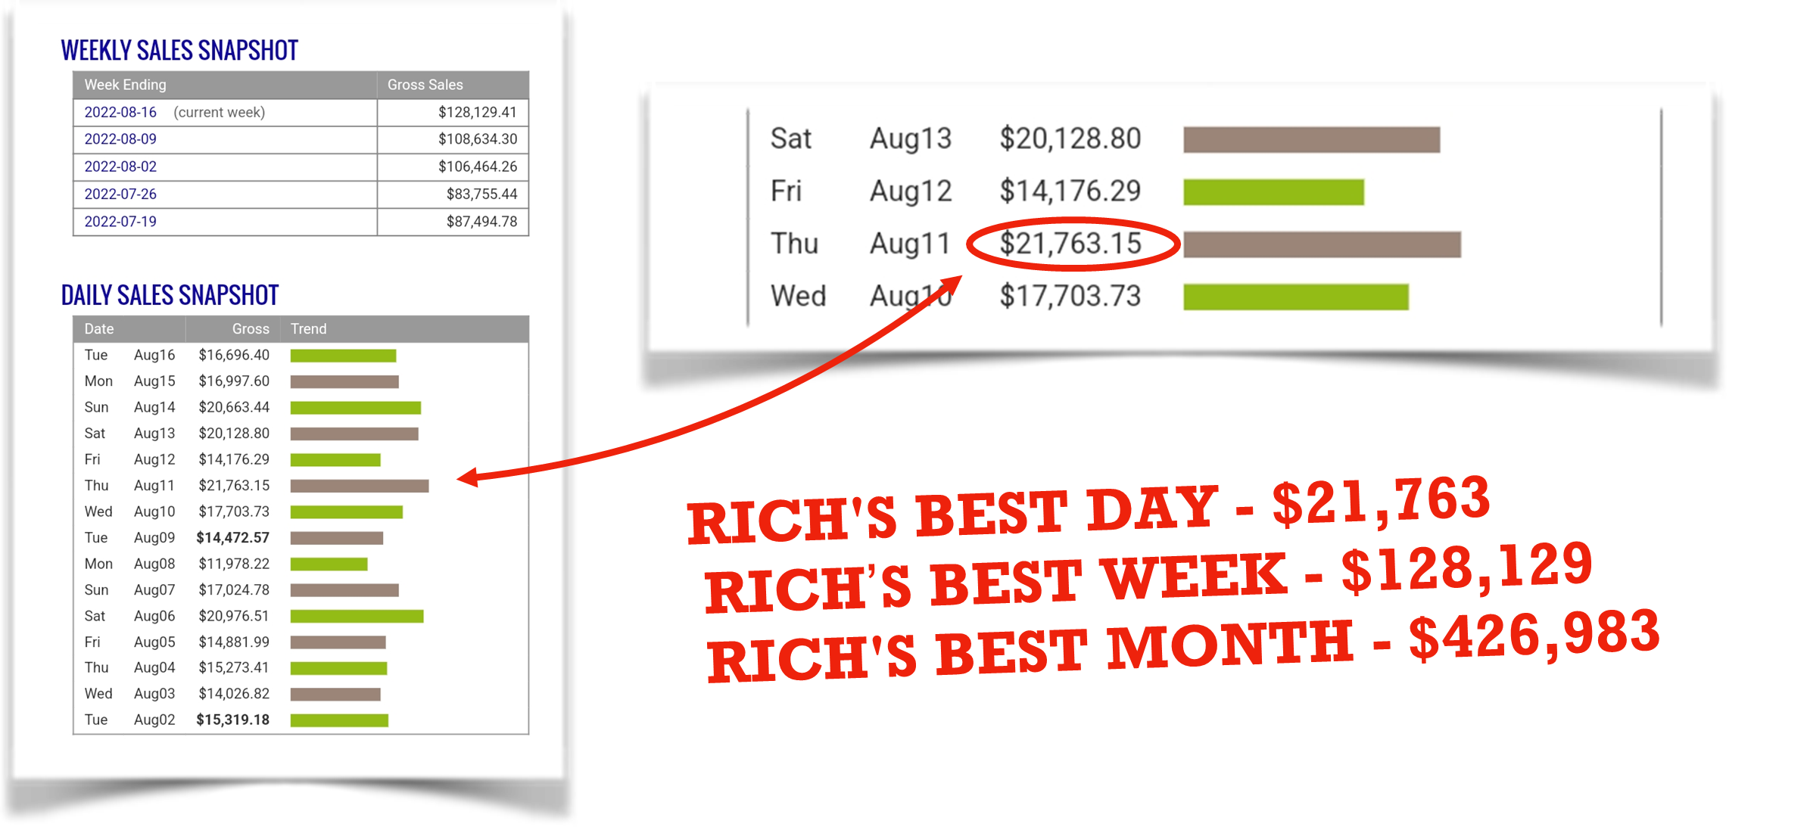
The training is so easy and laid out in such a step-by-step fashion that I gave it to my teenage daughter a few weeks ago.

Now, Sadie runs her own ads and quickly hit her first $600 day!
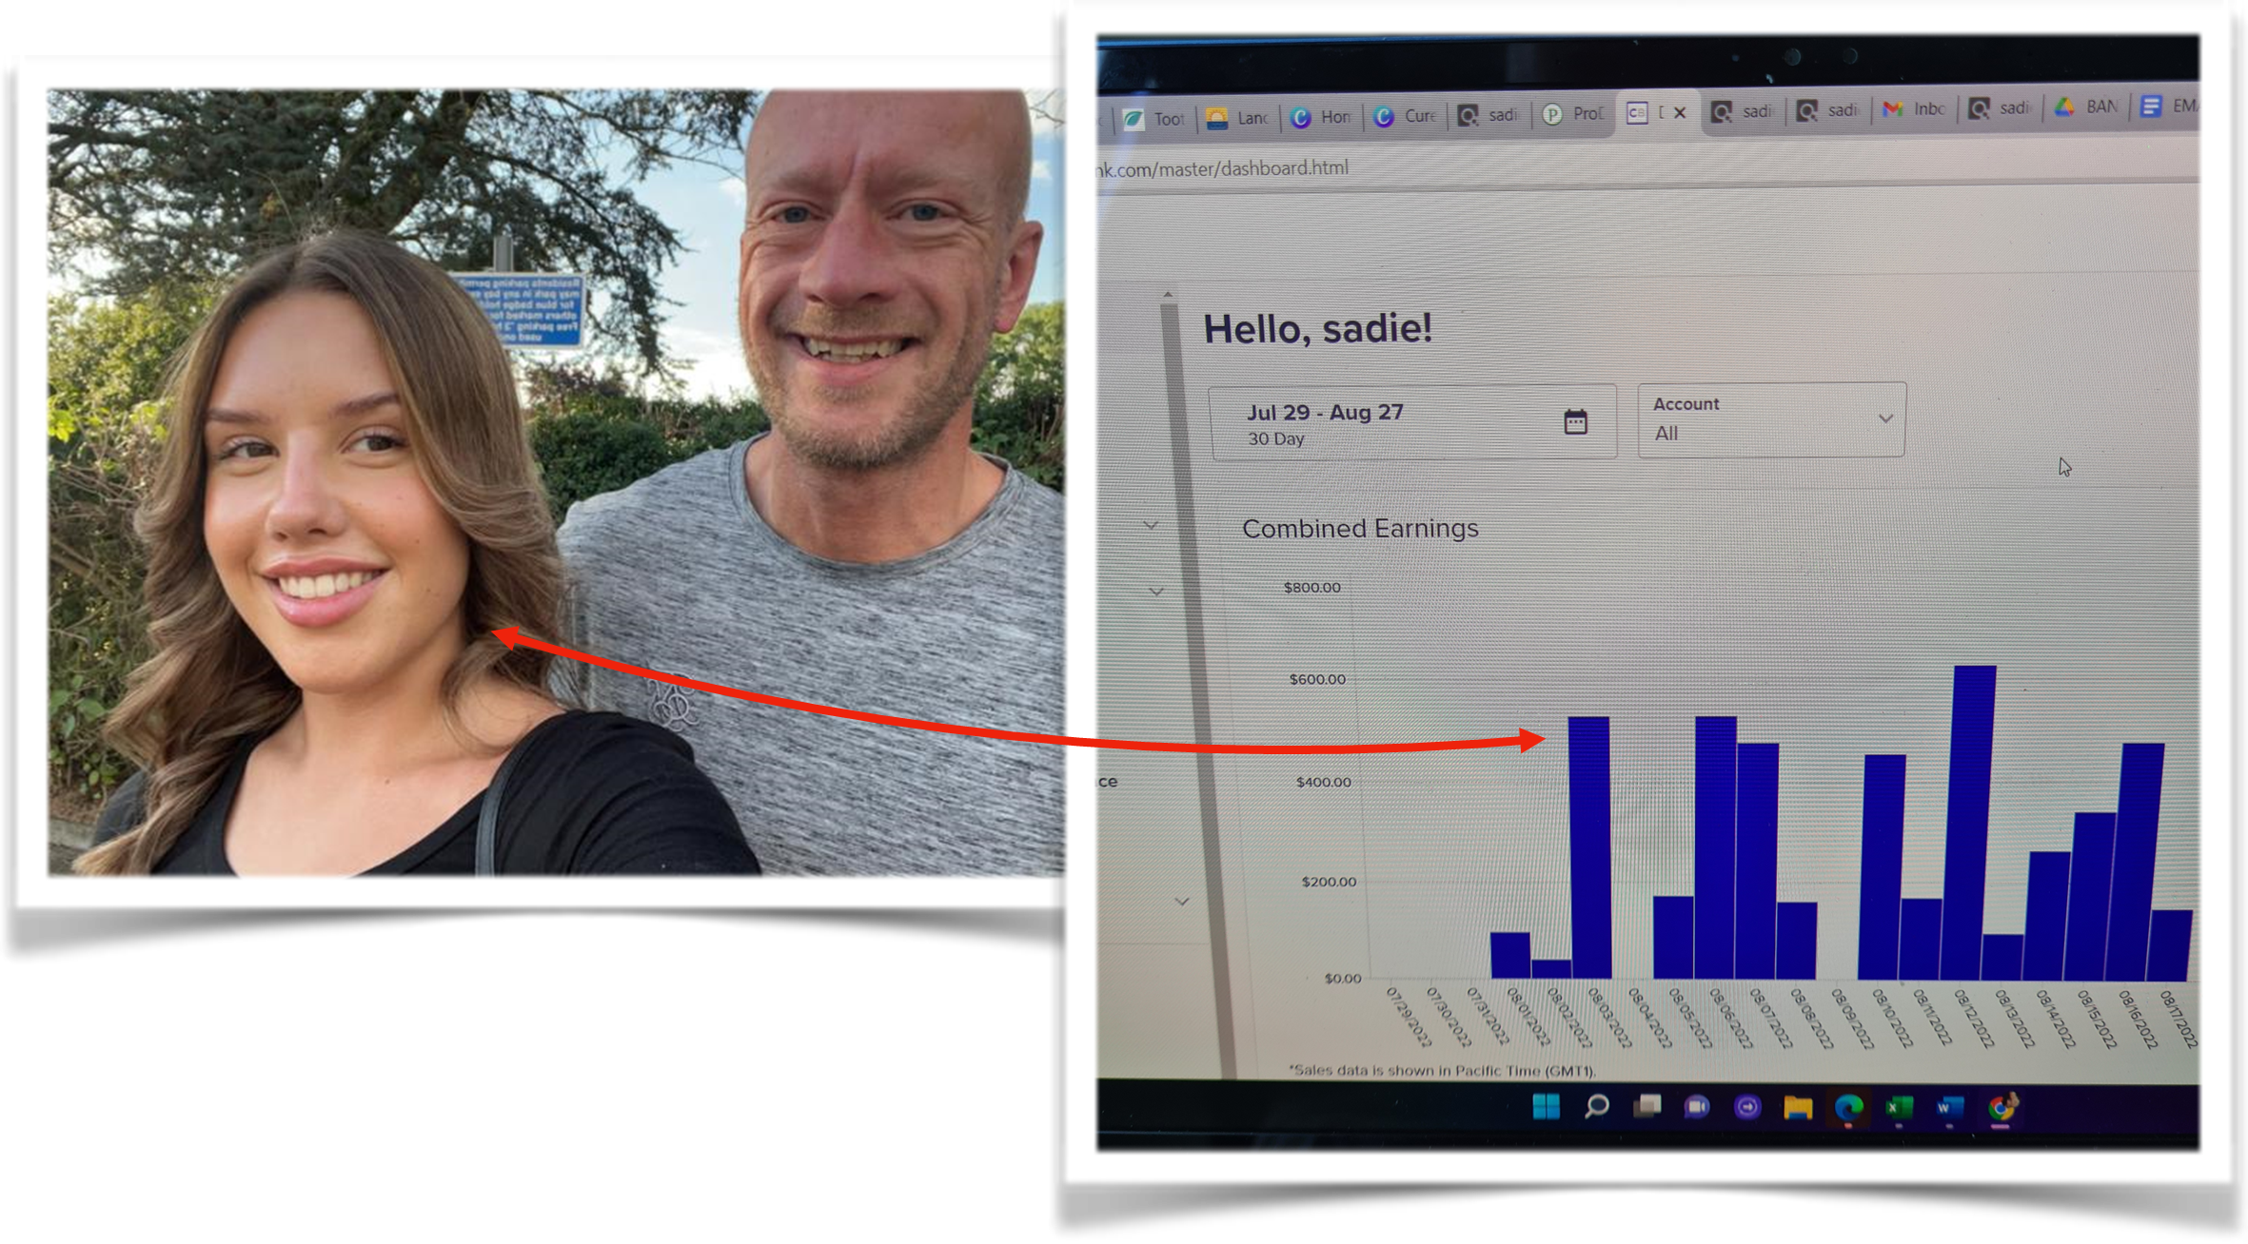

MY BEST ADVICE

Put yourself around people who are already doing what you want and follow their advice.

If I didn’t have people showing me what to do because there’s a bit of a learning curve when you’re brand new to online marketing in the beginning, then I’m not sure I would have succeeded.

Don’t try to reinvent the Wheel. I learned this the hard way.

Follow Keegan’s formula because he knows what he’s talking about having spent millions of his own dollars testing to see what really works.
Emulate their success!

My best advice is do not overthink things. Don’t waste time stressing out or worrying about all the things you need to learn. Take it one step at a time and follow everything in order so you don’t have time to doubt yourself.

I can tell you if you just focus on the next thing you need to do which they gave all of us and keep moving forward, then you will get there.

If you’re outside the US, use Wise to receive your commissions in your home country for a better exchange rate.

I live in a small tourist city. Walking around one day, I realized that I probably make more money than the biggest restaurants and boutique hotels in my neighborhood. It’s truly amazing how your life can change when you find the right method.

IMPORTANT
To learn more about this all new system our students are using right now to earn $1000's in daily profits, join one of our free live training workshops (details are at the link below):

https://goprofit.AI/FreeTraining

During the workshop you will learn about the entire business model and discover how you can deploy it into your own business immediately. We will also be taking your live questions on the call.

CASE STUDY #7

STEF LUM

BACKGROUND
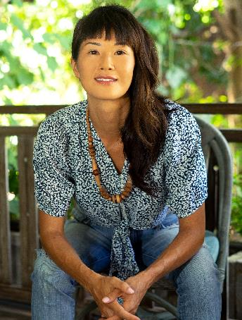

My name is Stef. I’m an American living in Bali, Indonesia raising my two children on my own.

I really connect with the outdoors and nature. Plus, I’ve always wanted to live overseas and give my kids a chance to see other cultures and opportunities as they grow up.

I want to give them a different perspective on life rather than being raised in a strictly Western culture. I can give them the best of both worlds living out here.

And with the high cost of child care, rent, insurance, a car, and all the other expenses I was struggling to cover monthly expenses on my own…we have an easier time out here where I can be at home more with them. I was searching for a situation where I could be there for them and see them grow up.

I’ve been in marketing, advertising, and branding for years. I worked with some great agencies and learned a lot.

I was always trying to help others grow their companies and brands, but I felt like I wasn’t building anything for myself except more experience.

I was also a Health & Wellness Coach for awhile. I had an epiphany one day talking with a client about setting goals and taking steps to achieve them.

It dawned on me that I was doing what most people do which is getting up each day to work hard, but not with an end goal in mind.

The pattern wasn’t going to stop unless I took intentional steps to make a change.

I took several courses on a variety of online business models, all without any sustainable results. Living in Bali, I heard about Rob & Gerry’s company and all of the success stories of everyday people they were helping so I reached out to join their bigger beta group.

To say that email to them changed my life would be an understatement. They showed me how to truly make the kind of money most people only dream about.

They’re definitely the real deal.

HER RESULTS

I didn’t know the first thing about how to get started. And beyond the basic Google search, email, and social media… I don’t consider myself a “techie” which made me nervous at first.

Realizing it wasn’t complicated at all as I went through the modules one by one, it was a HUGE relief.

The great thing was that we were all given exact direction on how to do everything to be successful and shown many examples of what worked. I didn’t have to worry about what to do next because it was all shared freely in the group.

Struggling at first, I eventually wrote a good script and made a good video. I followed the way I was taught exactly and it started working. A few times I had some bad days, but mostly they were profitable ones.

What really helped was letting go of my PERFECTIONISM SYNDROME. I was overly judging my work as “not good enough” and kept trying to make it as good as possible before running it.

I heard Keegan telling another student that it’s much more effective to do the opposite and try many things to let the audience tell you what they like to speed up the timeline to success.

Once I could do that, everything became so much easier.

One hard thing for me was when I was told to increase my budget. As a single mom, it felt almost irresponsible to spend that much money in a day on ads.

But you realize that you’re not going to spend money until you find a winner so it really takes all the risk out of the equation. 100% return on $10, $100, or $1,000 is just another zero.

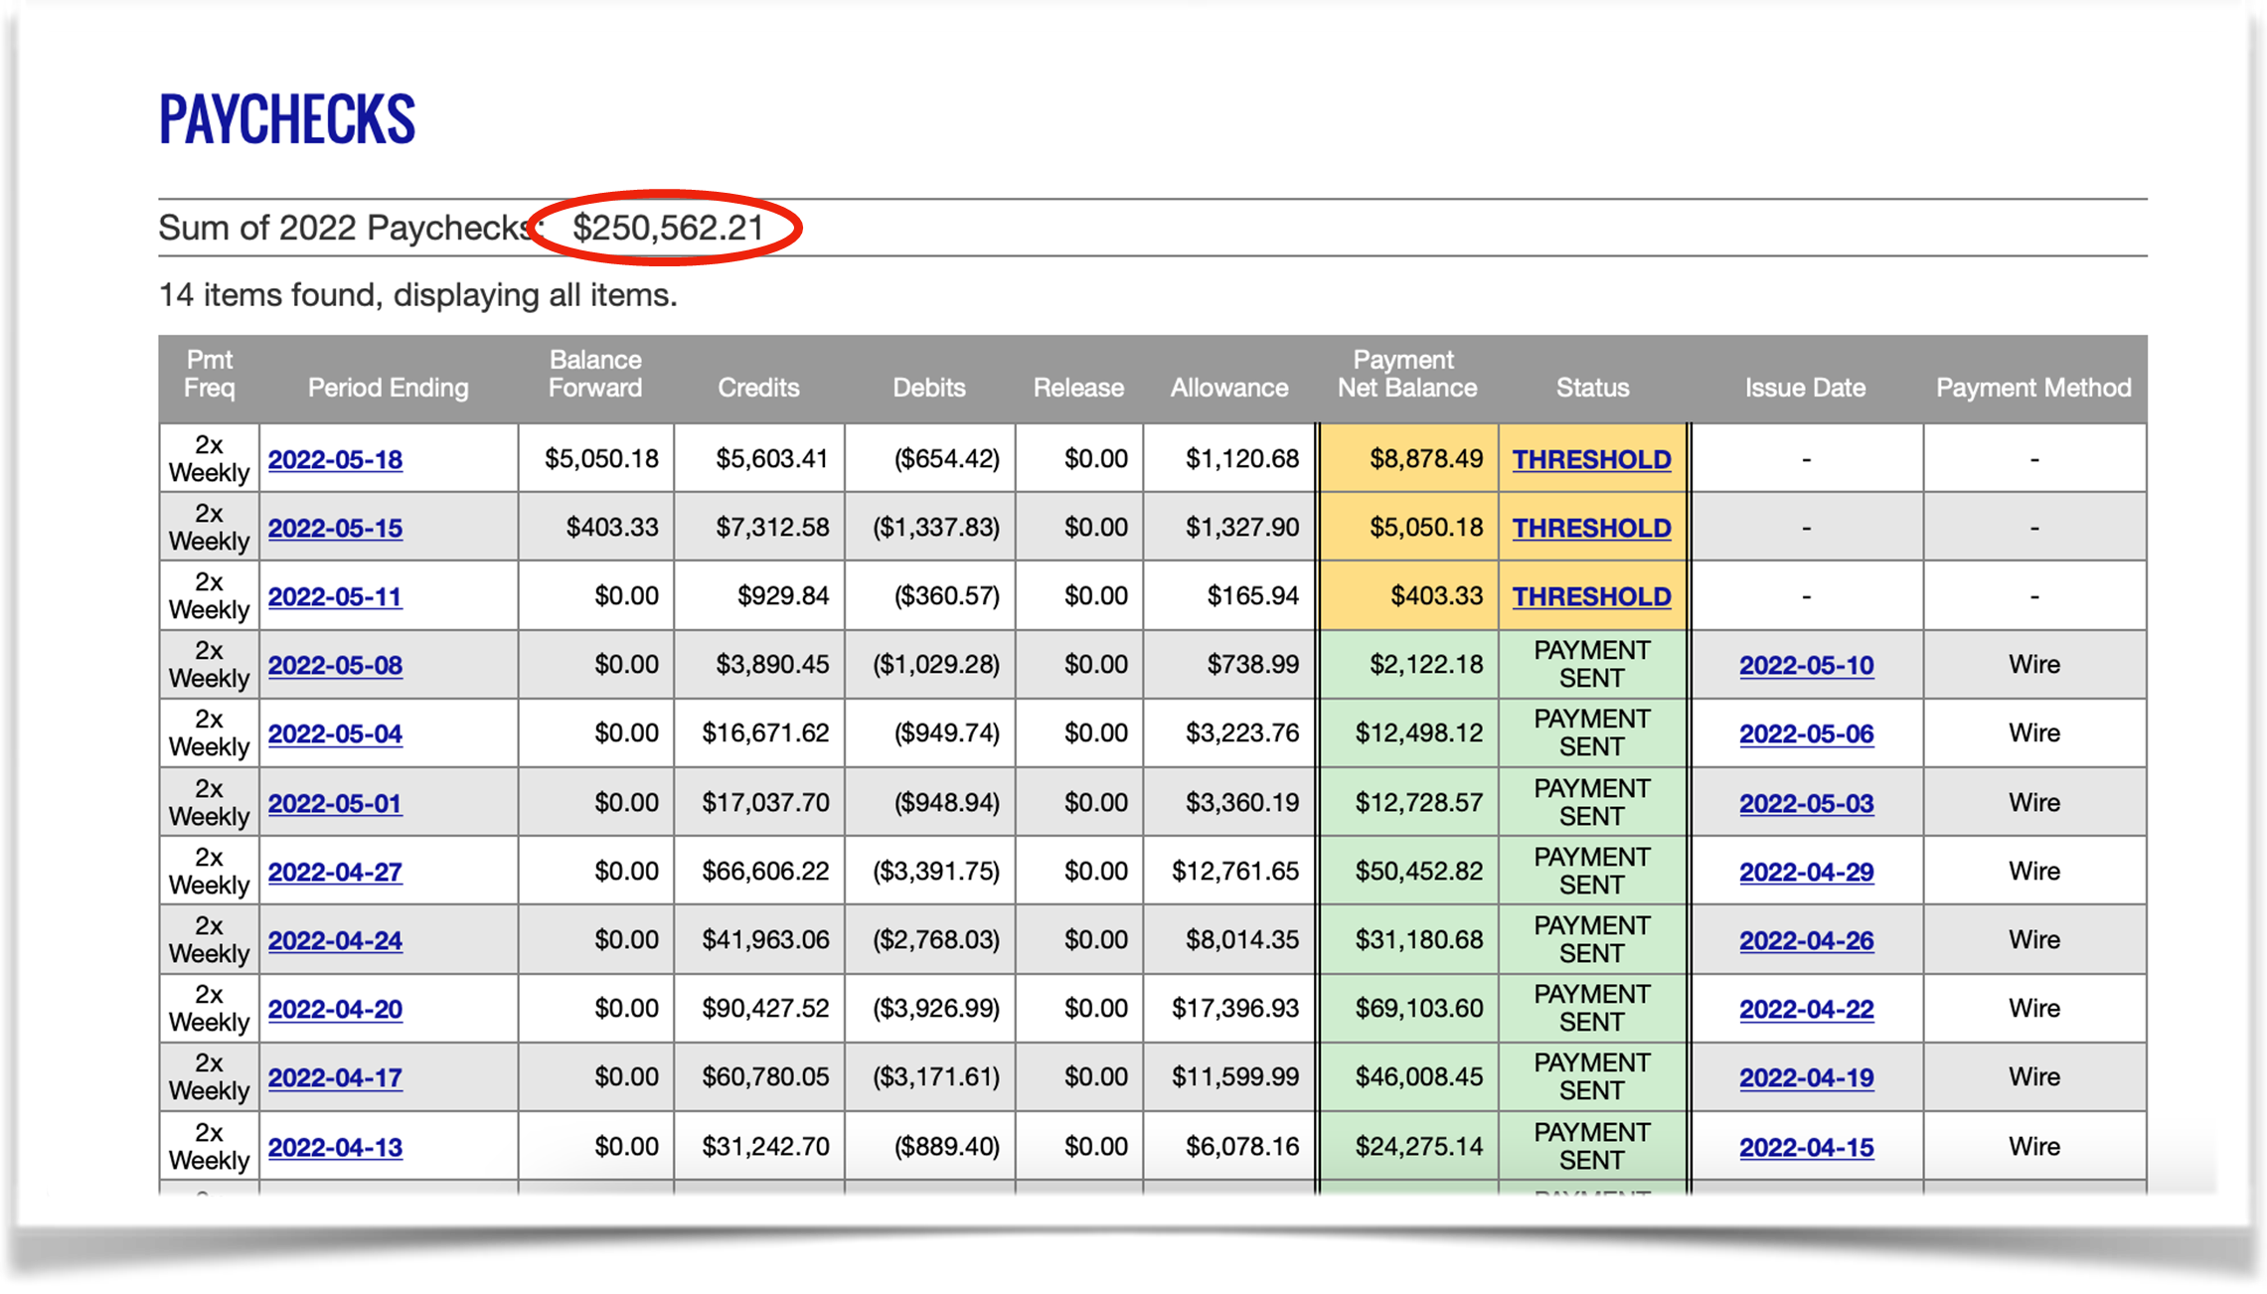
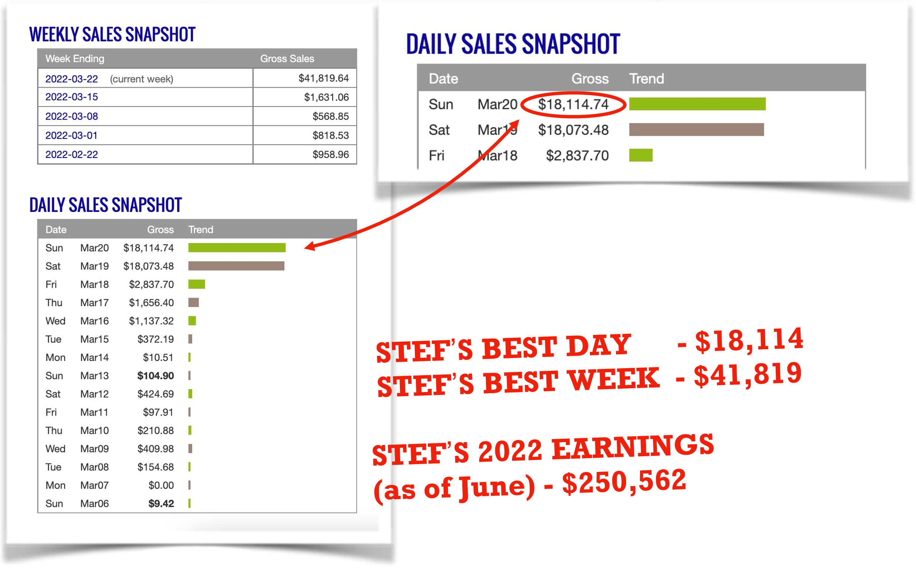
STEF’S BEST DAY - $18,114

MY BEST ADVICES

Be patient. It may take time to learn and it will take work. All good things take time. The best part is the entire system is already laid out so all you have to do is follow it. And, you...will...get...there.

You MUST experience it for yourself. DO the work.

What I love most about Chris & Keegan’s system is that it doesn’t take me a lot of time once I build my script and video ad. From there, it’s setting up campaigns and letting the A.I. do all the heavy lifting.

Claim your freedom. This system is THE vehicle that FINALLY allowed me the balance I needed between being a working mom and enjoying time with kids. As a mom, I can’t tell you how incredible it feels not dealing with the guilt of having to choose one over the other.

Try having more fun with the process than putting so much pressure on every ad variation to be a winner.

Mindset is also critical…don’t give yourself a hard time & Don’t take your ads too seriously.

Give yourself some goals and be realistic about results if you’re brand new to ads.

Be comfortable learning and doing things that you’re uncomfortable with to learn these essential skills → TRUST THE PROCESS

IMPORTANT
To learn more about this all new system our students are using right now to earn $1000's in daily profits, join one of our free live training workshops (details are at the link below):

https://goprofit.AI/FreeTraining

During the workshop you will learn about the entire business model and discover how you can deploy it into your own business immediately. We will also be taking your live questions on the call.

CASE STUDY #8

RAJ, HARRY, & SAM KHEIRA

BACKGROUND

We are the Kheira brothers from India.

I’m Raj and I was a police officer for many years. Sam and Harry are my younger brothers so they only know how to make money online with their big brother.

My middle brother, Sam, and I had really good success with Facebook a few years ago. It took a lot of hours and hard work because Facebook is so much more technical and challenging than Google.

We made in 6 months what would have taken me 144 YEARS to earn as a police officer.

But after the 2020 U.S. elections, Facebook became so much harder to make money or to keep an ad account open.

We started trying other business models and platforms to recreate our success, but nothing could compare.

Gerry reached out to us a year ago to be in the first big group of beta testers having met him in Bali to share our success.

THEIR RESULTS

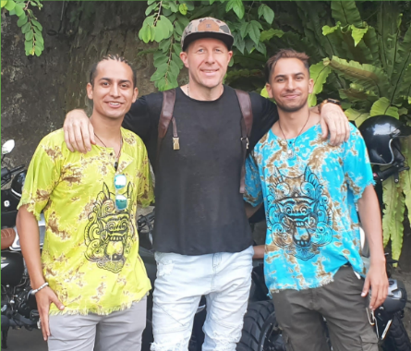
At first, it was a challenge making video ads for the first time. But you get better with each one. What were you ever good at the first time you tried it without any experience?

We generated revenue 3 weeks after taking the course. Having prior ads experience, we knew this was already going to work.

We hit our first $1k day within a month. Then $5k days. Then $10k days.

It took 3 months to go from a $1k Day to a $33k Day with a bunch of days in the mid teens on a daily basis.

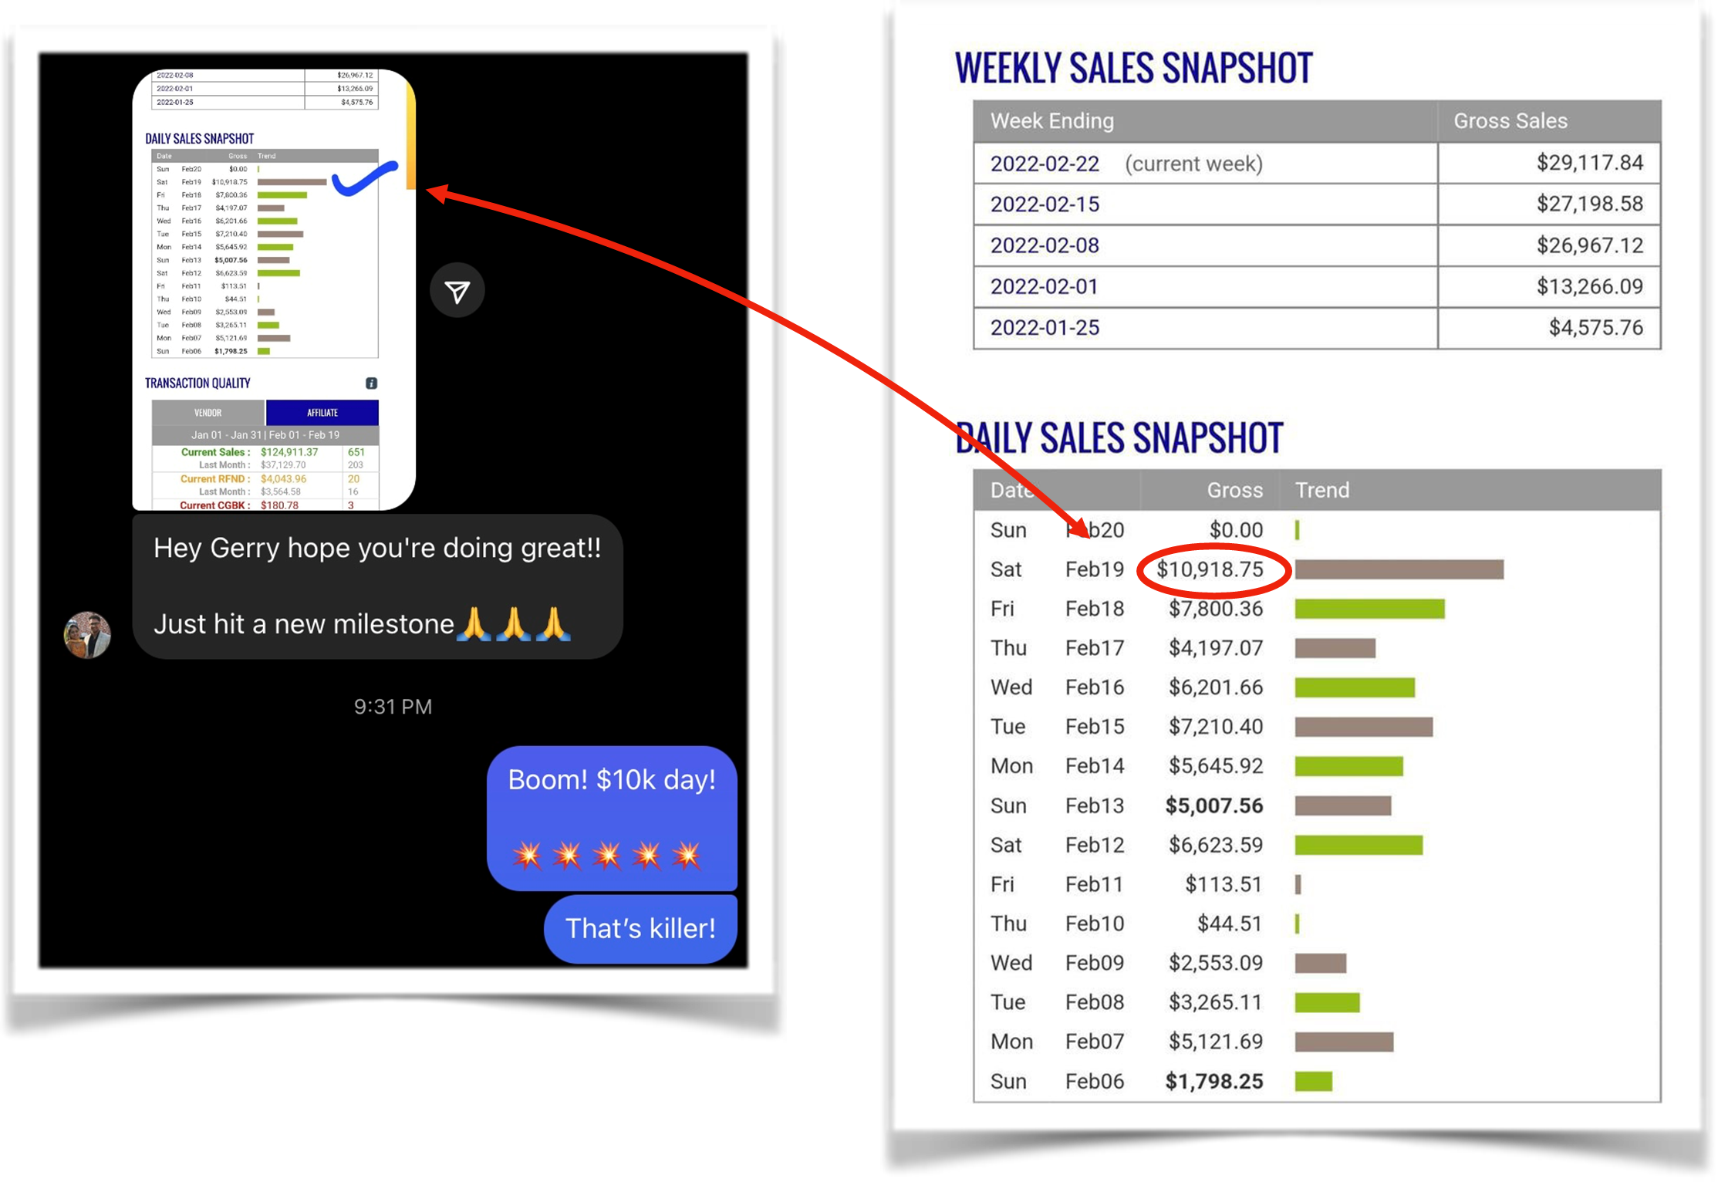
We noticed that without any restrictions on daily ad spend on the platform, once we found that winning video it was going to blow away all of our previous records…and it did!

We made in a few months on Google what took us over a year to generate on Facebook.

First $10k Day in February

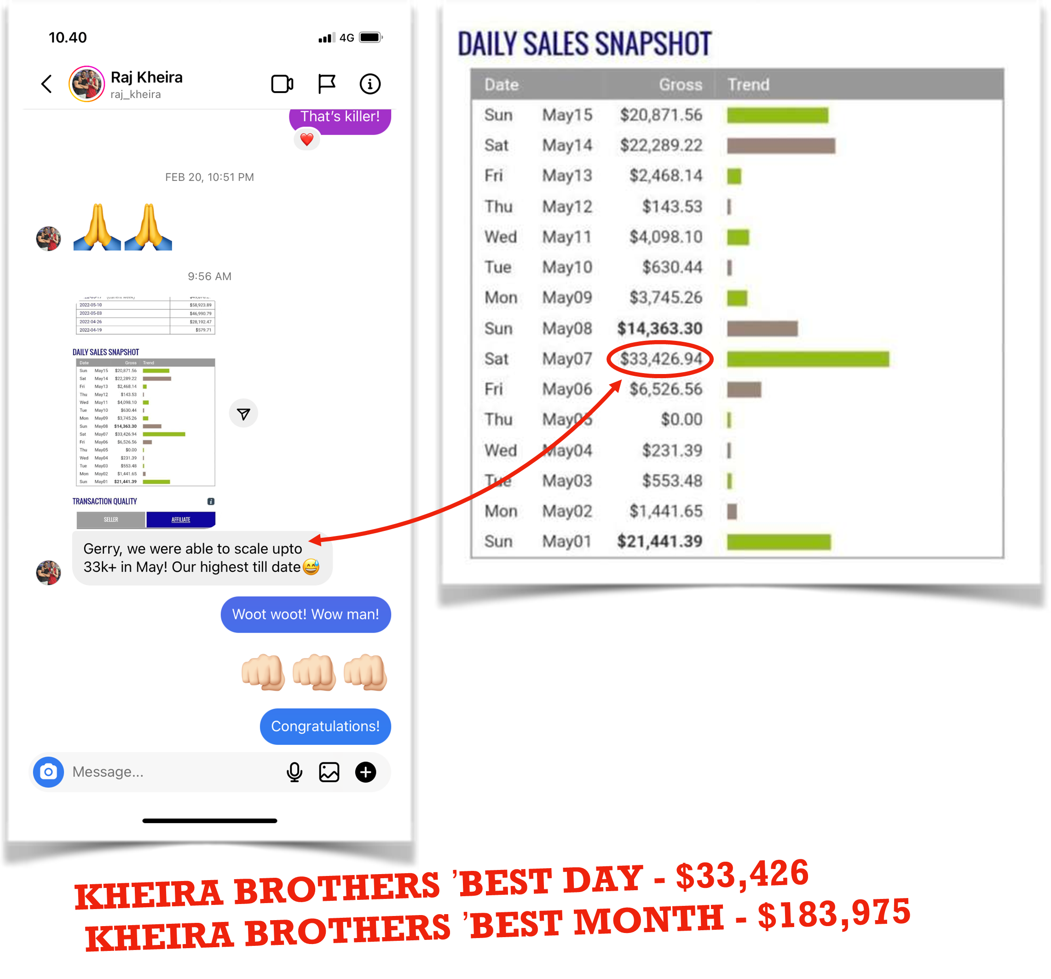
A few months later to $33k

OUR BEST ADVICE

Excuses are easy for people to tell themselves why they cannot do something. You can learn anything if you want it badly enough.

You have to have a dream and go after it as hard as you can and do not let anything get in your way.

At one point in our lives, we did not know English so we learned. We all have weaknesses and disadvantages, but we also get to decide if we can overcome them or let them beat us.

Sometimes we hear people in Western countries talk about how difficult their lives are. We understand, but when you come from a place where hardship and poverty is all around you, your biggest struggles make you stronger.

We cannot help where we are born. But we are alive so that means we have a chance to figure a way out and make a better life for ourselves and our families.

Gerry often talks about his students’ “Why’s”. We relate to that very much. It is what keeps us trying so hard and pushes us even when we are having a bad day.

Based on our childhood, having an ad that does not convert well is not a big deal. We have survived a lot worse things than losing $20 one day. It is all about PERSPECTIVE.

There’s no way you can’t win if you make enough video ads and test them.

Trying is the best teacher. Build on your ads that missed and you will find a winner

Always track the ROI to make decisions

Take all of that energy you spend being afraid or fearful that something may not work and use it to TAKE ACTION because when you’re moving forward, that scary voice goes quiet.

IMPORTANT
To learn more about this all new system our students are using right now to earn $1000's in daily profits, join one of our free live training workshops (details are at the link below):

https://goprofit.AI/FreeTraining

During the workshop you will learn about the entire business model and discover how you can deploy it into your own business immediately. We will also be taking your live questions on the call.

CASE STUDY #9

OWEN STOVALL

BACKGROUND

I’m Owen. I’m a 25 year old guy from Beuford, SC.

I was raised by a single mom. I’ve been working odd jobs like coaching tennis to help her out financially.

We both take care of my grandfather who has Alzheimers.

I played competitive tennis in college. I loved the game, but being realistic I decided to study finance in school so I could get a great job after I graduated.

I had the plan all worked out. At 21 years old, I knew I wanted a lot of money because I didn’t grow up with any.

I was doing summer internships so when I graduated, I would join a bank working 120 hours/week until I got promoted to the executive level with my big office, a beautiful house, and great car.

I graduated around the time the pandemic hit and that job never happened. I thought, “There went 4 years of studying my butt off. Now what?”

I moved back in with my mom to keep my expenses low and to find a new plan.

I was mentally and financially down before taking the course. All I knew is that I wanted to stop my family’s history and cycle of only making money to survive rather than “Living a full life”

HIS RESULTS

When I was first learning this before making any money, I kept thinking about all of my friends in tech jobs at big companies making six-figures while I’m living at home trying to start an online business.

I had my doubts. But I also knew I didn’t want to commute to work to sit in a cubicle for the next 30 years. It wasn’t about right NOW, but where will all be in 10 years.

I wanted to be HAPPY.

Keegan’s system is so efficient, well thought out, and provides a real step-by-step process that’s easy and fast to implement. I have not seen something like this in any other courses I’ve taken over the years.

It’s so specific and detail oriented that if you follow directions like a recipe, you will definitely start making sales fast.

In the past, I would question the modules or try to add my own spin on things. This time I promised myself I’m going to do EXACTLY what they tell me and nothing more.

And that was the right move because I started making sales in 7 days after I started implementing and running ads. Pretty quickly after that, I got to my $1k/day breakthrough. That’s never happened to me before. This is definitely the real deal.

It’s the best feeling making money even when you are not working. I remember early on, I was watching a movie with my mother at night when the platform emailed him saying, “Congratulations, you got a sale”.

We both were jumping up and down because we could not believe it was actually happening to me!

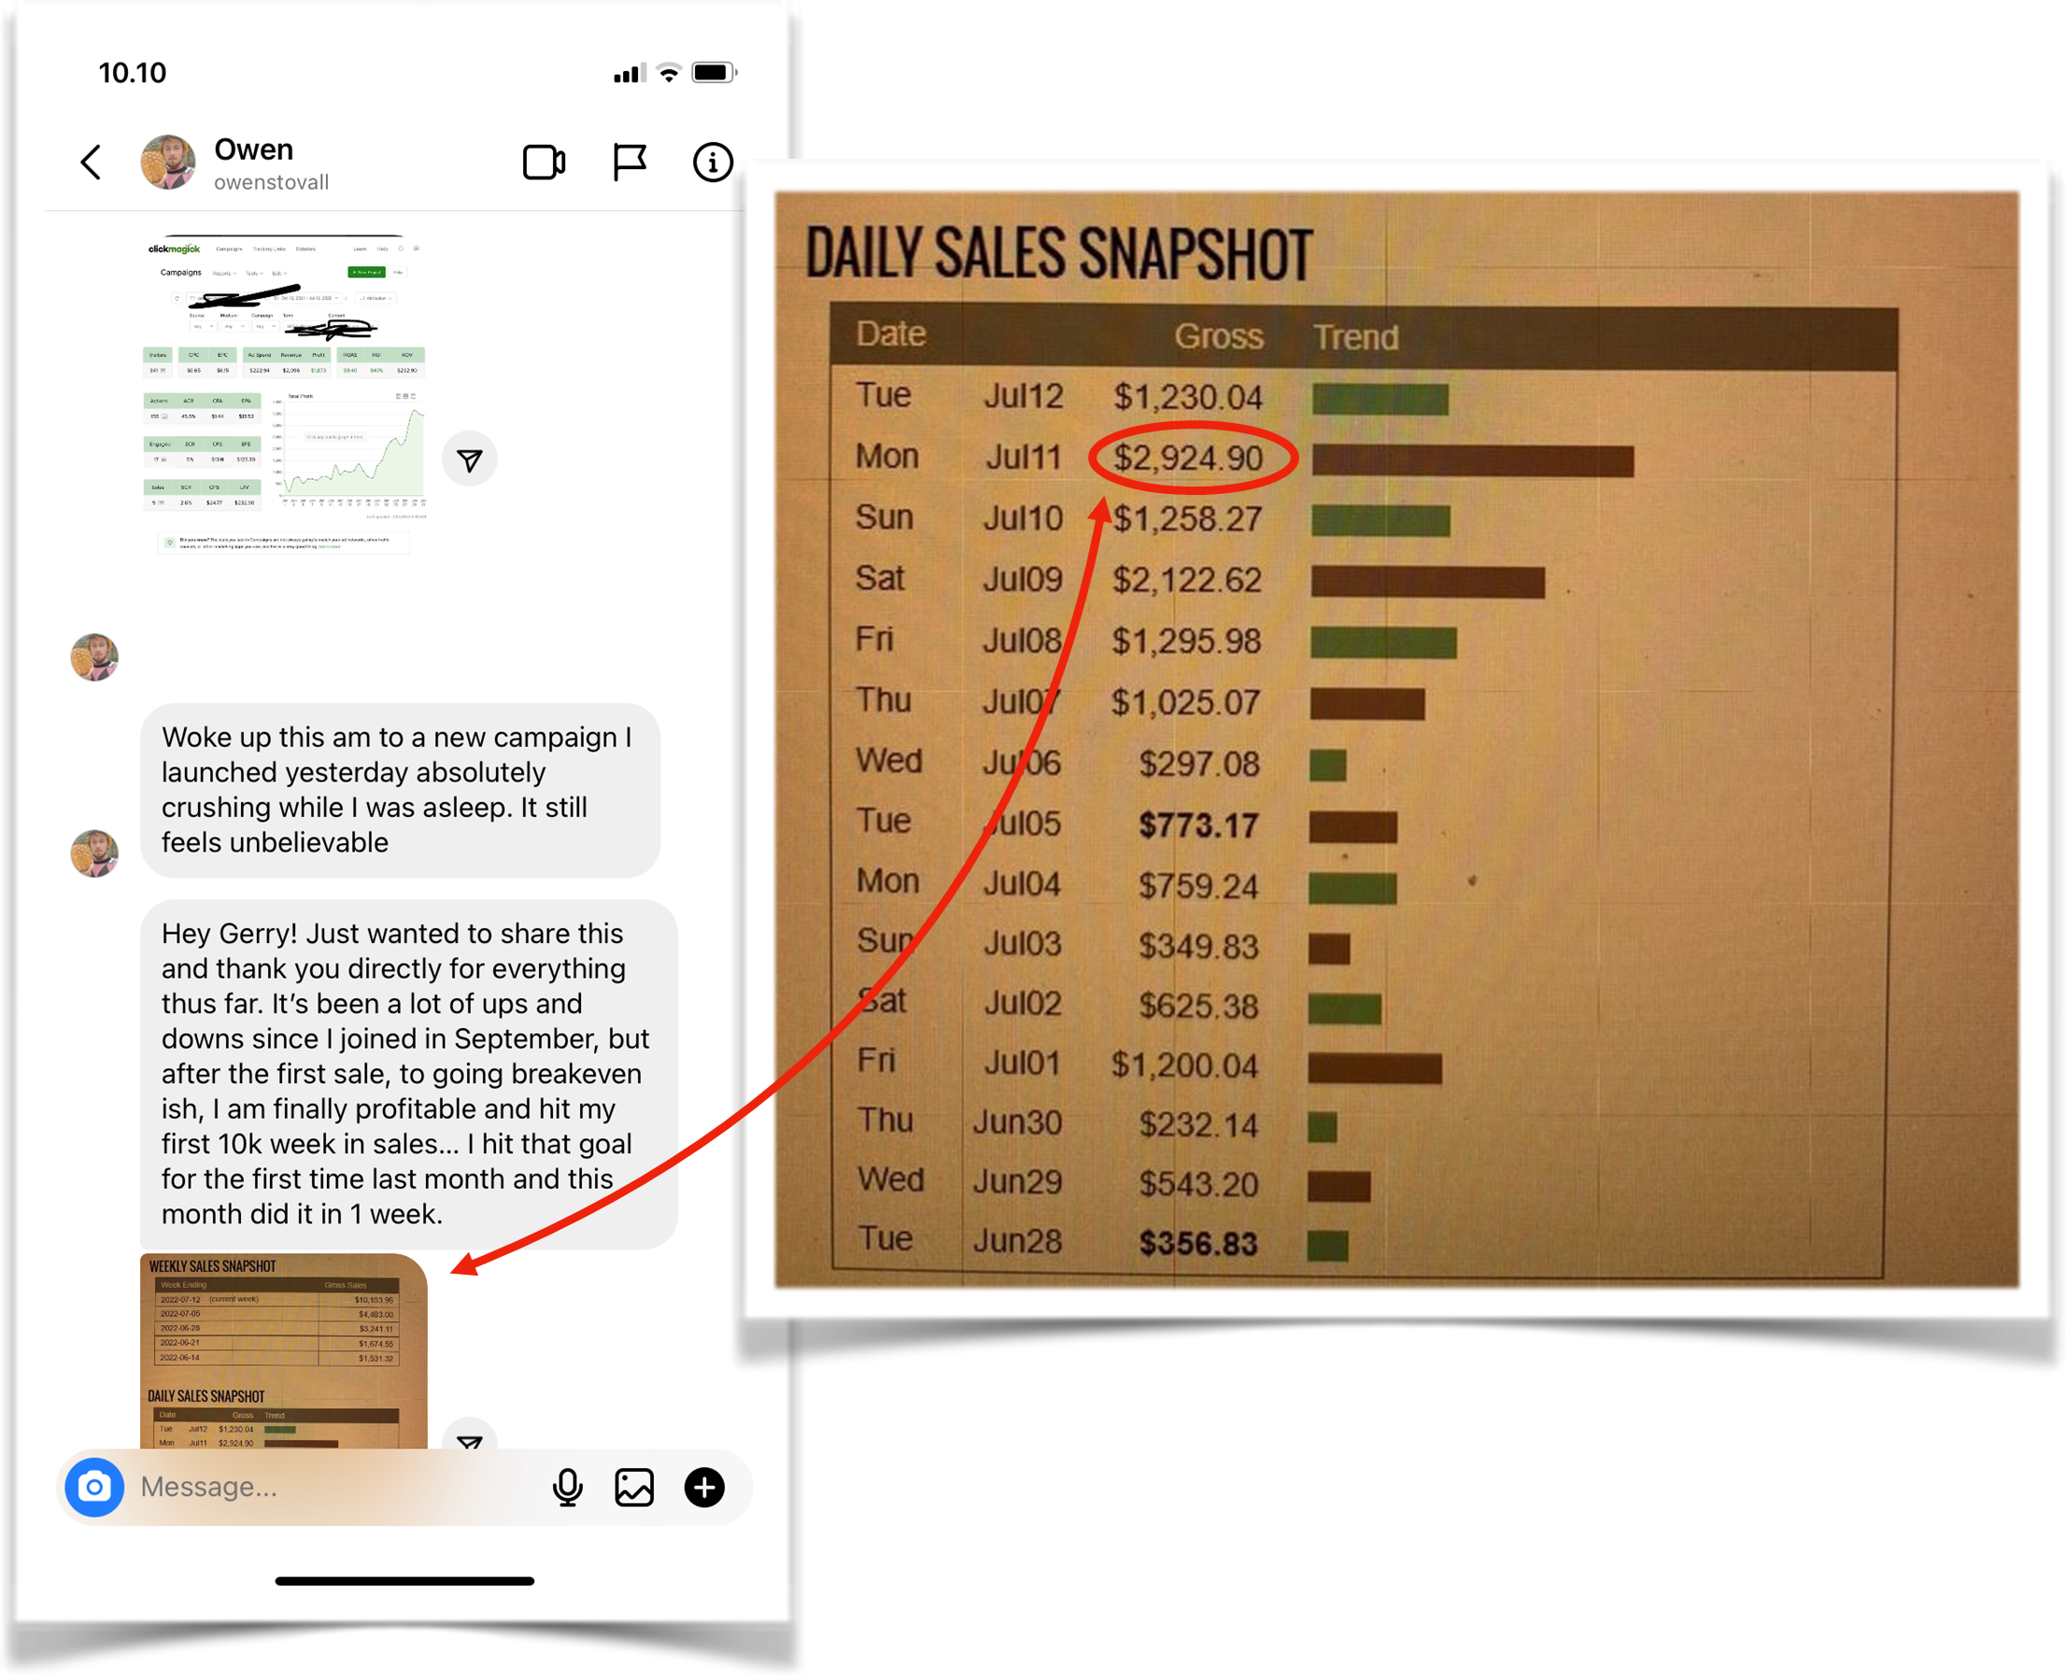
$2,924 Best Day on July 11th & first $10k Week

Five weeks later, I hit my first $9k Day & $42k Week

MY BEST ADVICE

It’s straightforward and simple to load ads
With a small budget, allow the A.I. to do its thing. Trust the Algorithm!
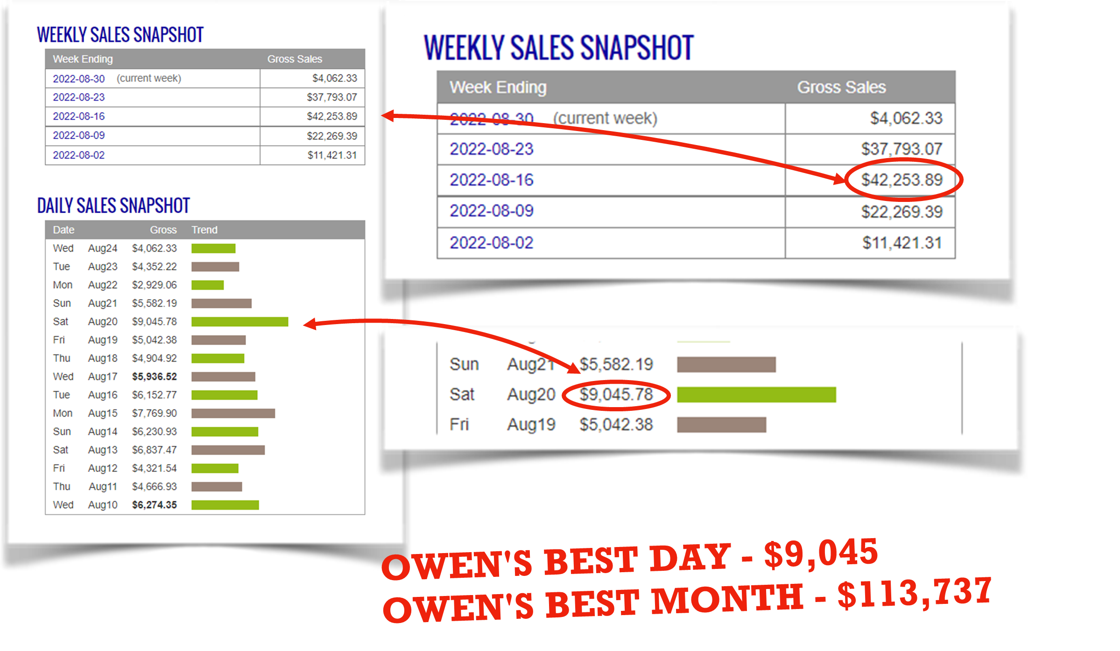
Don’t play around too much and be patient for 5-7 days and let it run so you can actually see who the buyers are and the demos who relate to your ad so you can focus on them.
Let the platform optimize the Ad rather than adjusting things too much.
The data is really powerful and learning how to read data is critical to success
Be swift. Shut off the campaigns sooner than later if things aren’t working.
Must have a “Never Give Up!!!” attitude.
Take action. You need to run a handful of offers to find a Winner.
If you work hard, an online business can be life changing.
As my high school tennis coach used to say, “Give yourself a shot to win”.

IMPORTANT
To learn more about this all new system our students are using right now to earn $1000's in daily profits, join one of our free live training workshops (details are at the link below):

https://goprofit.AI/FreeTraining

During the workshop you will learn about the entire business model and discover how you can deploy it into your own business immediately. We will also be taking your live questions on the call.

Thanks for reading,

Keegan Mueller, Rob Jones,
Gerry Cramer & Chris Reader

