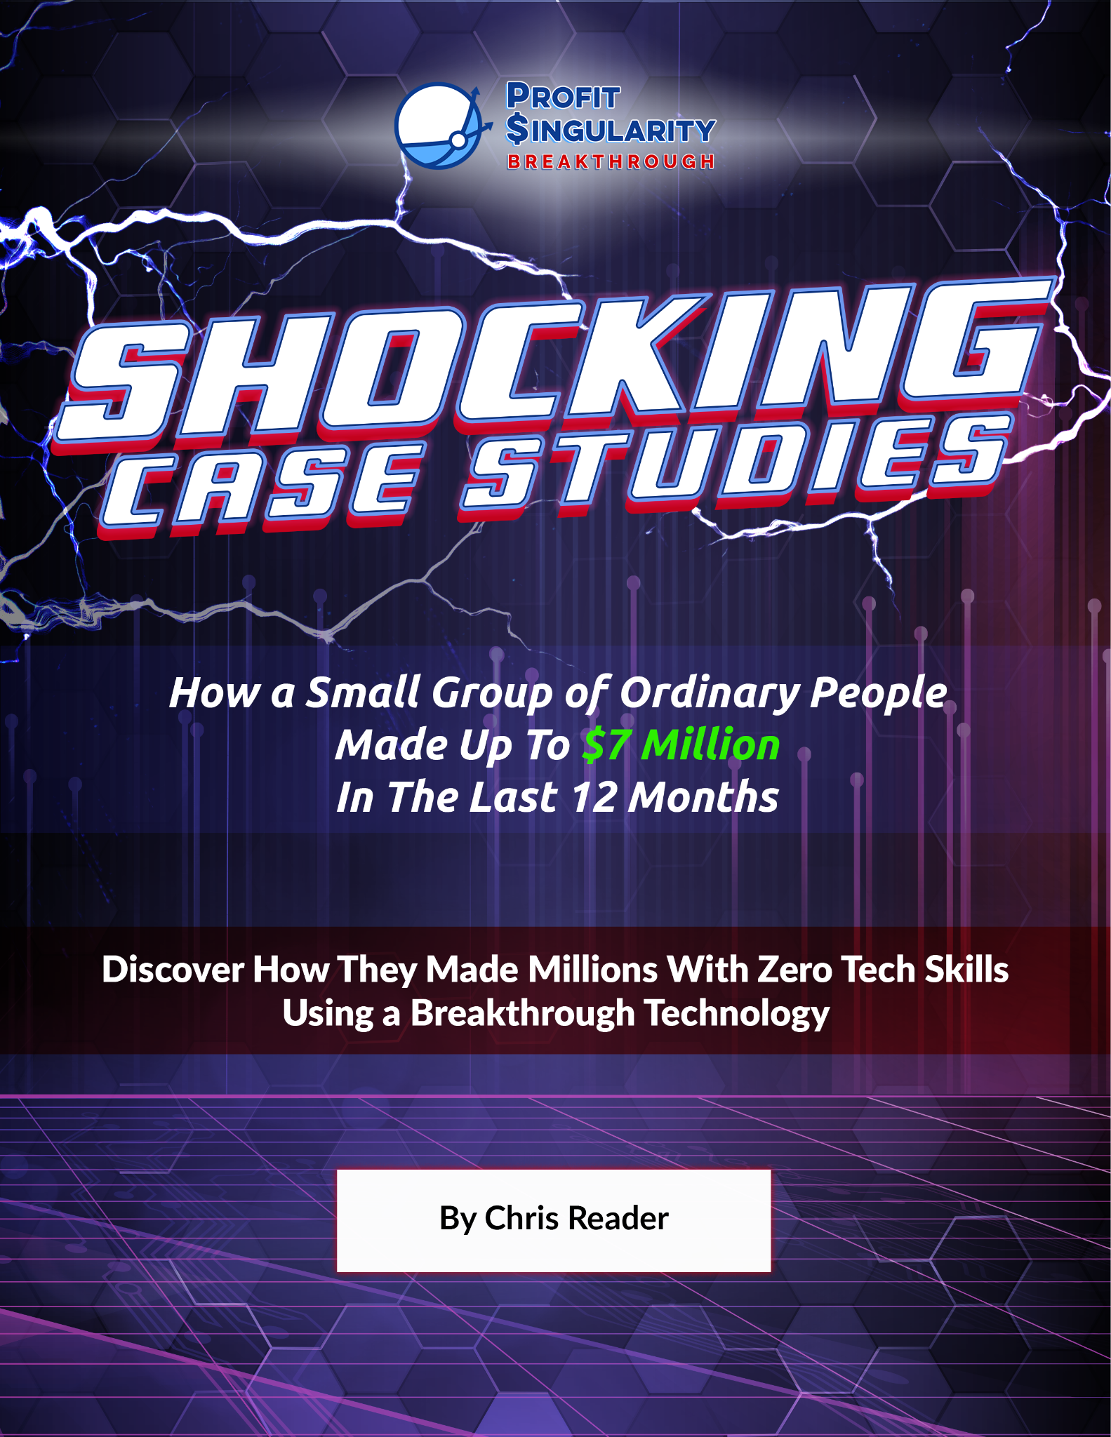

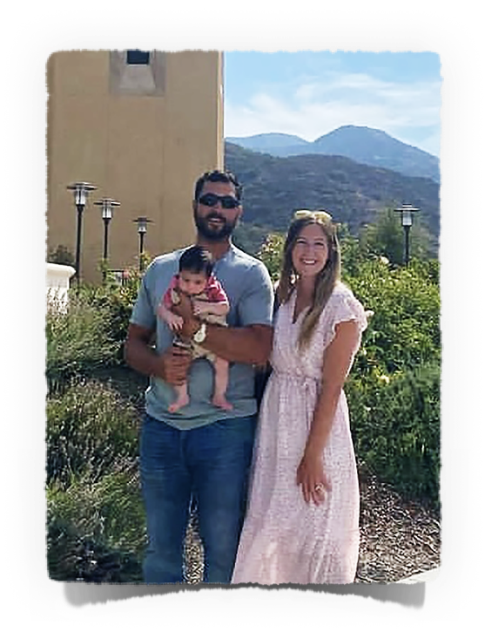
MADE OVER $6.3M IN FIVE MONTHS!!!
ANTHONY N.
CASE STUDY #1
Background
I’m Anthony from Newport Beach, California and live about 5 minutes from the beach. I’m in my mid-30’s and am married with a newborn daughter.

I had a pretty normal upbringing working in restaurants and at a grocery store named Trader Joes. Eventually, I thought I’d have a career in hotel management so I went to work for Marriott Hotels.

I refer to this as my getting a “regular job” period. I was content, but not really satisfied. It paid more than waiting tables, but it felt corporate and stuffy wearing a suit all day.

I saw the management guys in their 40’s and 50’s who started when they were young like me and I didn’t like where the future was headed for me. My soul was telling me I couldn’t work at a hotel for the next 30 years, but I didn’t know what else to do at that point.

One day a friend of mine showed me a way to make money online. At first I didn’t believe him, but then he showed me his bank account and I saw he was making $6k a month, every single month and that got me to think that maybe there was something to this.

He told him about Profit Singularity’s model and showed me their style of ads. It was like a bolt of lightning because I KNEW I could do this and someone had already cracked the code.

All I had to do was learn it and put it into action which you can see it worked out well for me.
His Results
I was optimistic that if I found that ONE WINNING VIDEO AD that it would take me to where I wanted to go. I never dreamed I would be at this level in less than a year running ads.

With 1 Ad, 1 Video, and 1 Offer I’ve made over $6.3m in Commissions in 5 Months and $2.5m in Profit! And it all came from testing a few scripts for a month and then letting it run to the moon.

Don’t get me wrong, there’s work involved in the beginning because you have to find the right product, make a good script and video, and make sure it works.

But once you have it all dialed in, Google does the rest. I kid you not, the last 3 months of my winner I spent most of my days at the beach with my family checking my stats on my phone to make sure it was all going well and then back to making sandcastles.

This model makes money every week of the month, but I only have to spend one week’s worth of ad spend over and over to generate four weeks of Profits!

The one thing I value the most is the freedom to do what I want to do and running ads gives me that.

In 5 Months I Generated $6,339,714.
At that level, that’s 3,665,322 VIEWS & 42,465 SALES
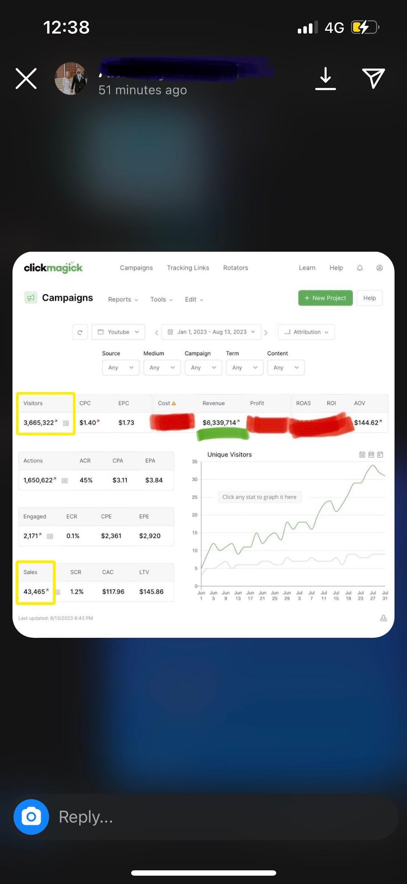

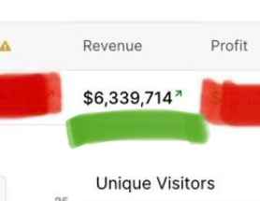

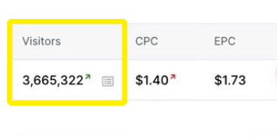

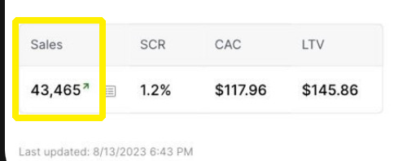


He’s a first time CLICKBANK DIAMOND AWARD winner which means he generated $5m in a single year.
ANTHONY’S FIRST 5 MONTHS OF SALES - $6,339,714

My Best Advice

“Do what is taught in the course and NOTHING ELSE!”

The biggest difference for my (or anyone else’s) breakthrough is having the CONFIDENCE to KNOW it’s going to work. It’s just a matter of giving myself time to find the winner.

MINDSET and having a POSITIVE ATTITUDE are super important. You can learn something new with each ad so don’t be afraid something won’t work.

Talk to your account manager because there might be an offer crawling its way to the top which is a much bigger profit opportunity than when it’s already at the top and everyone else is starting to run it.

Writing the scripts with a good angle is really important.
But I promise if you put your faith in this method and keep moving forward, it’s only a matter of time before you start seeing results.

Remember when you start this and have a bad day to remind yourself what the great Jim Rohn once said, “Profits are worth more than wages.”

When you’re learning from a 5 Consecutive Year SUPER AFFILIATE and follow his training exactly, I don’t know how you DON’T win if you keep going!
IMPORTANT
To learn more about this all new system our students are using right now to earn $1000's in daily profits, join one of our free live training workshops (details are at the link below) :

https://goprofit.AI/FreeTraining

During the workshop you will learn about the entire business model and discover how you can deploy it into your own business immediately. We will also be taking your live questions on the call

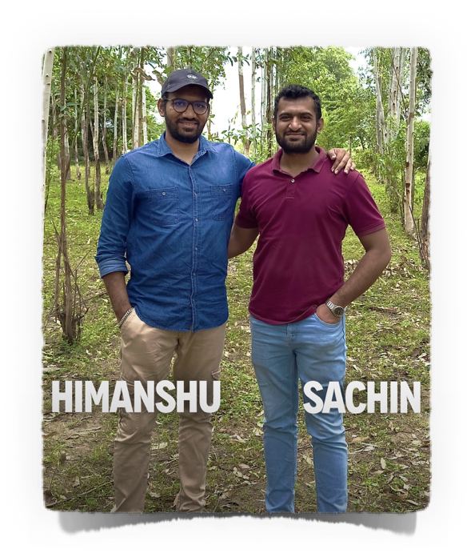
MADE $520K IN FIVE MONTHS and RETIRED HIS PARENTS!!!
HIMANSHU PATEL
CASE STUDY #2
Background
Hello, I’m Himanshu from a small village in India. I grew up in a family of farmers. I always wanted more than the life of farming like generations of men in his family and dreamed of financial and time freedom which no man in his family ever acquired.

At an early age, I focused on reading as many marketing and self-development books as I could find to change the way I thought about business and the skills required to be an entrepreneur one day.

My parents wanted more for me and made a great financial sacrifice and sold all of their jewelry to send me to University for a degree in IT and computer science because they didn’t have any money saved. It was a huge risk, but they wanted more for my brother and I which made me more determined that I would not quit until I succeeded since my family risked their future.

I didn’t want to work for a corporation for the next 30 years so I started an IT business as an App developer, but struggled because I had no cash flow and only lost money so I was forced to close it which was emotionally scarred because I let my family down.

I taught myself how to promote products on Instagram posts. It took me 6 months of my parents asking me every night at dinner, “Did you get a sale today?” But finally, I received a message that I made my first $25 sale. It felt like a million dollars after trying so hard to see if I could make money online.

I did make some money over the next year, but I realized it would take too long to build it up into a real, sustainable business.

I came across a presentation for Google and YouTube ads and the ability to create a great ad and increase the budget to make money I could only dream about. Afterwards, I felt that I could make it work.

At first I struggled. Not so much with understanding and applying the material, but my impatience with waiting for Google to take my ad and find the right buyers. I decided to invite my brother Sachin to join me. I knew his patient and methodical approach to engineering would be better suited to buying media for my ads.

English is my 3rd language so I needed to write scripts that sounded Native English. We discovered that was quite easy once we found the right online tools and software so no one would know.

Another motivation for me to have money and freedom is that it would allow me to achieve my other great passion…To have impact on others’ lives which is very satisfying for me.

To this day…I can proudly say I’ve NEVER had a salaried job in my life and plan to keep it that way!
His Results
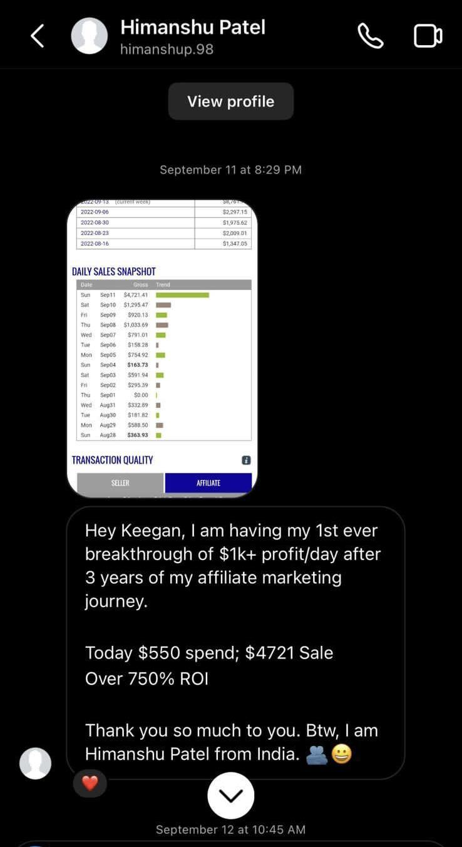

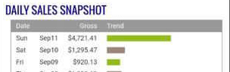

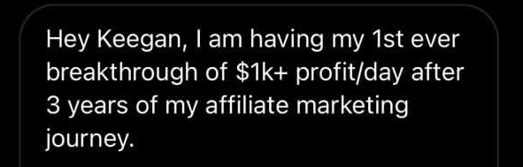

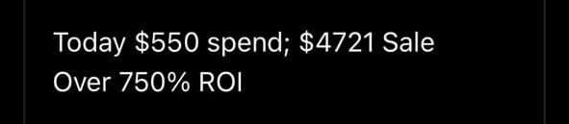


Early on, he spent $550 to sell $4,721 for a $4,500 Profit = 750% ROI.

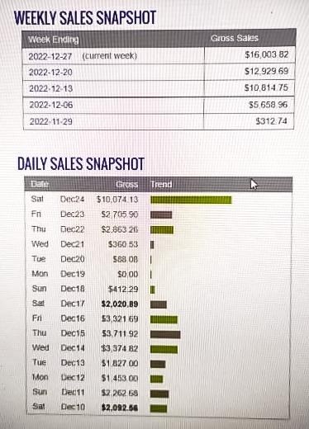

Only a few months later, he achieved his Highest Day of $10k

By the first 2 months of 2023, he earned $300k on his first winning ad (which was only the 2nd offer he tried) and

Total Sales of $520k between (both of his Clickbank accounts) over the first 5 months of 2023 (see next 2 pages):

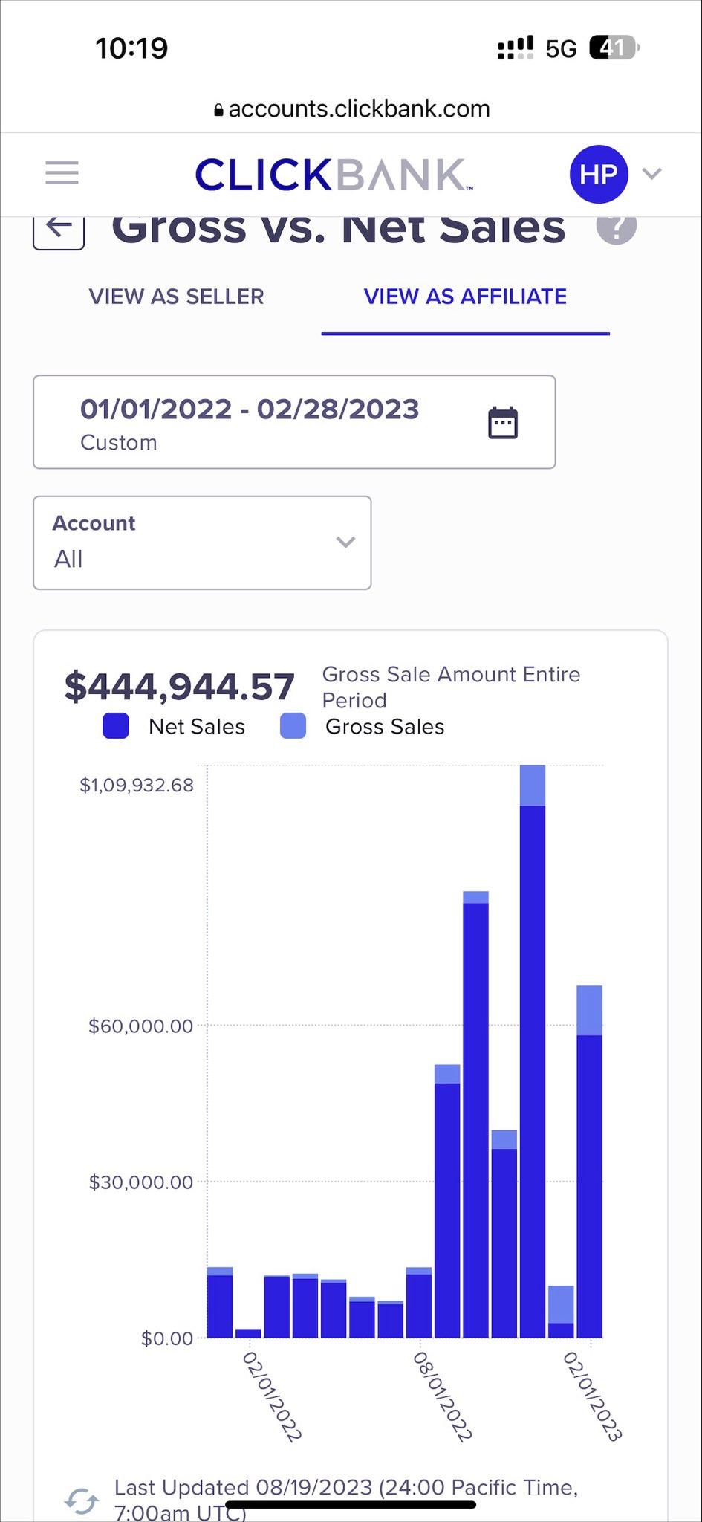

$445k Total Sales in Account 1

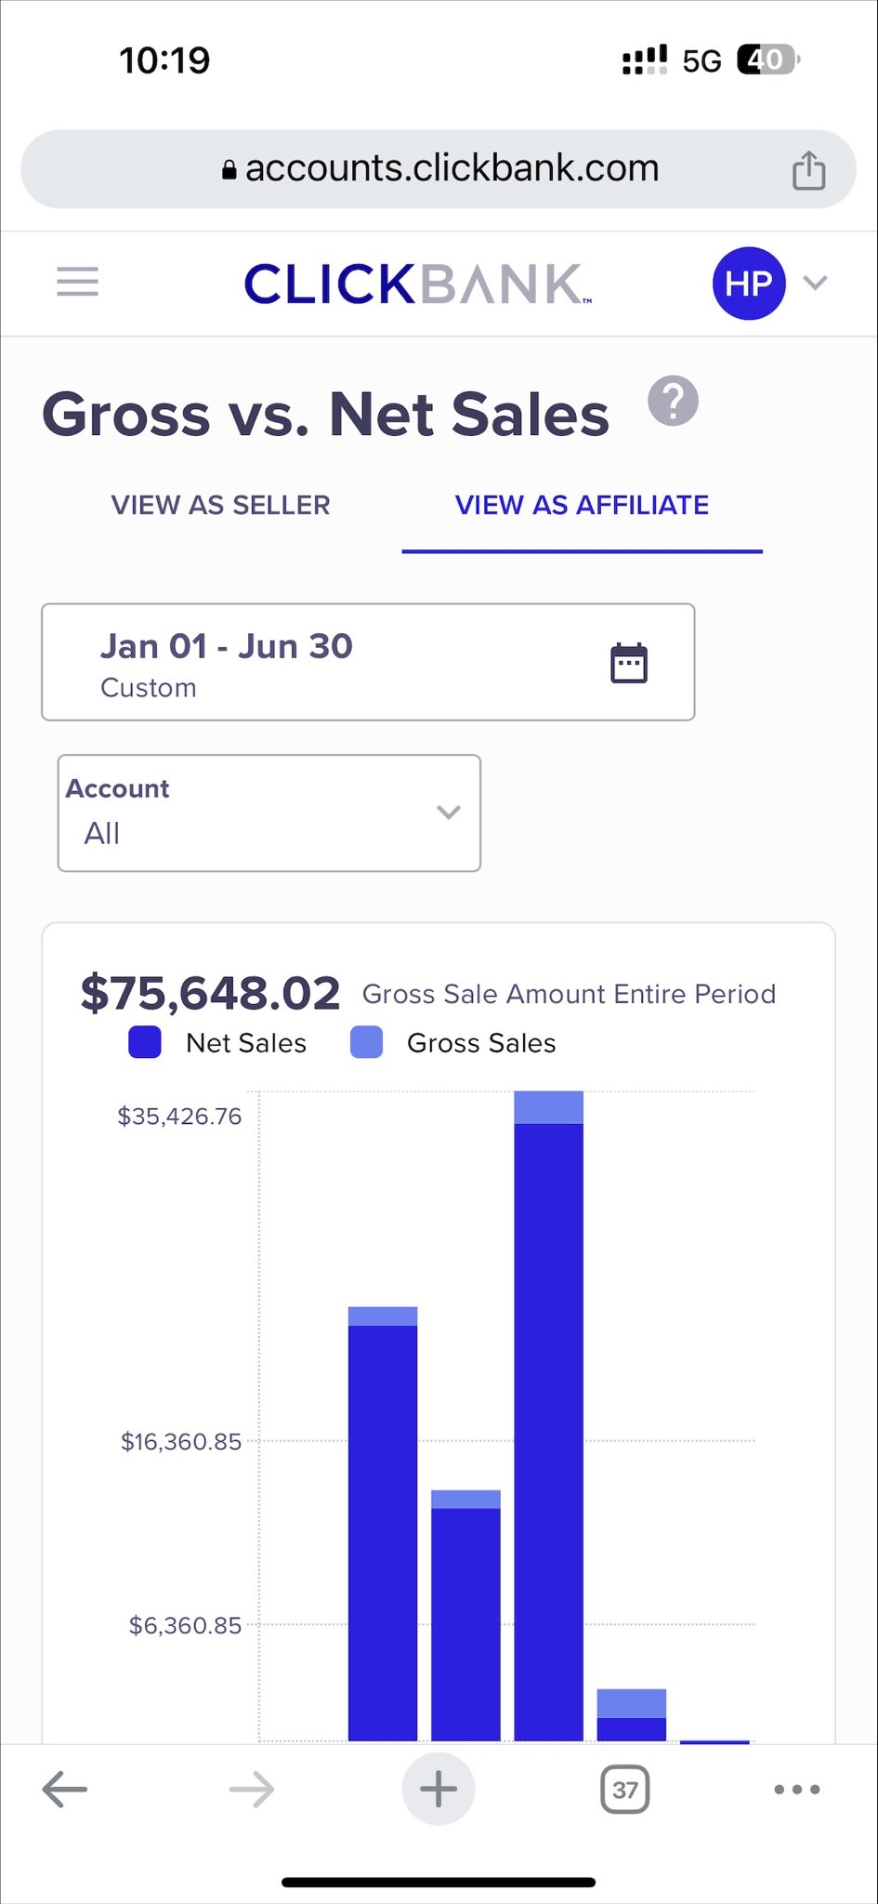

$75k Total Sales in Account 2

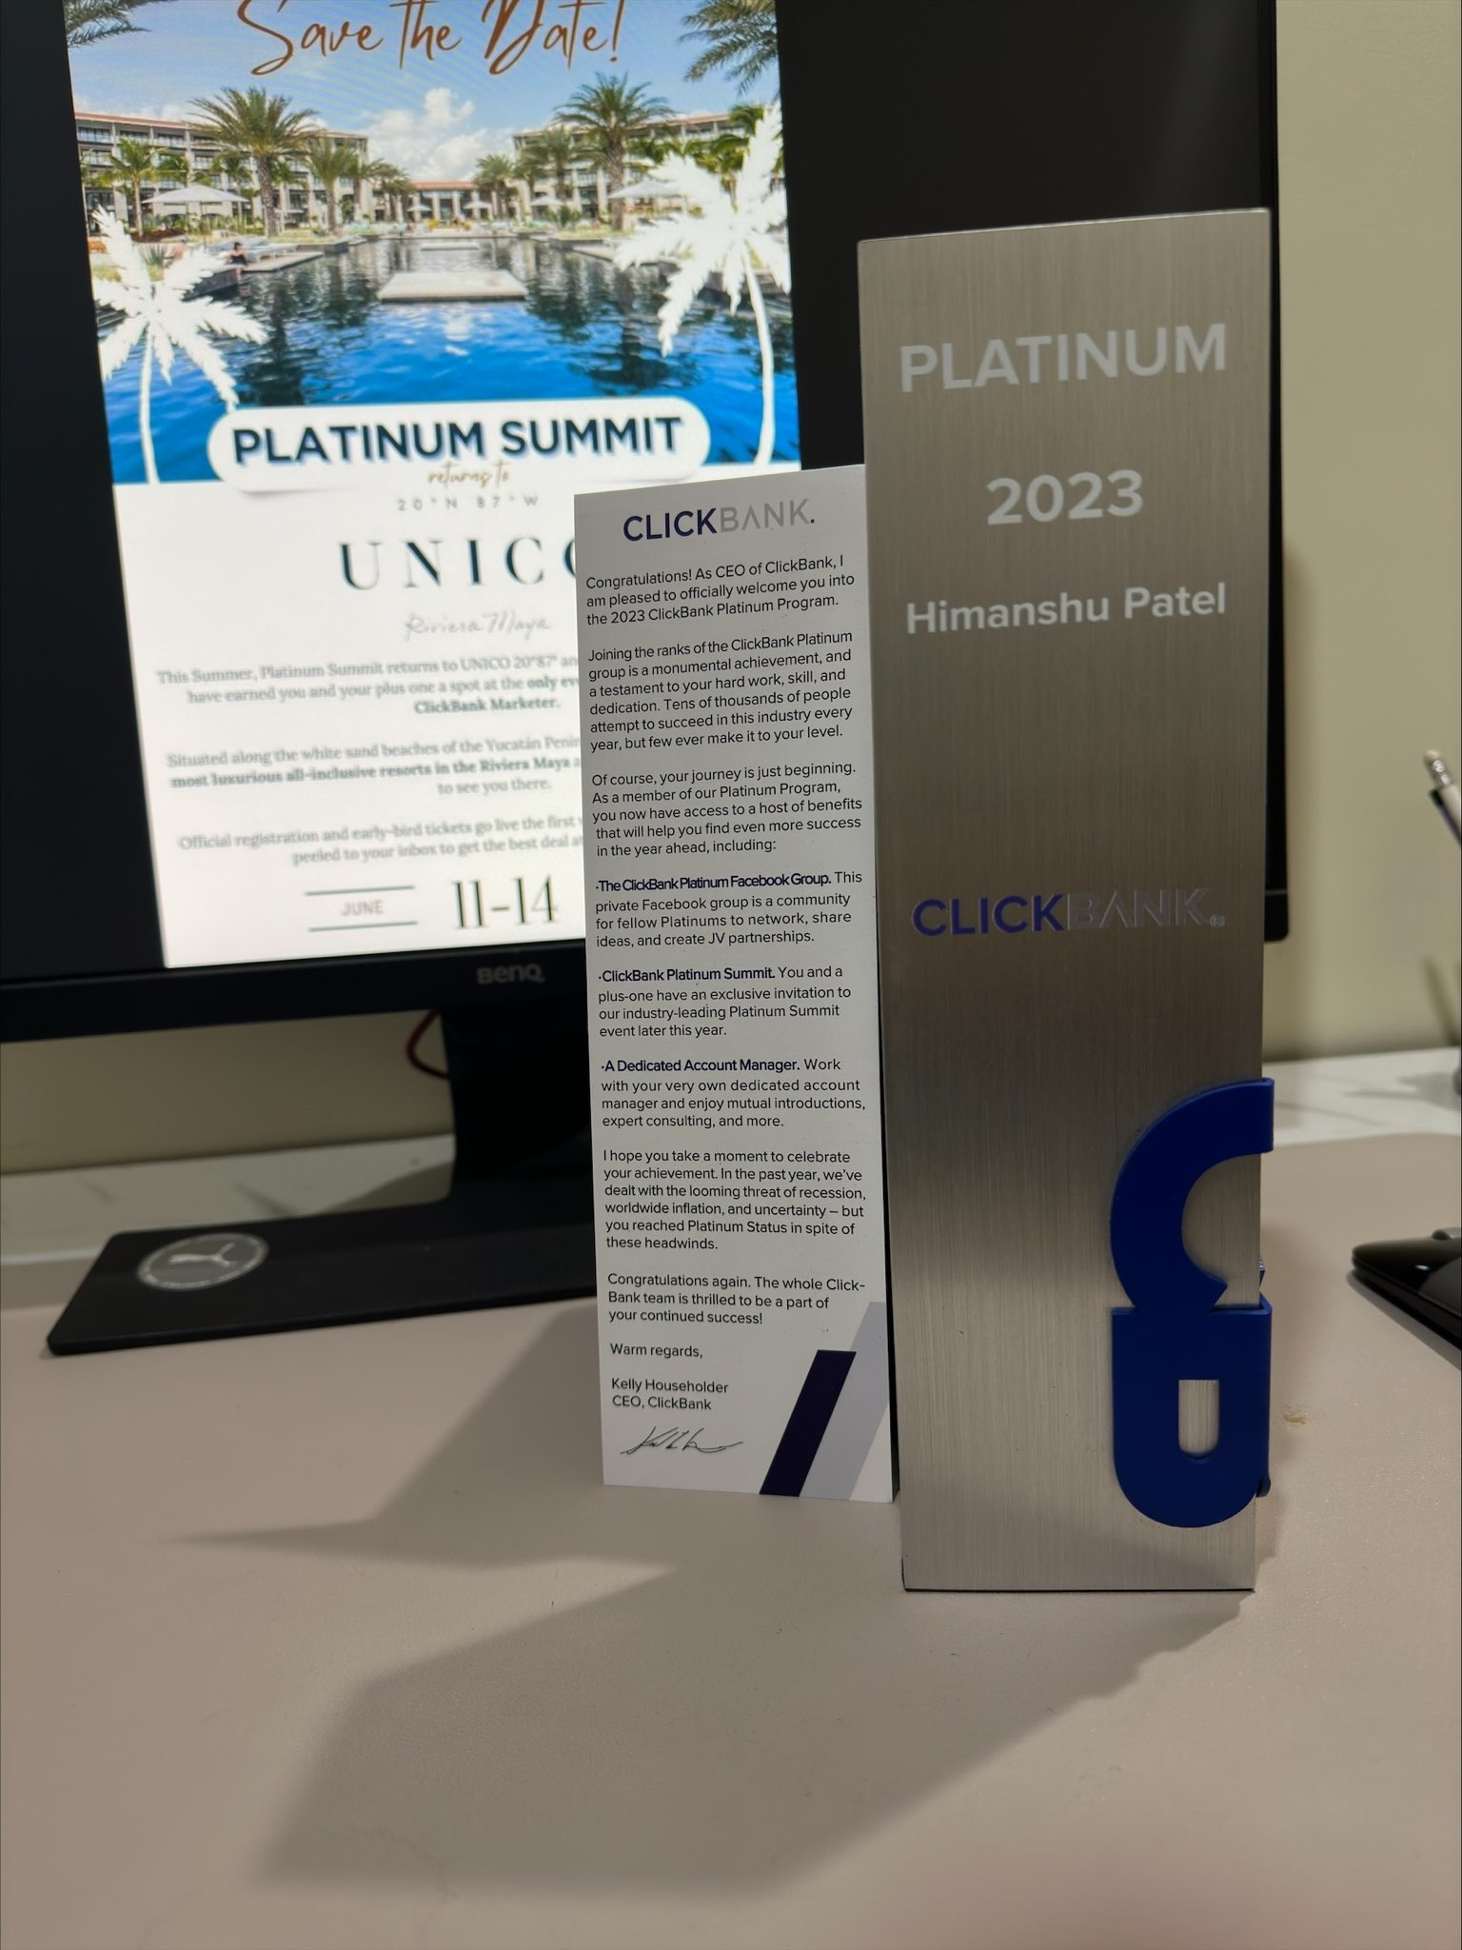

He also proudly Achieved Clickbank Platinum award within 90 days of finding his winner.

Their father made $3k a year so they made 100 years of his salary with 1 ad ($300k) within 90 days and 148 years ($444k) in 5 months.

In less than a year of watching our presentation last year, they were able to pay off their parent’s mortgage, buy back their mother’s jewelry, refund the initial money to join our course, and officially retire their father for LIFE!

“It came much quicker than I thought!”

“Now I have the confidence and skills to make money any day I want which feels as good as the money in the bank.”

I gave myself GOALS to achieve each day and then went back to write the date I completed them. Here are my 2 FAVORITE achievements:

Make $10k in a Week (Completed)
Pay off his Parent’s mortgage to make them debt free
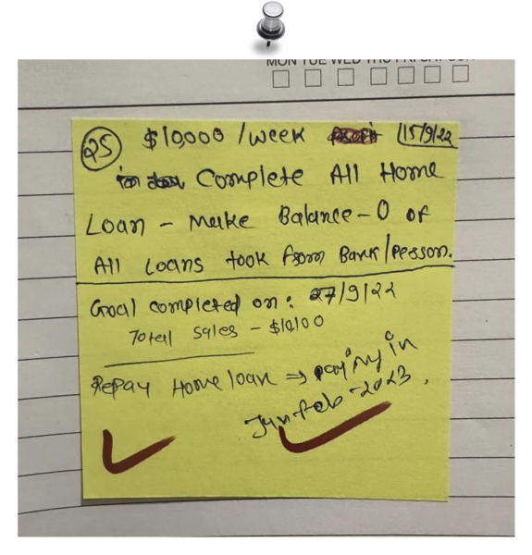

Make $3k Profit (Completed)
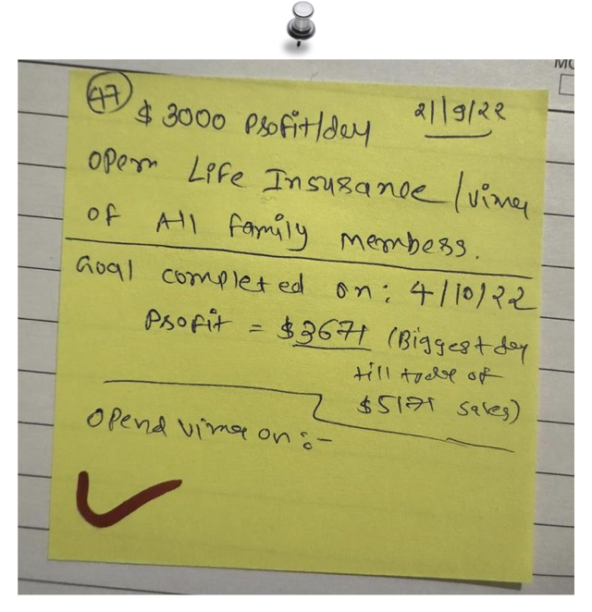
and Get Life Insurance for ALL of His Family Members

HIMANSHU'S BEST DAY - $20,075
HIMANSHU'S BEST MONTH - $113,264
HIMANSHU'S FIRST 5 MONTH IN 2023 - $520,592

Learn and perform one thing at a time otherwise you can confuse yourself in the beginning.
My Best Advice
Write down daily milestones to achieve and come back when you achieve it. Have something to look at every day while working to keep you motivated. I found that achievements started happening much faster once I found my winning ad.

All the resources, tools, and templates you provided in the course was everything I needed. I just had to do the work and launch my ads and make minor improvements each time until I found my winner.

Google is the easiest ad platform to learn and use. It’s so much better than Facebook. I didn’t need to learn all the complicated targeting, but Google does all of that for you. Making changes little bits at a time and allowing Google to do its thing works best.

I learned from my Organic Instagram days that patience and a positive mindset are critical to success. You must keep trying every day even if you don’t see an immediate result. It’s only a matter of time if you keep working at it.

Once you find your winner, it’s easy to go from $1k to $5k to $10k per day in a week or two. As someone who could only afford a $40 per day budget, I wouldn’t have imagined I would be saying this esp so quickly after starting the program.

I KNEW this method would work once I put in the effort.

“Everyone can achieve these types of results, or even better results, with the Profit Singularity course.”
IMPORTANT
To learn more about this all new system our students are using right now to earn $1000's in daily profits, join one of our free live training workshops (details are at the link below) :

https://goprofit.AI/FreeTraining

During the workshop you will learn about the entire business model and discover how you can deploy it into your own business immediately. We will also be taking your live questions on the call

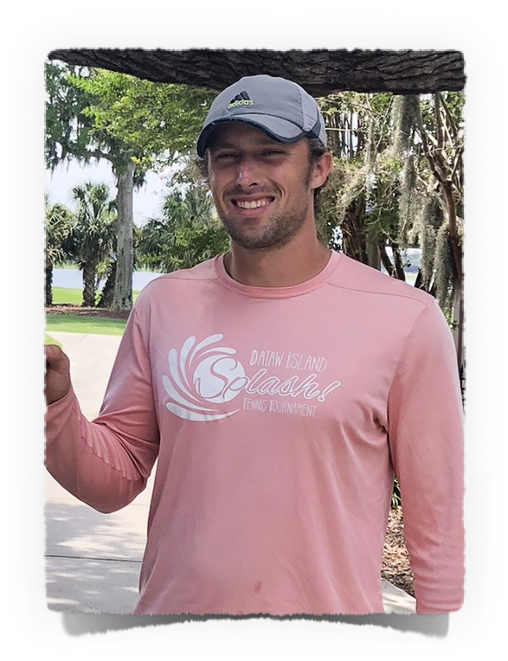
OWEN STOVALL
CASE STUDY #3

MADE $3.3M IN 2023 and is ALMOST FINISHING PAYING OFF HIS MOTHER’S MORTGAGE!

Background
I’m Owen from Beuford, SC. I’ve been playing competitive tennis since I was a kid and still love it as much today.

I was raised by a single mother and it wasn’t easy for us growing up. Since I was a teenager, I felt like the man of the house and believed it was my responsibility to financially contribute to his mom’s monthly bills to help make things easier for her.

I had to move back home after college in 2020 because I didn’t get the job offer I studied for in the Finance Industry. Being super competitive, I felt like I failed since all of my buddies from college got their dream banking job that would pay them $120,000 in the first year and for a 21 year old, that felt like all the money in the world.

I let myself down and felt like I let my mom down though she never showed it. I pretty much thought my future was screwed at that point.

Being unemployed was rough at first. I got my old job back teaching tennis to kids and adults. I always felt better outside on the court and it was a way to get away from my feelings of mild depression not knowing what to do with my life.

So I had to figure out how to make money on my own and eventually found this course.

I knew I wanted to stop my family’s history and cycle of only making money to survive rather than “Living a full life on MY terms.”

After a pity party one day, I remember my tennis coach when I was 16 said to Me, “It looks like you don’t want to win. Give yourself a shot to win” which changed my outlook and beliefs about my abilities and the future.

I took that belief and applied it to this course and as you can see…the rest is history.
In July 2022, he hit his first $1k to $3k Days by 7/11.
His Results
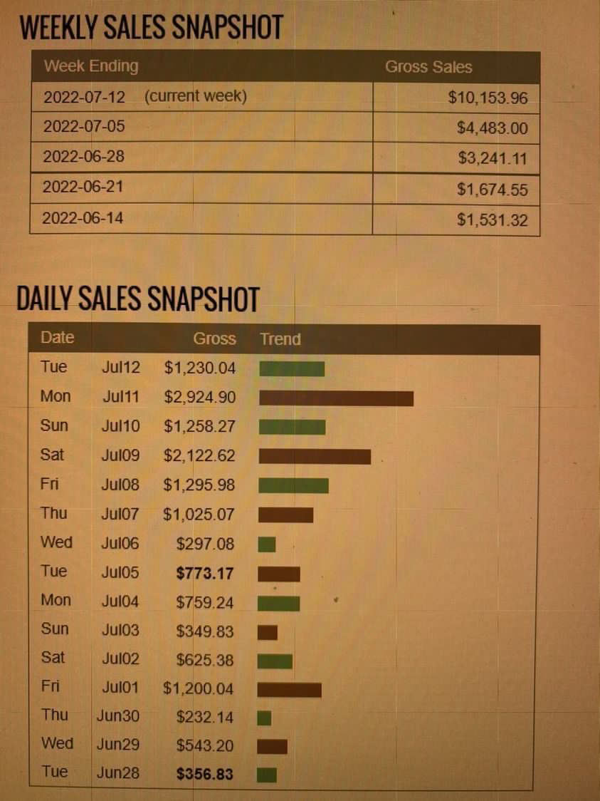

Then a few weeks later on Aug 20, 2022, he had his first $9k Day.

His first HUGE breakout was when he hit $56k profit from $162k in Sales in January 2023 alone, plus he started hitting his first $10k Day.

“It’s pretty crazy how fast things can change with one ad.”
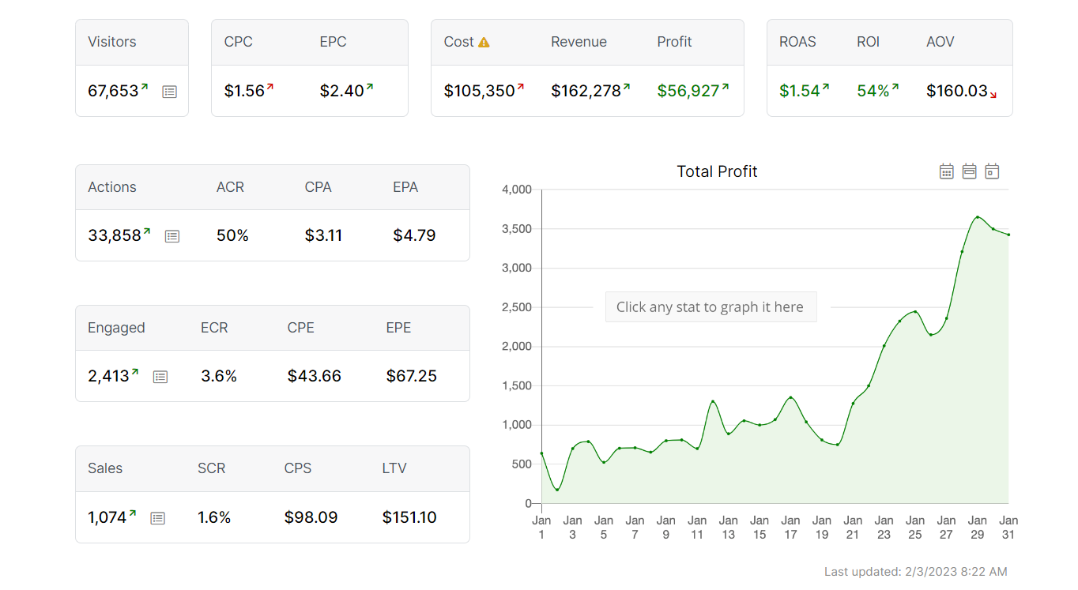

By Feb 2023, he was consistently hitting $21k-$45k days and did a $214k Week at the end of Feb.

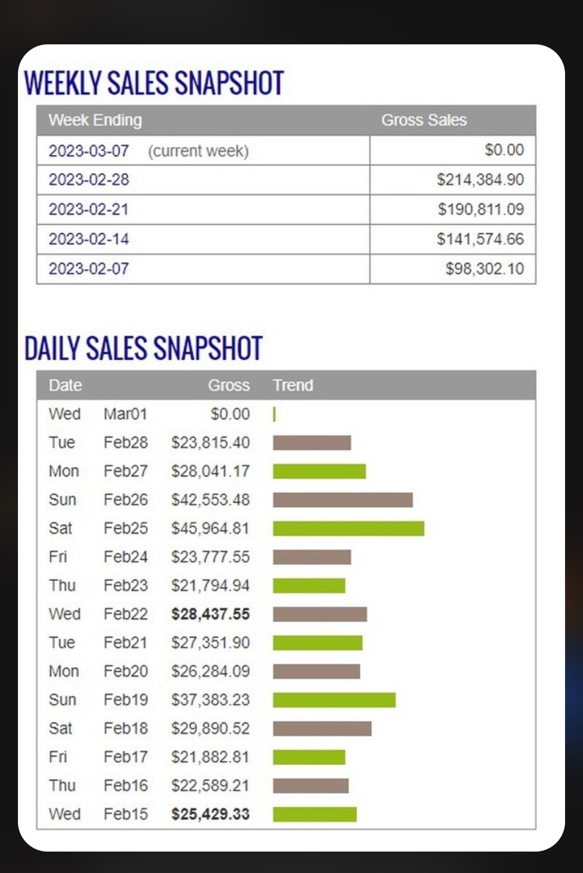

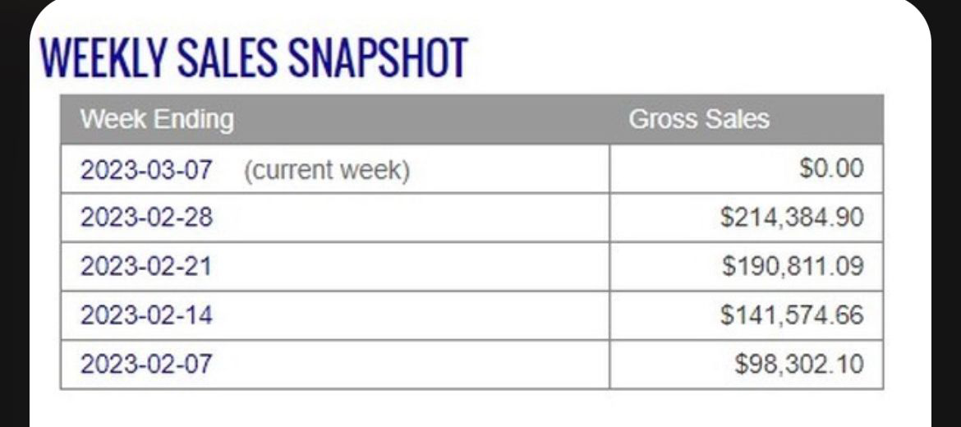


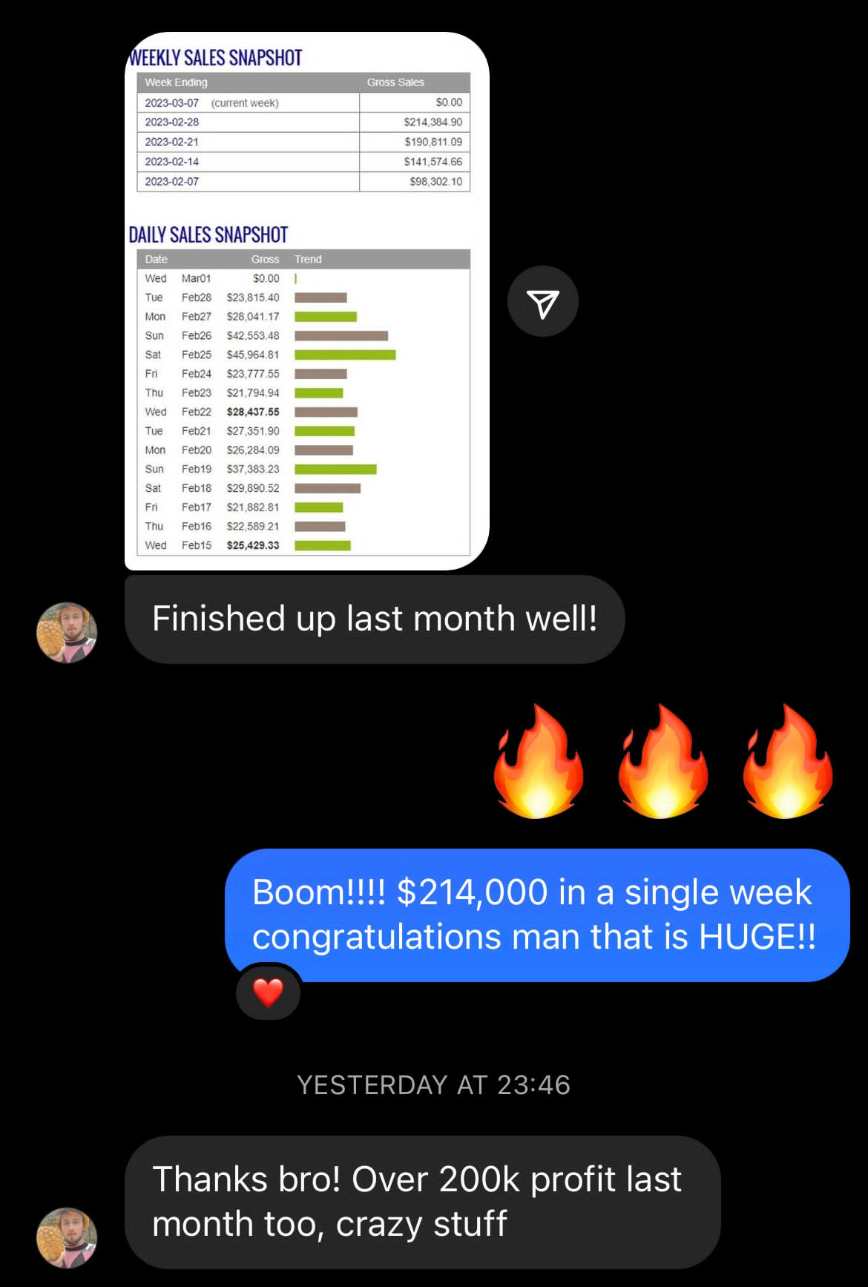

And $200k PROFIT in Feb:

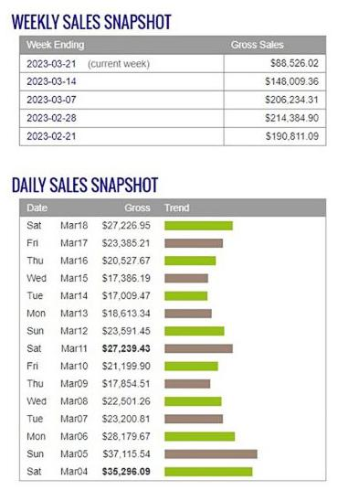

Again in March 2023, he continued his $17k-$37k consistent days.

$46k | Best Day (Feb 25, 2023)
$214k | Best Week (= $653k Month)
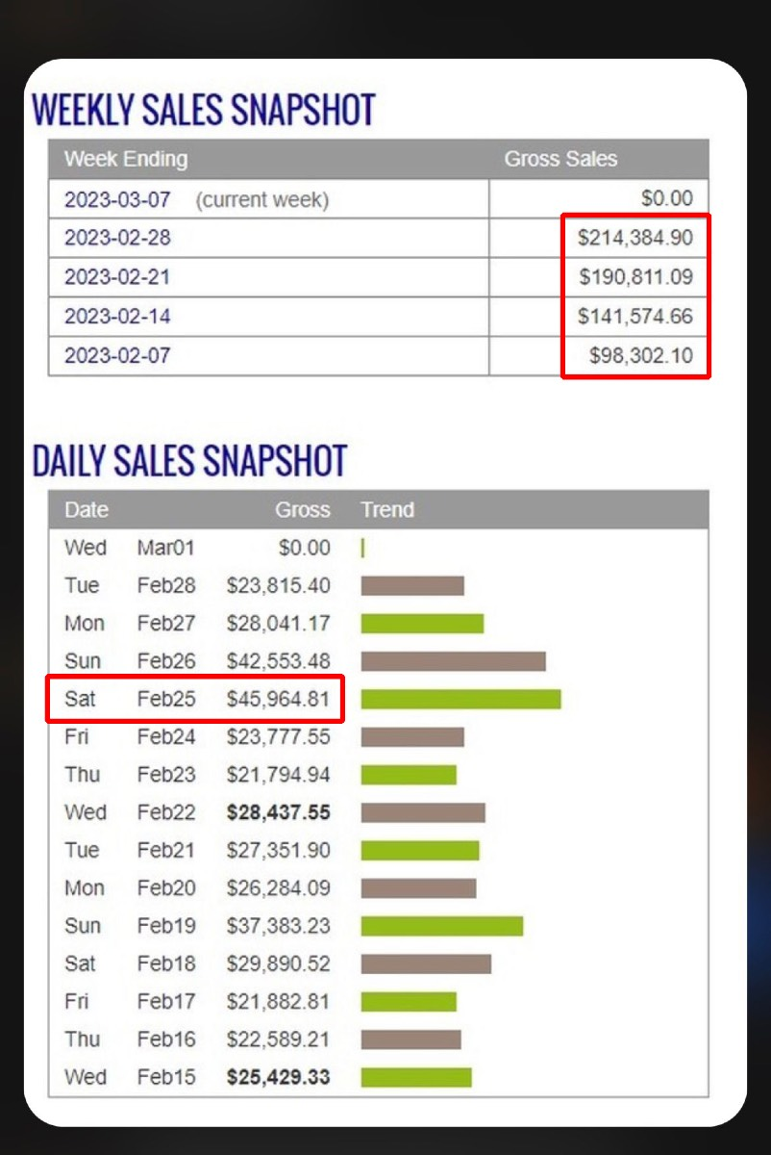


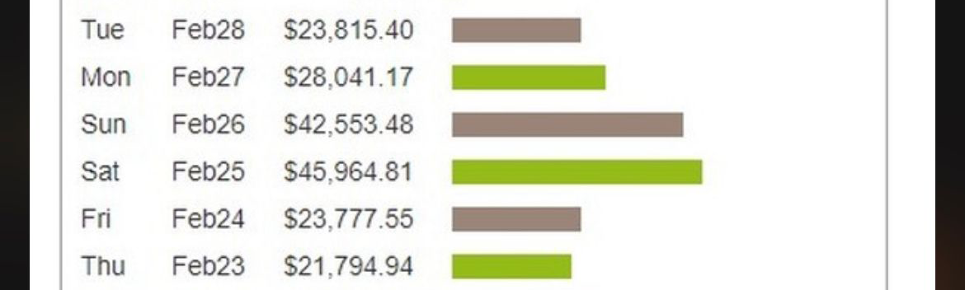

$960,863 | Total revenue (Sept-Dec 21, 2022)

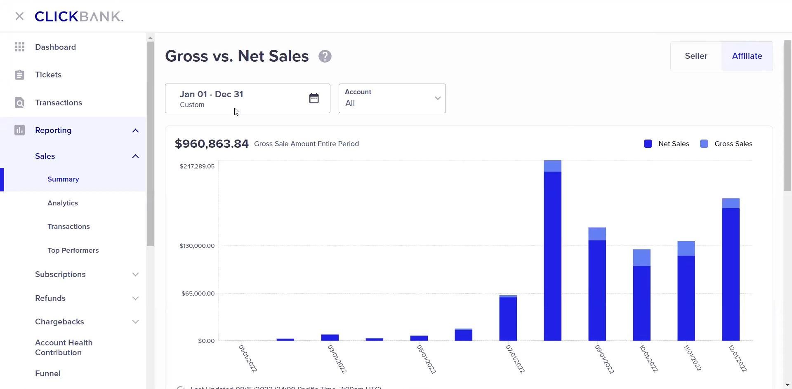


$3,340,920 | Total Revenue (Jan-Aug 15, 2023)
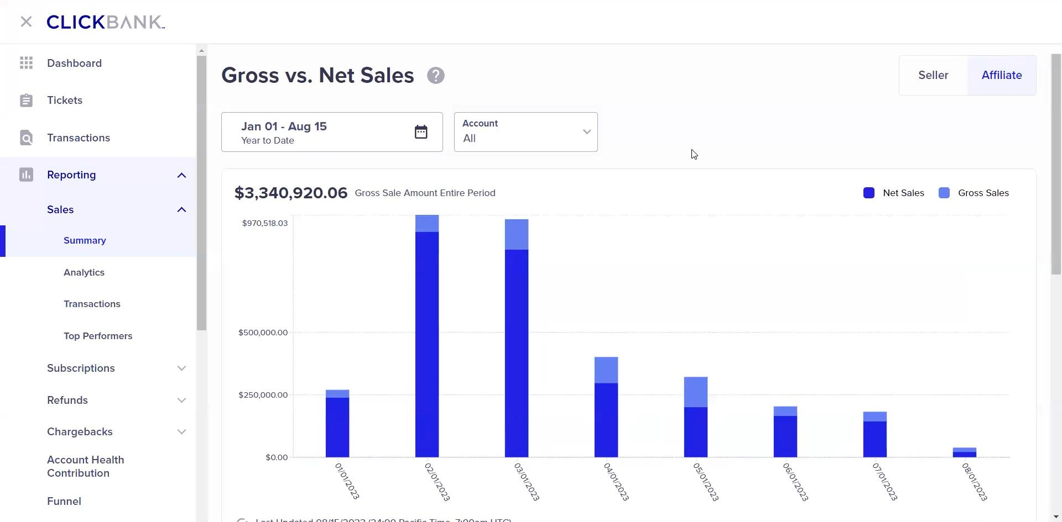
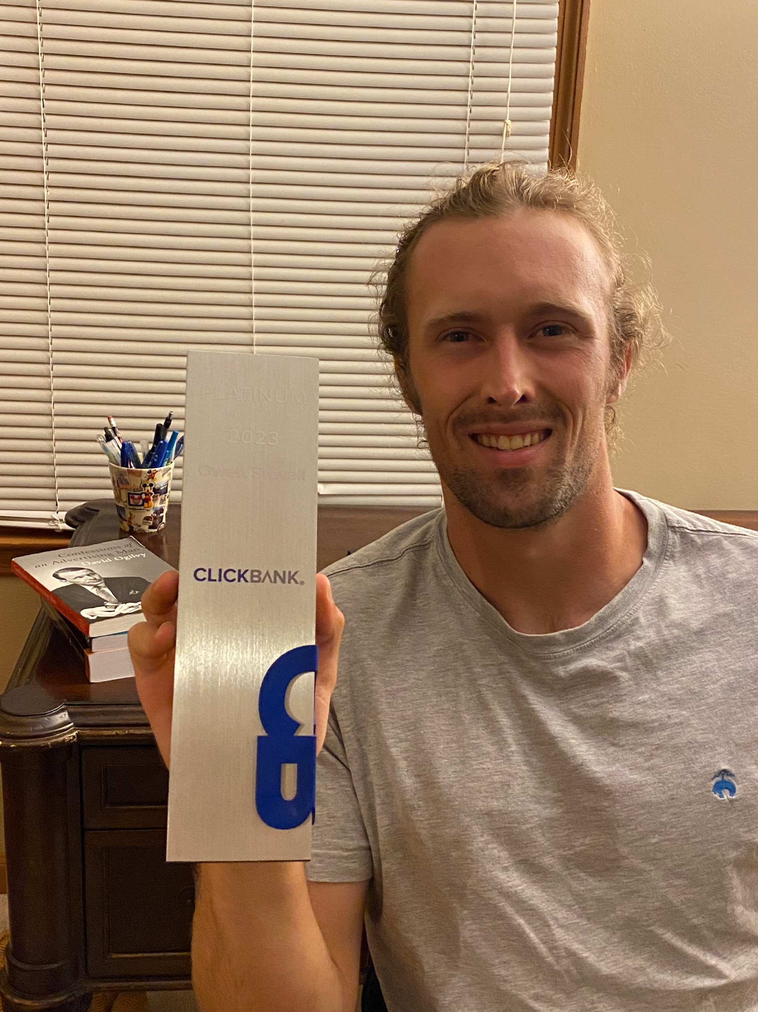

Generated almost $1m in back-to-back months (Feb & Mar) Clickbank Platinum Award

He stuck with it, and only a few months later after seeing slow and steady increases…one day it EXPLODED for him and he’s been on that path ever since.

Only a year later from when he felt like his future was over ... .Now his friends who are working at their tech and banking jobs at big companies making $120k/year and working 80-120 hour weeks are JEALOUS of the path Owen is on.

They see the kind of money and freedom lifestyle Owen is living and now they feel STUCK ON THEIR CAREER PATHS and feel chained to their desks.

Best of all, he’s almost finished paying off his mom’s mortgage to take the huge financial burden off of her.

“People think a year is long, but it’s quite short in hindsight.” It’s going to take my banker friends at least 5 years to make what I did in my FIRST year of affiliate marketing.”
OWEN'S BEST DAY - $45,964
OWEN'S BEST WEEK - $214,384
OWEN'S 2022 REVENUE - $960,863
OWEN'S 2023 REVENUE - $3,340,920
Put in the first 100 hours, then you’ll be competent and confident. That may sound like a long time, but it’s the greatest ROI you’ll ever do for yourself.
My Best Advice

The SECRET to finding success with this model is to do it every day, learn something you didn’t know yesterday, have patience, and don’t make excuses why you can’t do something each day.

There’s no way around the reps. The real growth happens by DOING.

Focus and work hard on testing. Pay close attention and track all testing because that’s where the sales come from.

The Google platform is straightforward and simple to load ads. The data is really powerful and learning how to read data is critical to success.

Keep pushing yourself, “Keep your head up because it will get better. Just keep learning and push another 30 days to see what happens” because it can be far beyond your wildest dreams if you don’t QUIT”

FAILURES are stepping stones to SUCCESS and valuable to the process.

Bump the budget with a winner and the bigger money comes TRUE!

It’s the best feeling knowing you have a skill you can build upon, replicate, and use to build a life for the people you care about.

Now I can AFFORD to ask myself…what’s the type of lifestyle I choose to live b/c the money affords that rare opportunity? That wasn’t possible a year ago.
IMPORTANT
To learn more about this all new system our students are using right now to earn $1000's in daily profits, join one of our free live training workshops (details are at the link below) :

https://goprofit.AI/FreeTraining

During the workshop you will learn about the entire business model and discover how you can deploy it into your own business immediately. We will also be taking your live questions on the call
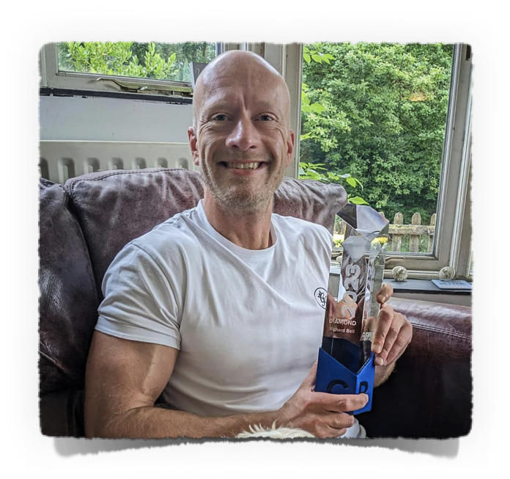
RICH BELL
CASE STUDY #4

PROVEN PAYCHECKS HE’S MADE $7M IN JUST OVER A YEAR!!!
Background
I’m Rich from a small town in the UK. I live with my wife and our 3 teenage daughters.

We both came from humble, middle class families and expected the same for ours. We never dreamed of making big money.

I’ve had a bunch of jobs over the decades, but none that had any potential of turning into something great financially.

I had a small job paper where companies paid to advertise jobs. It was a small town so ultimately it wasn’t scalable. But at least it was mine and I didn’t have to work for anyone else.

Like a lot of people during the Pandemic, I started looking around online to see if there was any way for me to make money or learn a new skill.

I tried eCommerce and dropshipping, but it was a lot of work for low margins and honestly, I found myself annoyed by all of the customer service complaints I had to deal with.

I did try Facebook ads for a short time, but it didn’t get very far learning later I already missed the boat on that platform and now I was always dealing with ad account shutdowns.

I didn’t have credit cards and was low on cash so I started with a 100 British Pounds a day budget and put all of the profits back into new ads.
His Results

A few hundred dollar days turned into several hundred into $1k to $2k and so on into 5-figures never touching his initial profits for anything personal. Always back into increasing his ad budget.

Now he averages 30k pounds a day in ad spend.

At this point, Rich cleaned up his credit reports and got high credit limits on new credit cards which he know how to leverage quickly

Here are RICH’S 2022 BEST STATS:
$29k | Best Day (Aug 27, 2022)
$141k | Best Week (Aug 30, 2022)
$480k | Best Month (Aug 2022)
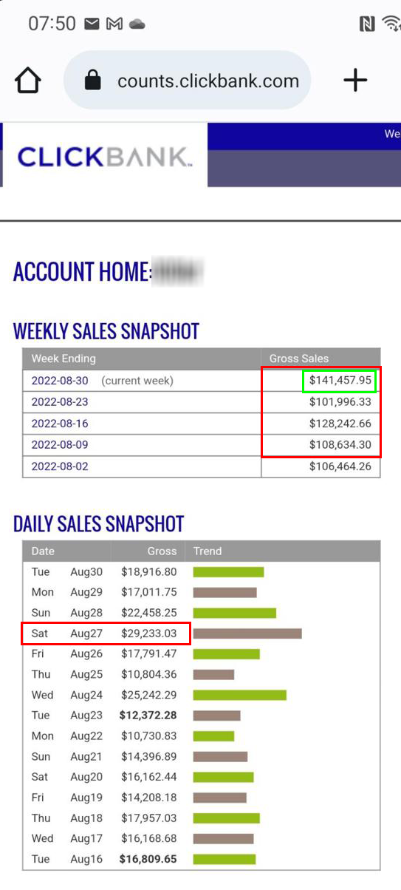

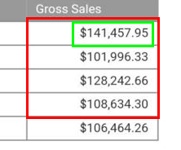

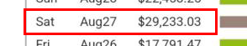


$63k | Best Day (Oct 30, 2022)
$363k | Best Week (ending Nov 1, 2022)
$1,053,793 | Best Month (Oct 2022)
$40k-$60k | Daily Sales for 2 weeks straight

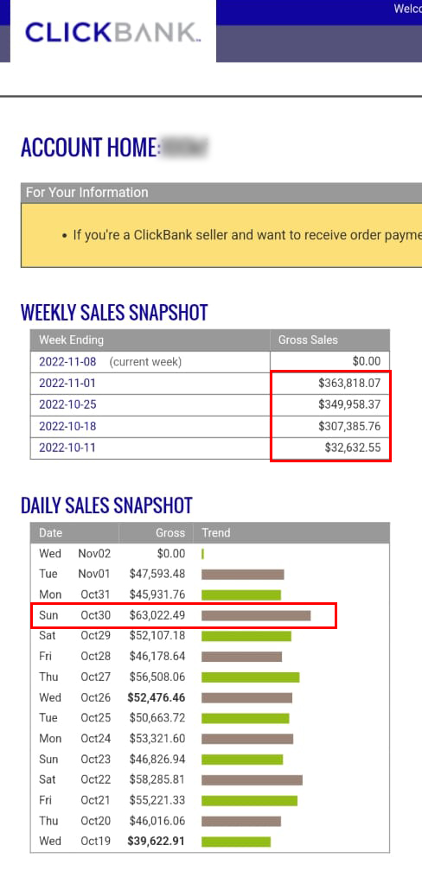

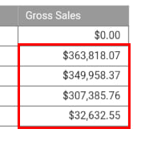

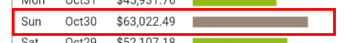


Here are RICH’S 2023 BEST STATS:

$47k | Best Day (April 29, 2023)
$201k | Best Week (ending May 2, 2023)
$625,558 | Best Month (April 2023)
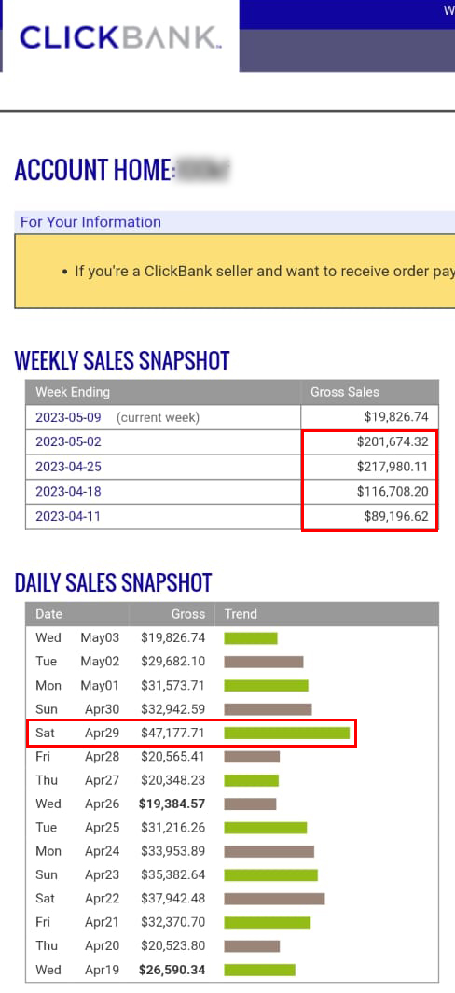

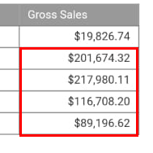

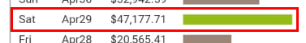

$20k-$40k | Daily Sales for 2 weeks straight

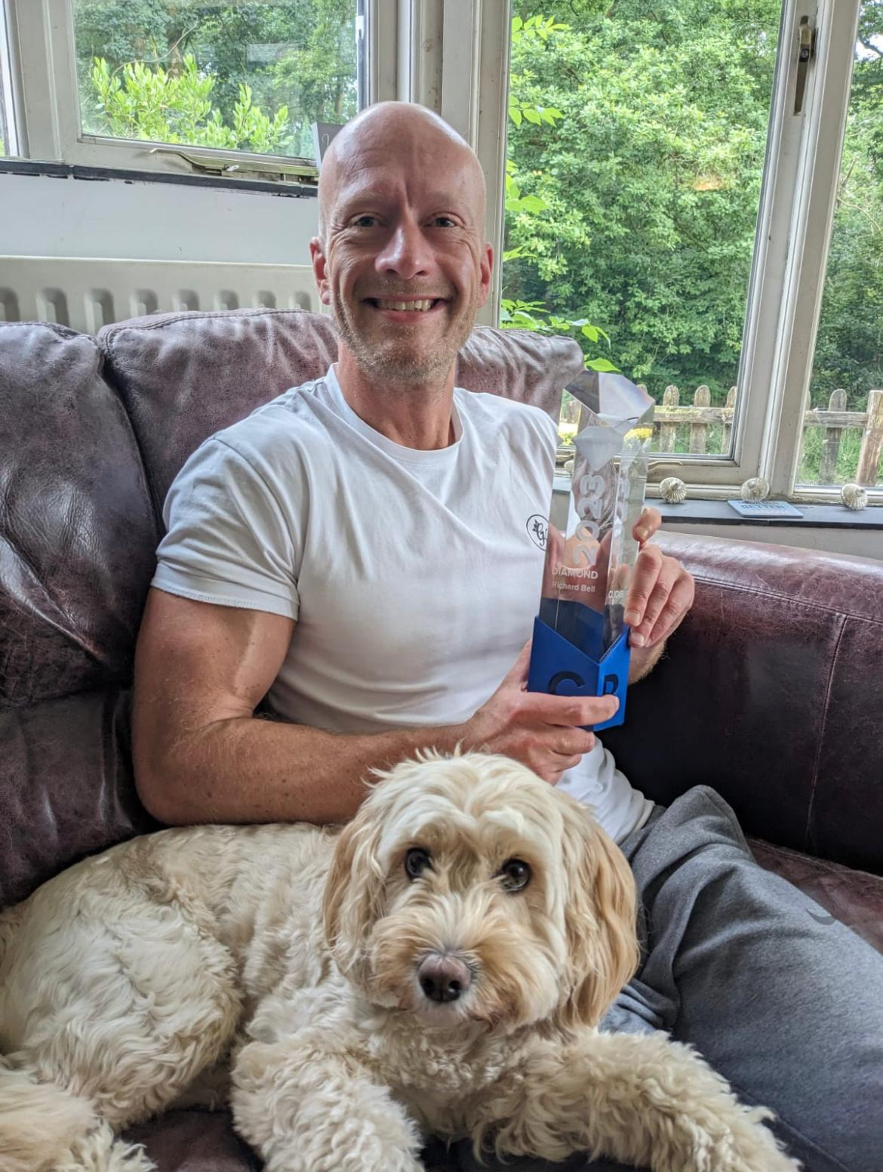

CLICKBANK DIAMOND AWARD winner (that’s $5m in Sales!)

TOTAL CLICKBANK PAYCHECKS
2022 | $3,617,154
2023 | $2,332,940

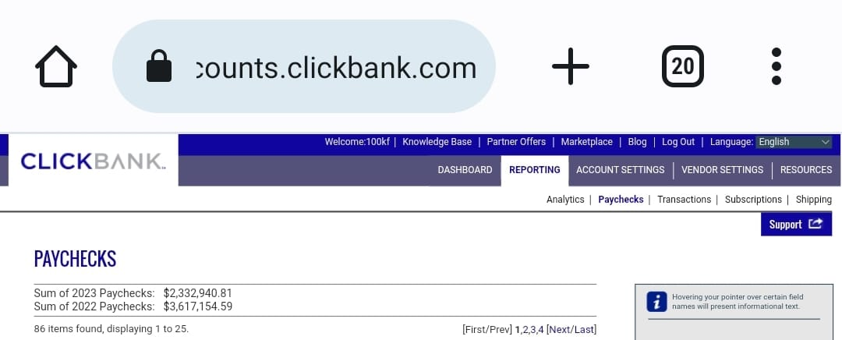

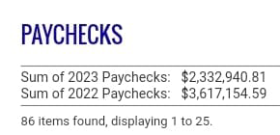


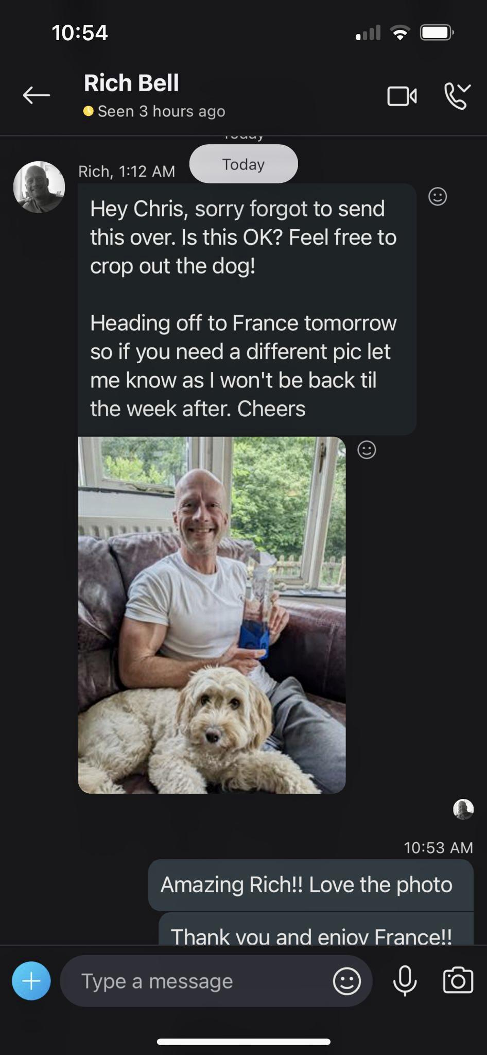

IG DM with Chris

Here are the total Views on his most winning videos
9m views
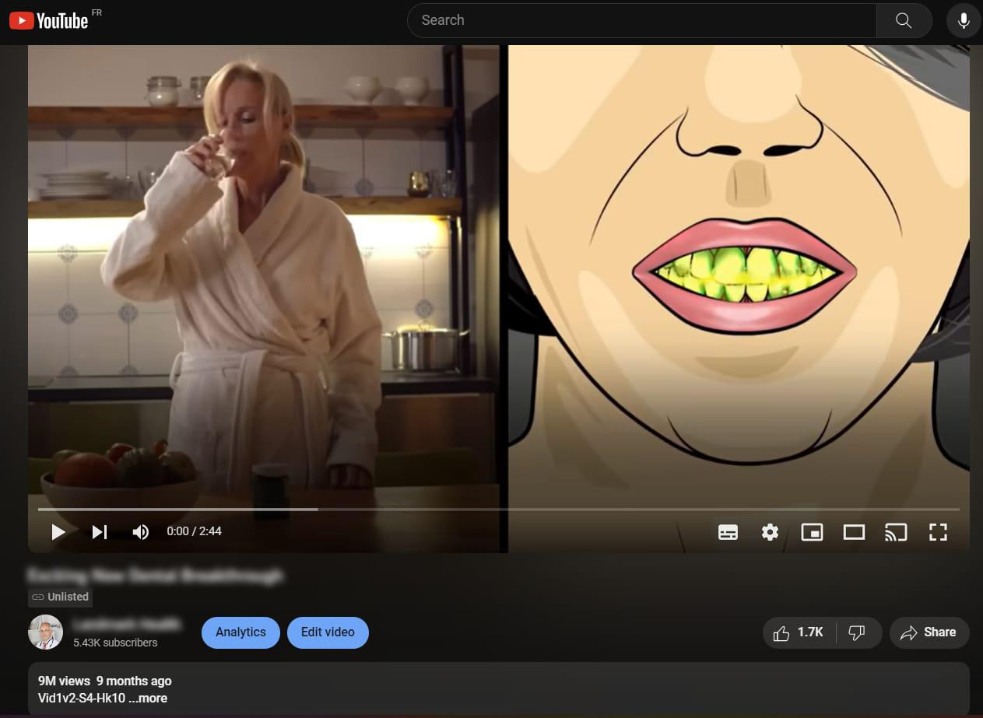

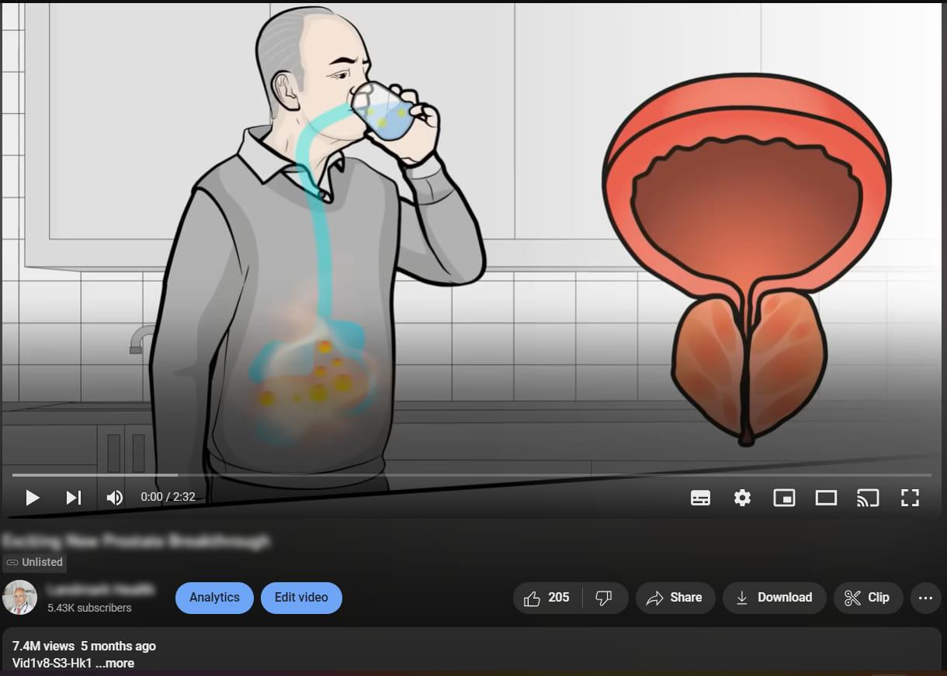

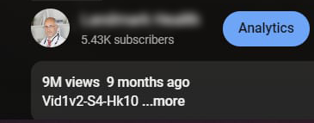

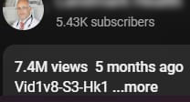

7.4m views

He wants his kids to have options in life and be able to get them things they need the way he couldn’t growing up.
RICH'S BEST DAY - $63,022
RICH'S BEST WEEK - $363,818
RICH'S BEST MONTH - $1,053,793
My Best Advice
The training is laid out so well step-by-step it’s so easy to apply it. Don’t be afraid.

For your ad copy, try to find original hooks because it makes 80% of the difference even when the rest of the ad doesn’t have to bet’s an 80/20 Rule coming up with hooks. Curiosity is the key.

Use the Million Dollar Copywriting formula because it works.

Make at least 2-3 new ads every week and you’ll get much better quickly rather than waiting to “know more” before you try. In hindsight, that’s such a waste of time because there’s no more perfect time to begin than right now.

Keep pushing yourself out of your comfort zone.

Reinvest profits to finance your own growth and never borrow money or go into debt.

Don’t be afraid to raise budgets when you find a winner. Keep edging it up if you’re getting the return. You have full control and can turn it off at any time so don’t be afraid.
The results get more consistent when you’re daily ad budget is multiple 4-figures

If you’re outside the US, use Wise to receive your commissions in your home country rather than having Clickbank sending it through bank to bank. Or consider setting up a US LLC and leave the money in the US to keep paying for new ads with new commissions
IMPORTANT
To learn more about this all new system our students are using right now to earn $1000's in daily profits, join one of our free live training workshops (details are at the link below) :

https://goprofit.AI/FreeTraining

During the workshop you will learn about the entire business model and discover how you can deploy it into your own business immediately. We will also be taking your live questions on the call


MADE ALMOST $1M IN LESS THAN A YEAR!
HAN
CASE STUDY #5
Background
My name is Han and I’m from Malaysia. I know I look 14, but I’m 34 years old and I’m married with 2 kids…a son who’s 4 years and a daughter who’s 8 months.

I studied computer science at University. My first job was a software engineer developing language for banks working a lot of hours and not seeing my young family much. Plus, there wasn’t much potential to make $100k/month like affiliate marketing.

Ultimately, I told my wife that I didn’t want to waste time slowly building a career and income so she encouraged me to look for a way to make money online.

To allow me to responsibly quit my job to have an income, I took a full time job as a software tester from home. I’ve been doing that for the last 6 years.
This both allowed me to be around my kids more as they grow up and to spend more hours than a “side hustle” type commitment on an online business.

I tried a few things like trading stocks and then dropshipping. But once I discovered the benefits of the affiliate marketing model, I knew it was the best thing out there.

I had some success with paid ads on Facebook, but things really took off for me when I learned how to run Google and YouTube ads.
His Results

It took 1 month of testing to find the winner.
During Oct-Dec 2022, he was hitting $1k-$2k consistently with a $6k Best Day (not sure when and looking for that screenshot)

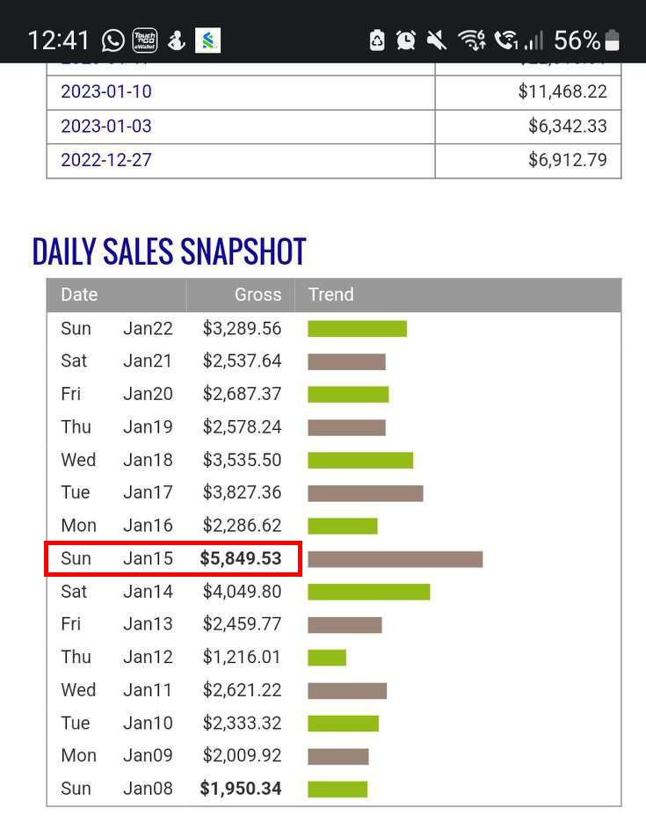

Then it began snowballing quickly.

$5,849 Best Day - Jan 15, 2023

$8,845 | First $9k Day (Feb 21, 2023)
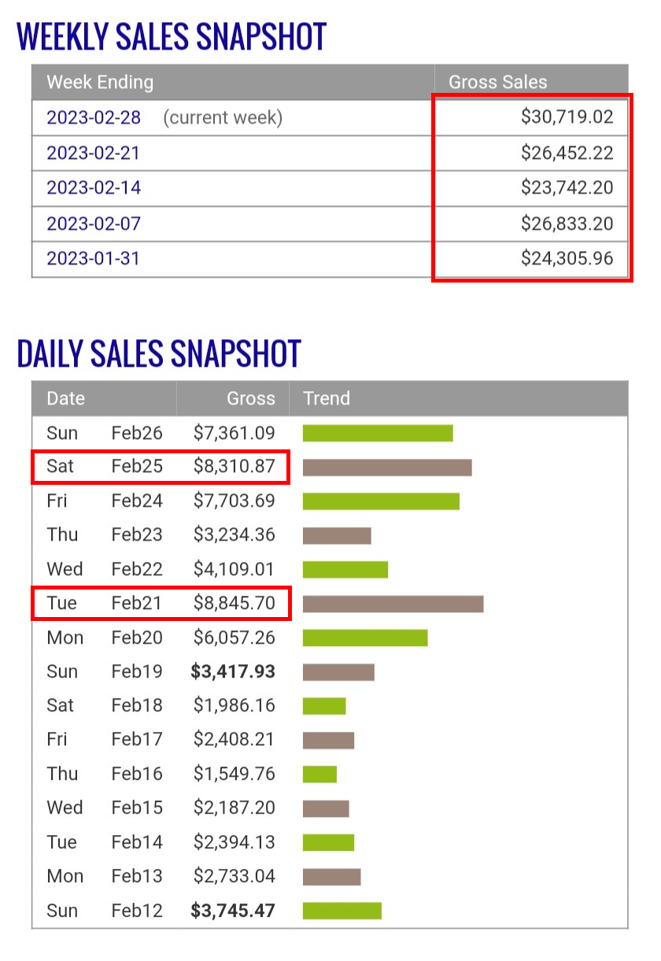

Averaged $23k-$31k Weeks for 5 weeks straight

Only a few months later, more than doubled his stats.

$18,823 Best Day (July 16, 2023) right after previous Best Day of $16,786
$20-$80k Best Weeks back to back.
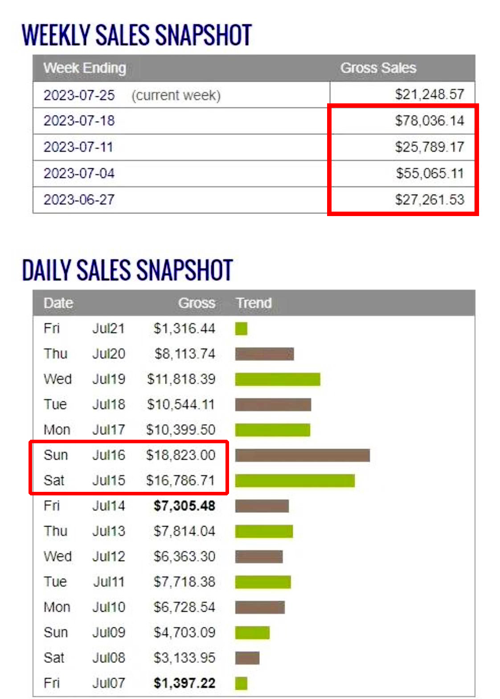

$186k Best Month (ending July 18, 2023)

$200k | 1 Ad ran for 41 days (100% ROI)
(June 4, 2022 - Aug 21, 2023)
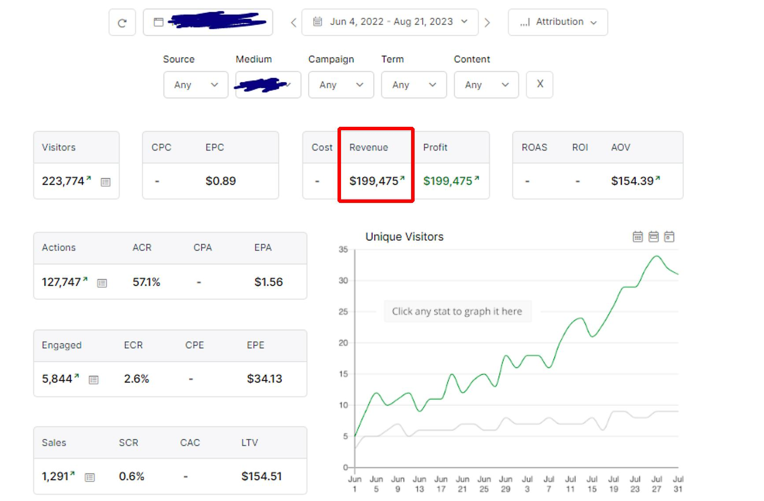

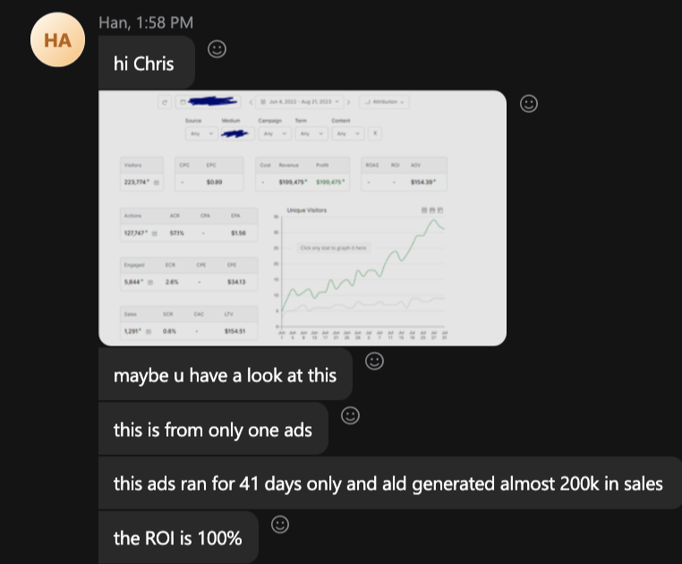

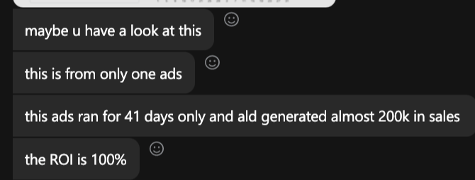


$870,803 | Total 2023 Revenue so far from Jan-Aug, 2023
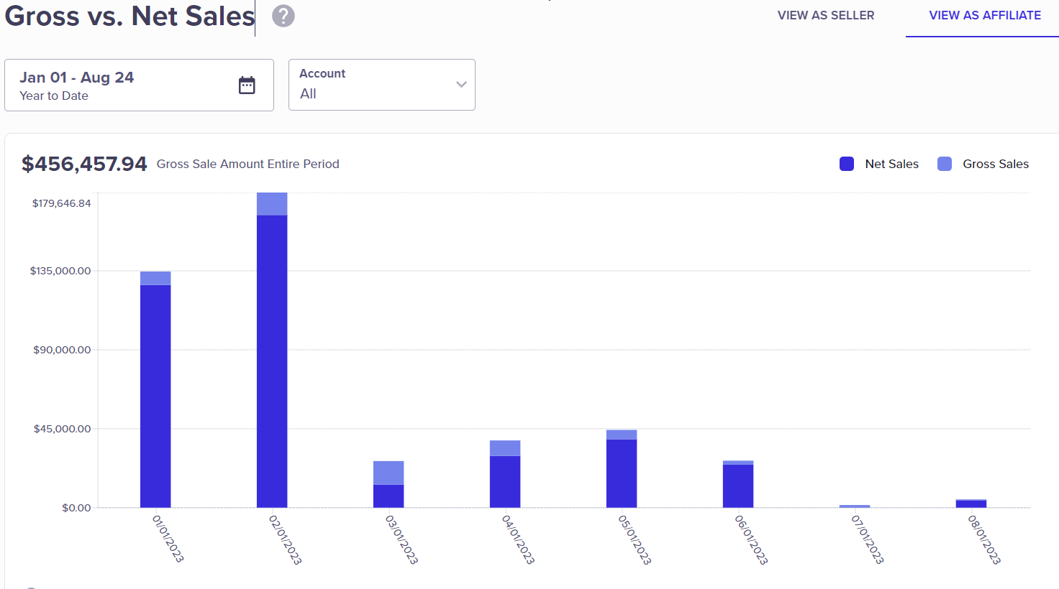

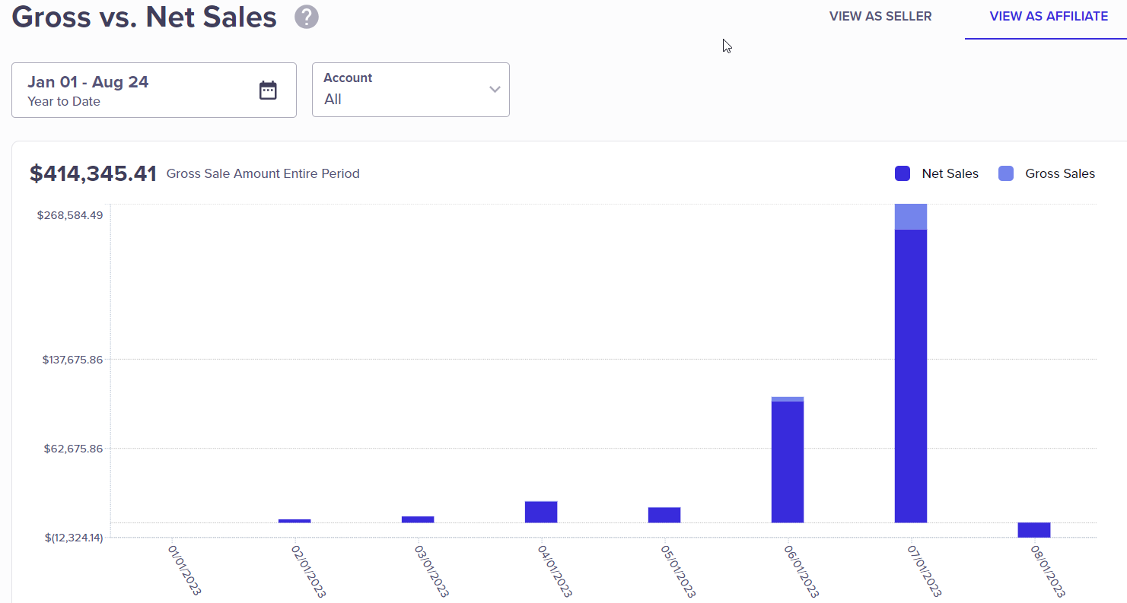


Han is also a first time CLICKBANK PLATINUM AWARD winner

1st time he did $250k in 2 months (Feb 2023)
2nd time he did $250k was in less than 30 days (July 2023)
HAN'S BEST DAY - $18,823
HAN'S BEST MONTH - $186,151
HAN'S TOTAL SALES - $870,803

My Best Advice
Going through a course that has a Blueprint to follow is a much better decision. Looking around for free YouTube videos takes too long, is confusing, and not complete step-by-step information.

If you’ve never done this before, then it will be challenging but that’s ok. That’s when you have to keep going.

I was quite impressed by the skill sets the owners have. Plus all of the provided images, templates, video creation software, the AI features, and the Million Dollar Script Generator made a huge difference in both the speed and quality of my ads.

I didn’t test enough at first. What I thought was a lot wasn’t enough so do more. Pay attention in the course about which parts to focus on that are important and don’t waste time trying to learn things in the beginning that don’t matter.

Our community and owners are so sincere and really care about their students. The money I’m making now feels amazing and so unreal. It truly feels like I’m printing money.
IMPORTANT
To learn more about this all new system our students are using right now to earn $1000's in daily profits, join one of our free live training workshops (details are at the link below) :

https://goprofit.AI/FreeTraining

During the workshop you will learn about the entire business model and discover how you can deploy it into your own business immediately. We will also be taking your live questions on the call

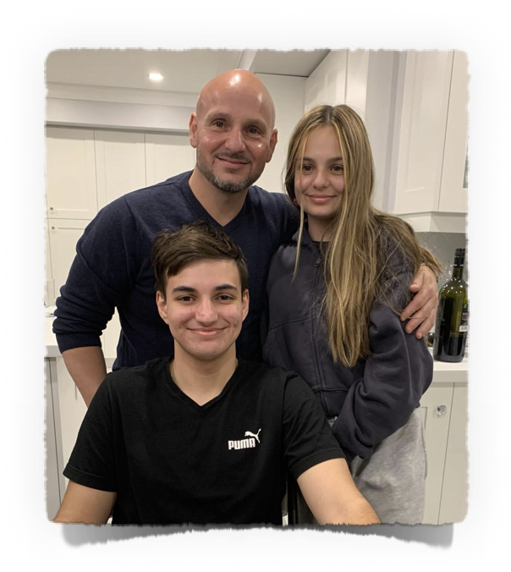
MARCO DANIELE
CASE STUDY #6

PROFITS FROM HIS ADS JUST BOUGHT HIM A VACATION HOME IN ITALY FOR CASH
Background
I’m Marco from Eastern Canada. I’m in my mid-40’s, divorced and raising 2 kids full time.

I worked as a software developer for a traditional corporate American company for 25 years. I was sick of working 16 hours a day, not having as much time with my kids, and being on the hamster wheel and the years passing by.

I wanted to do something for myself and to live life on my terms rather than for a paycheck.

I previously dabbled in affiliate marketing on the side, but nothing ever caught fire for me. I hit a $1k day a few times running Facebook ads, but nothing sustainable.

I stumbled across this course and what’s so amazing about it is that Google and YouTube are the two biggest search engines in the world, yet no one could figure out how to run affiliate marketing ads on it.

That’s why the timing of this course has been so fortunate to be one of the first people in the world to implement this model before everyone else hears about it or figures it out and it gets ruined like Facebook.

Paid ads obviously cost money. I needed to be more patient and strategic since I only had a personal credit card with a low limit and some cash. I had to rely on debit cards, but I needed to be cautious with 2 young kids at home counting on me.

Cash flow has always been an issue, especially trying to scale first winning ads. I could’ve scaled more and faster had I been working with an AMEX business card, but I couldn’t qualify for it until this year.

Time has been tough and difficult to tell my kids that sometimes I can’t spend time with them because I’m testing ads to find a winner to eventually get his time back once things pop.

I’m working so hard now because my main goal down the road is to make my life more balanced, retire early, and have steady profits.
His Results

Due to his cash crunch and low credit limits, he decided to find more obscure offers he figured no one was looking at and therefore he wouldn’t be bidding against anyone since we’re virtually the only people in the world running YouTube ads.

That strategy worked especially well in the beginning when he found his first winner and focused on putting his profits back into his slow and steady daily scaling.

A few months later, with patience, it started growing into 4-figure days in February
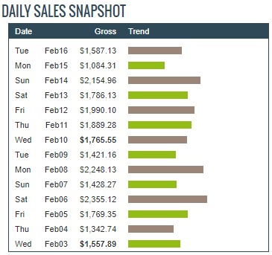


Quickly went from high 4-figure days into the 5-figure days two months later at the end of April into May:
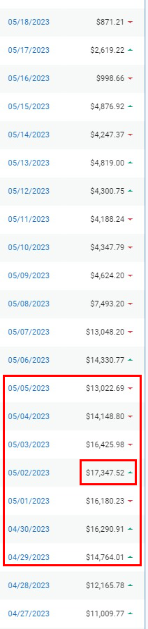


$17k | Best Day (May 2, 2023)
$104k | Best Week (ending May 5, 2023)

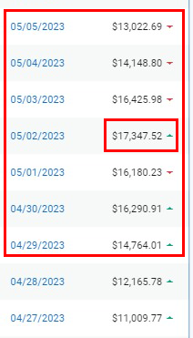


Making $3k-$6k consistently every day for the month of Aug 2023
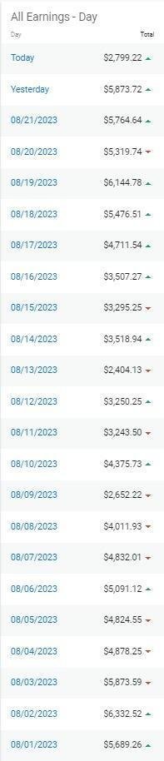

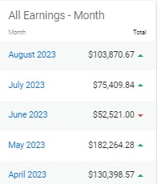


$182k | Best Month (Aug 2023)

Averaging 6-figure months for the most recent 5 months shown above
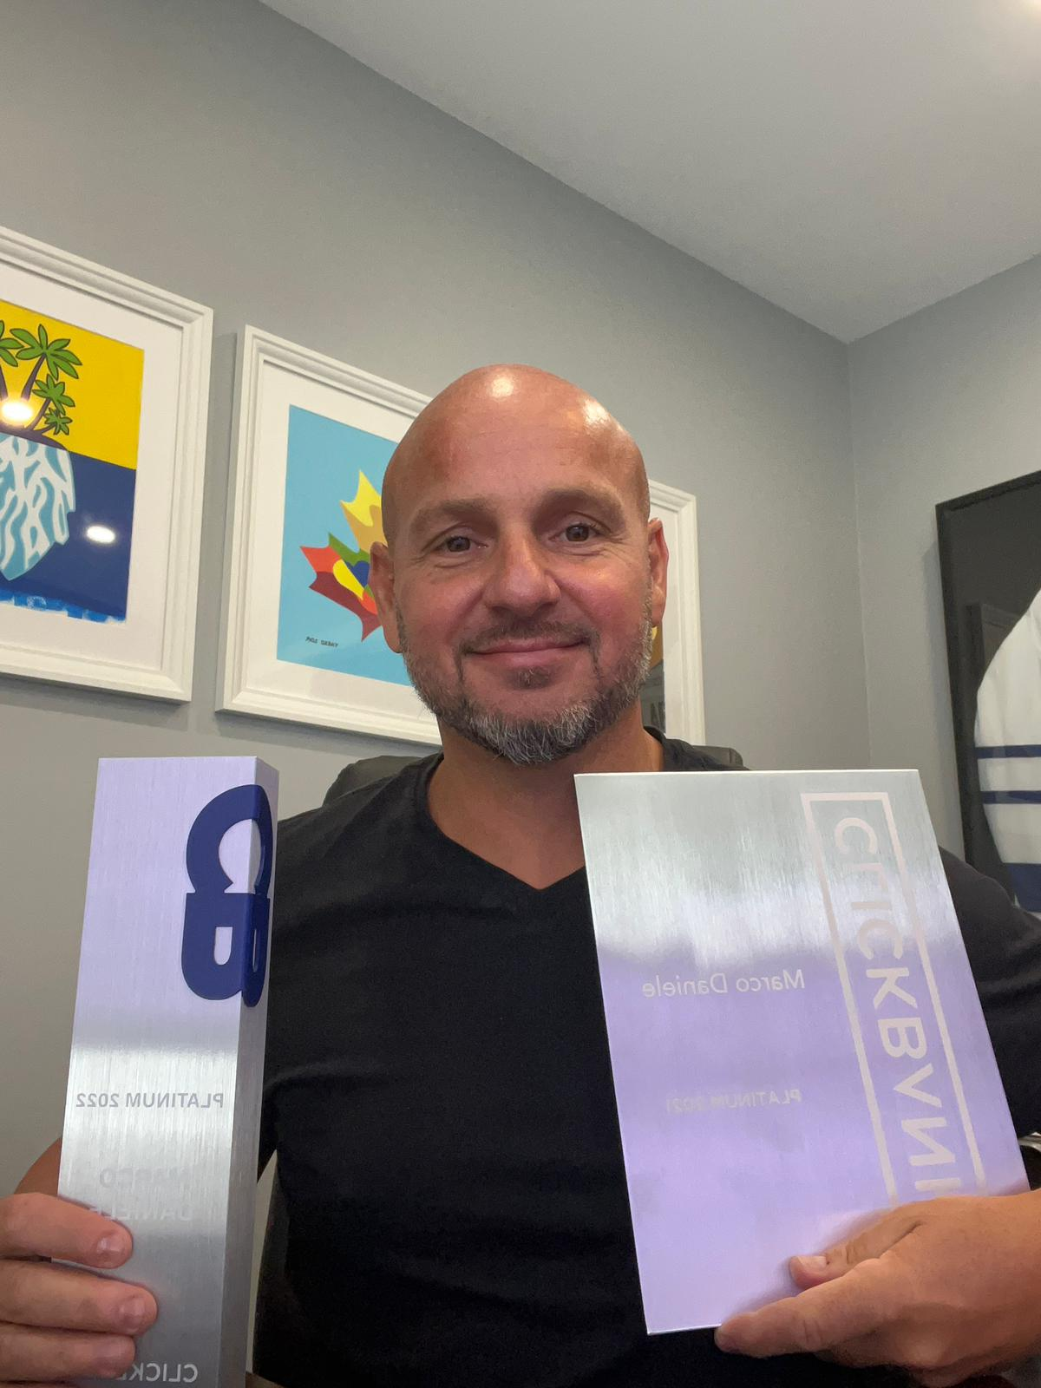

CLICKBANK PLATINUM AWARD - 2 years running

Now his life has changed 180 degrees…he has more time for his kids and especially financially.

He just bought a vacation home in Italy by the sea for cash with the profits he made from our course. Here’s the view with his girlfriend on their terrace:
MARCO'S BEST DAY - $17,347
MARCO'S BEST WEEK - $108,176
MARCO'S BEST MONTH - $182,164
Your ad doesn’t have to be perfect, but keep running them to get Google feedback and then make adjustments.
My Best Advice

“Don’t overthink it. Just get ads out there.” Get your pride out of the way.

My first winner wasn’t even that good. I used his own voice. It’s laughable now, but it worked.

Keep it simple…don’t search for perfection. With script, video, and lander.

Letting go of the pressure of knowing everything in the beginning and trusting the process really helped.

Focusing on smaller niches where there’s less competition makes it easier to get quick wins and build your skills and confidence. Then take that experience and go into the biggest niches that you can scale to 5-figures a day and beyond.

There’s not one way to scale your ads. Just think about your personality. I’m pretty conservative, so it’s more about a more slow and steady approach. I’d rather make $3k-$5k per day with steady ROI that I can count on that only takes me a few hours a day to maintain so I can enjoy time with my kids than others who try to kill it and make $1m per month.

The key to mastering any niche is to have a system to make creatives, follow a strict testing plan, and employ patience and perseverance.

Affiliate marketing is truly a great business model so stick with it, even if it gets challenging because it’s definitely worth it once you get to the other side. Don’t forget that anything good in life requires growing pains.
IMPORTANT
To learn more about this all new system our students are using right now to earn $1000's in daily profits, join one of our free live training workshops (details are at the link below) :

https://goprofit.AI/FreeTraining

During the workshop you will learn about the entire business model and discover how you can deploy it into your own business immediately. We will also be taking your live questions on the call
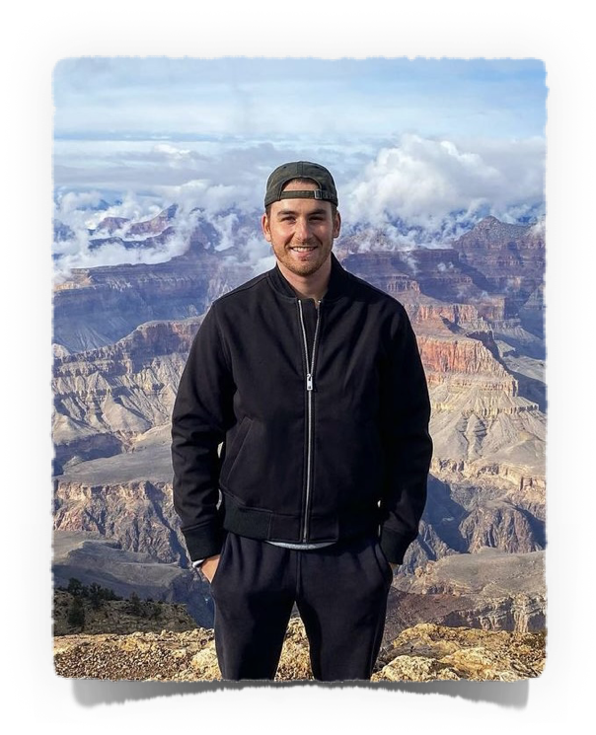
RYAN HOOD
CASE STUDY #7

MADE $512k WITH ONE OFFER!
Background
My name is Ryan and I’m 26 from Toronto, Canada. I’ve been working online since I was 22.

In high school, I had a job selling clothes and sports equipment. One skill I learned from sales was how to deal with people and figure out what they want when they’re shopping.

That’s been a great help to me using it for online marketing with my copywriting to tap into people’s emotions and psychology.

Since college, I’m proud to say that I’ve never had a 9-5 salaried job!

I’m not married yet so my Why is about Lifestyle (lots of traveling) and financial, location, time freedoms to live my life however I choose and to write my own ticket.

Currently I run an ad agency that’s very time consuming. Over the years, I’ve had to deal with 600 clients and they all want perfection at cheap prices.

Plus, owning a business like this has many drawbacks such as people management. With 15 employees worldwide, that means there’s 15 personalities, egos, compensation and insurance plans, 5 time zones to hold meetings, and all the drama that comes with people whether it’s his clients or his team members.

While it’s profitable and a stable business, I wanted something that was just for myself and didn’t need a team or clients to make it work. Don’t get me wrong I’m grateful to have had this business for years, but I wanted to make a change.

I already had a lot of experience and spent millions of dollars running ads for clients, but I realized when starting this course that I was Risk Averse on my own ads while spending millions for his clients.

I knew about the business model of Affiliate Marketing, but I was waiting to find the right course and the right guys to learn from when I found Profit Singularity last year.

After the first month reviewing all of the training modules, I decided to take things to the extreme and rather than taking a long time to implement what I learned around my life and business…I flew to Mexico City for 1 month. I locked myself in a room at night and I wouldn’t stop producing ads until I found a winner.

I don’t recommend it, but for my own personality I knew I needed to put all of my Focus on this one task of running ads. My objective was to test at least 1 ad every day until I cracked it. I’ve seen so many others do it so it was only a matter of time.

Everyone needs to ask themselves what they’re willing to do for their own success?

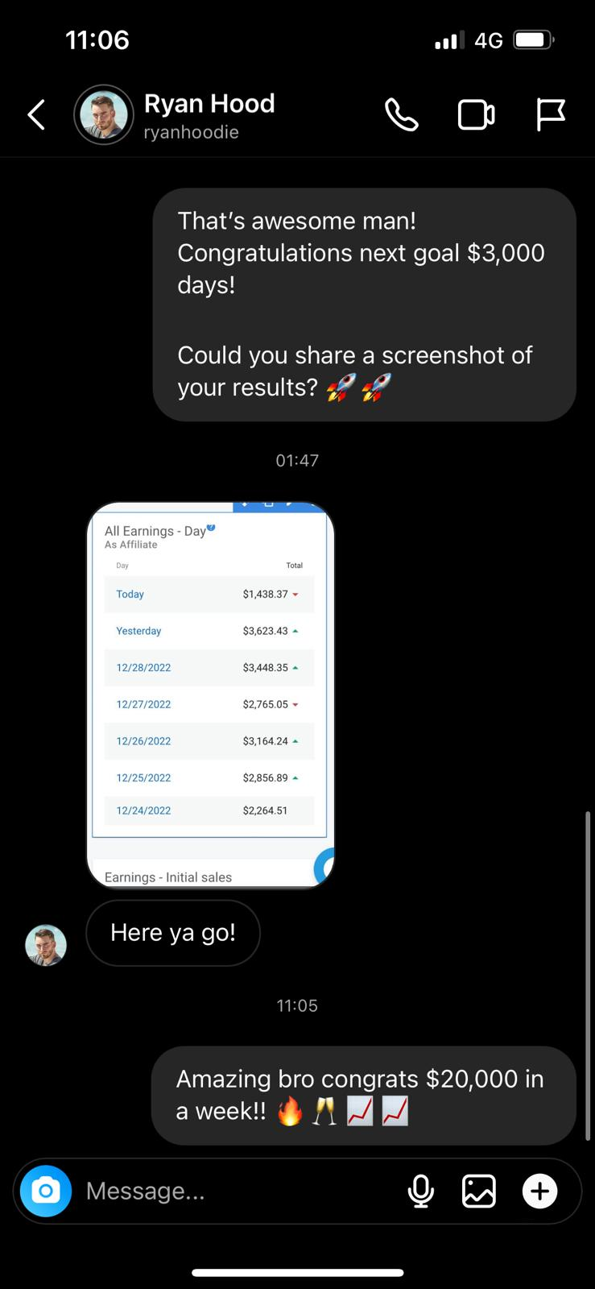

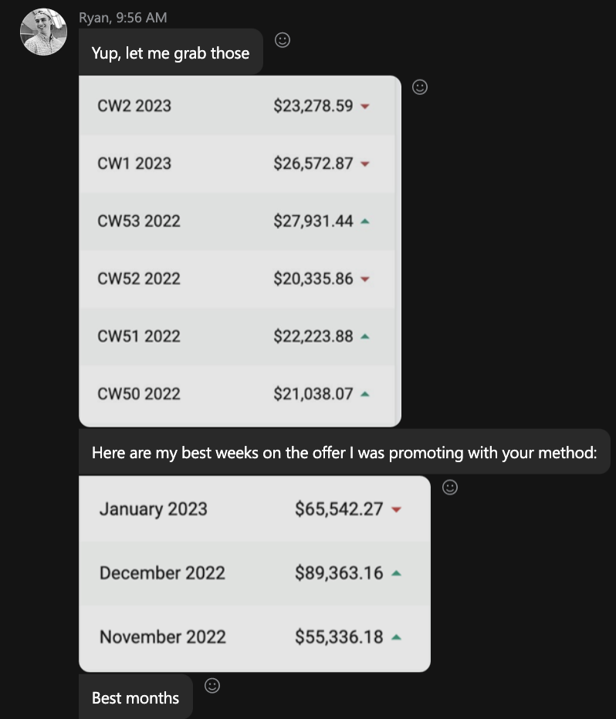

My MANTRA: A weak person in a strong environment outperforms a strong person in a weak environment.

$89k | Best Month
($35k profit) on 1 Offer
$26k | Best Week
$3,623k | Best Day
His Results
$512k | Total Revenue on 1 Offer
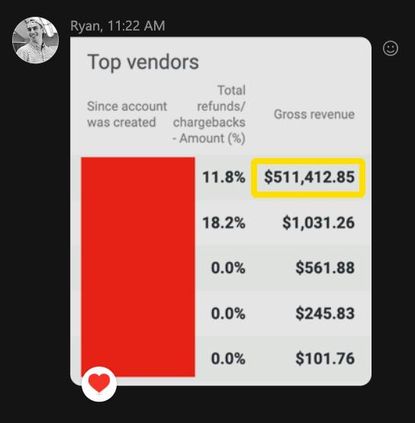

My Best Advice

RYAN'S BEST DAY - $3,623
RYAN'S BEST WEEK - $26,572
RYAN'S BEST MONTH - $89,363
The biggest challenge I had to overcome was the belief of “can this actually work?” When you start something new and you see other success stories of others you think, “Can I make this work for myself?” At the end of the day, if you don’t test then you’ll never win.

The biggest thing is having the belief in yourself that you can actually make it work. Once you get that first crack, then you know it’ll work and you can actually go all in.

Once you decide that, it just comes down to a couple of things:
1) Taking the right actions and the course shows you that.
2) Doing it for a long enough time to get enough sample size.
3) Being consistent doing it every day to become better.
As long as you apply those three things, then I think you’re well on your way.

It comes down to what are you going to do with that course and the knowledge you learn. Obviously, the course is proven by the results of the people making it happen every single day.

Now it comes down to the person behind the computer. What are you going to do and then you have to take action? It separates the people having success from not having success. If you follow the process, you’re going to get results, plain and simple.

My favorite thing in the course is the framework you give people…basically a sequence of things to do which is as simple as 1, 2, 3, 4, 5.

Unlike Facebook having so many issues, with YouTube it’s very, very stable for over a year now. So your revenue will also be consistent. It’s not a big time consumer of your day.

Once you do hit a big winner, I don’t think it’s super complicated to scale quickly. You can basically write your own ticket. This industry isn’t going away.

Nothing compares to the affiliate marketing business model.
Being able to run ads and make money every single day.
IMPORTANT
To learn more about this all new system our students are using right now to earn $1000's in daily profits, join one of our free live training workshops (details are at the link below) :

https://goprofit.AI/FreeTraining

During the workshop you will learn about the entire business model and discover how you can deploy it into your own business immediately. We will also be taking your live questions on the call
COREY ROSE
CASE STUDY #8

MADE $100K SINCE JOINING

A FEW MONTHS AGO
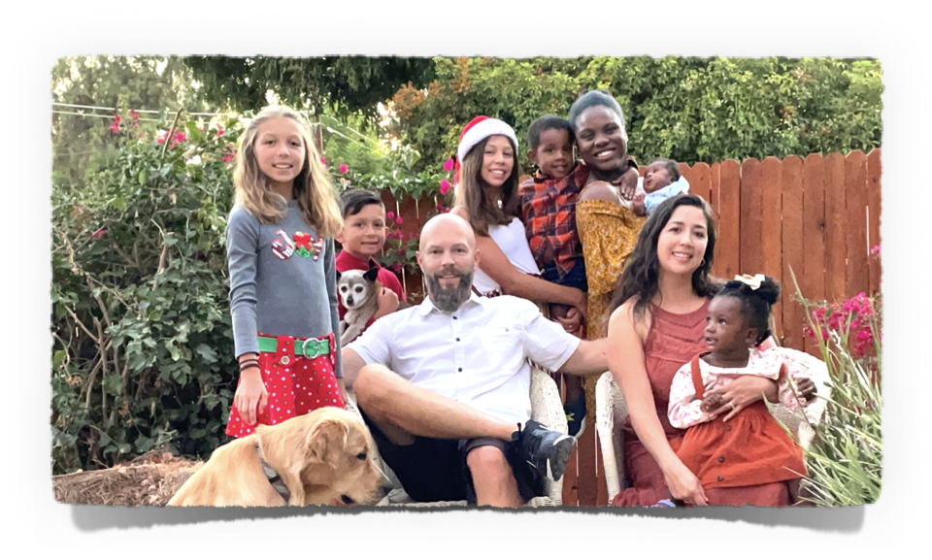
I’m Corey. I’m married and live in San Diego, CA with my beautiful wife, 4 kids, and 3 grandkids
Background

In addition to my business, I’m also a Youth Pastor at our church. My wife and I adopted our first child who was 12 at the time when we met her mother through the church. Her mother unfortunately passed away, but we were blessed with a wonderful child who’s now made us grandparents while still raising our other children.

Our families grew up pretty poor. In fact, while they’re wonderful people my parents are still living paycheck to paycheck which scares me about their future. And now they’re getting older and aren’t able to move around as much so I worry.

I don’t want that for my kids. I’ve always felt that everything was on me. It’s always been that way. I didn’t have any help in high school and college so I had to rely on myself and always worked as long as I can remember.

As an adult, I can see how that instilled in me a POOR MINDSET and I never thought I could get to the other side and BREAK THE FINANCIAL CYCLE my family has been in for generations.

My first online job started with graphic design to web design. Then we needed traffic so I learned SEO. I became a Marketing Dir for a software company in Irvine for 10 years, but I excelled at SEO bringing in the best leads so I branched off on my own.

I’ve had my own SEO agency and Search Ads for Google for 10 years now. Though, those fears that everything could go back constantly push me to always have something on the side looking for ways to get out of the system and secure my family.

Plus spending more time with my family and the church is crucial to me. When the kids were young, I was always away from them working long hours and commuting so I wanted a career to work from home.

“I love this paid ads model because I can create one ad and it can keep paying me over and over. If I want to get paid in SEO, then I need to keep doing more and more work with original creatives which is very time consuming and always trying to please the client.”

I believe Success is my Duty. Duty to myself, my family, and to the people that are going to benefit from the products I’m marketing.

I see myself as a Warrior King for my family. Someone that goes to battle with themselves to conquer the daily battle is in his mind…asking myself what do I want to do versus what the needs of my family and kids are?

I’m also motivated because I worry about where the world will be in 5 to 10 years to take care of my kids into adulthood to get them started so they have a good foundation so that’s why I work so hard now when I see this incredible once-in-a-lifetime opportunity in front of me.

Corey stayed in one niche and had “some” success, but nothing he was satisfied with.
His Results

Once he ran enough tests to know he thoroughly tried everything, he decided to switch niches.

And on his FIRST AD in the new niche, it was a HUGE WINNER and he began SCALING immediately.

$6,047 | Best Day (Feb 4, 2023) ($3k Profit) then NEXT DAY
$7,468 | Best Day (Feb 5, 2023) ($3k Profit)
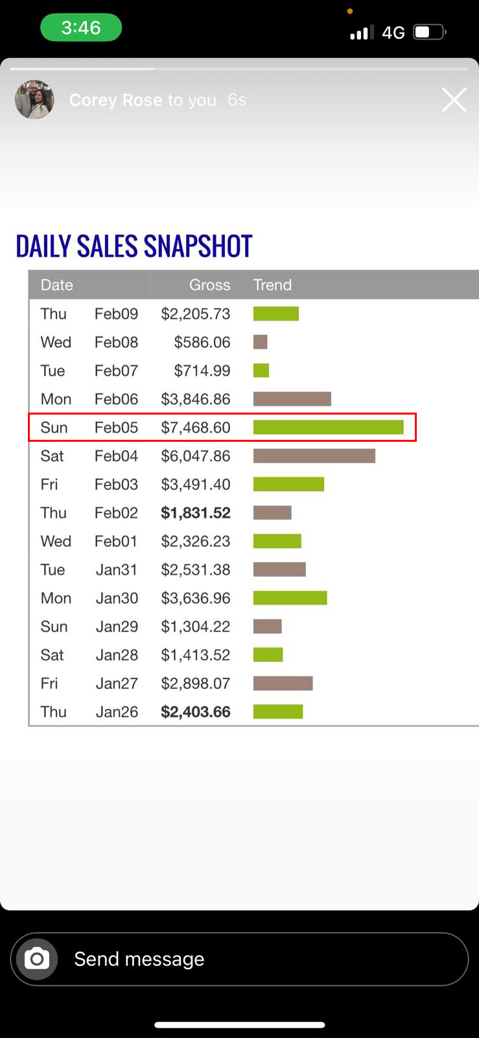


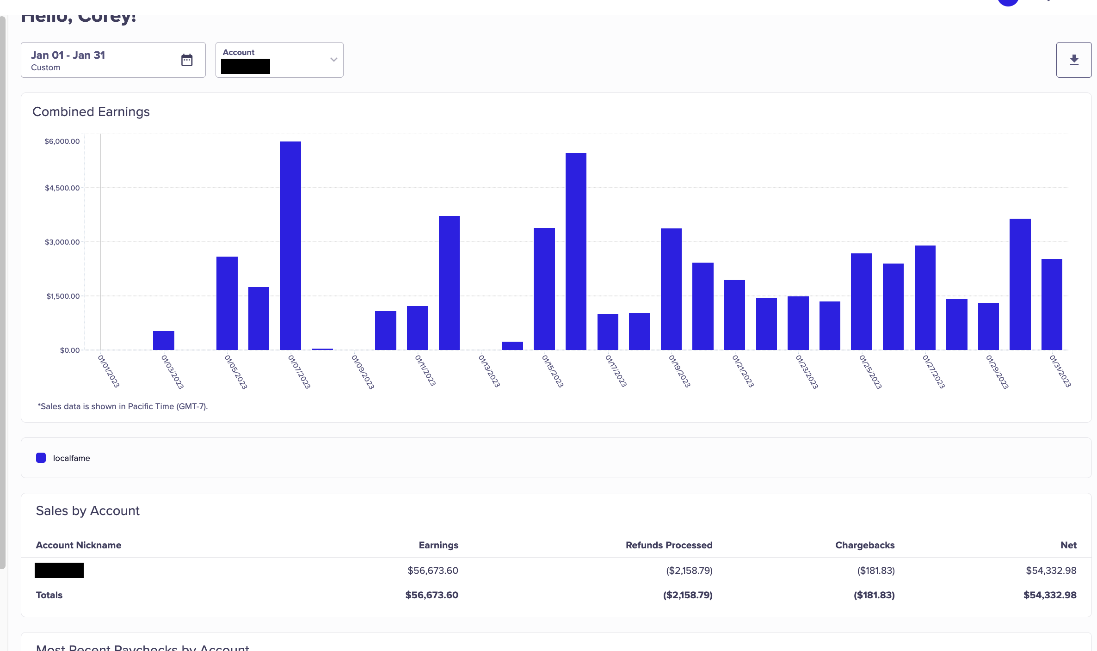

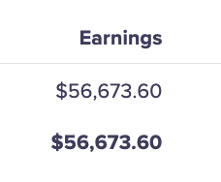

$56,673 | Best Month (Jan 2023)

$27,333 | Best Week (ending Jan 30, 2023)
$98,850 | Best 2 back to back Months (Jan to Feb, 2023)

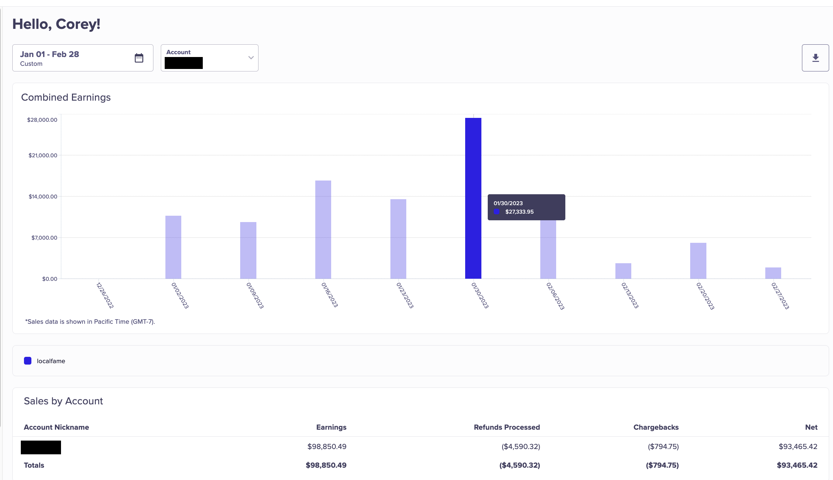

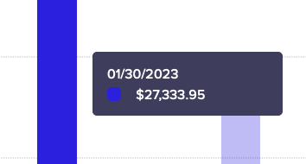

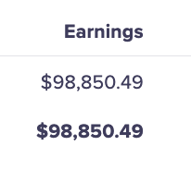

COREY'S BEST DAY - $7,468
COREY'S BEST MONTH - $56,673

$133k | Total Sales first 5 months of running ads

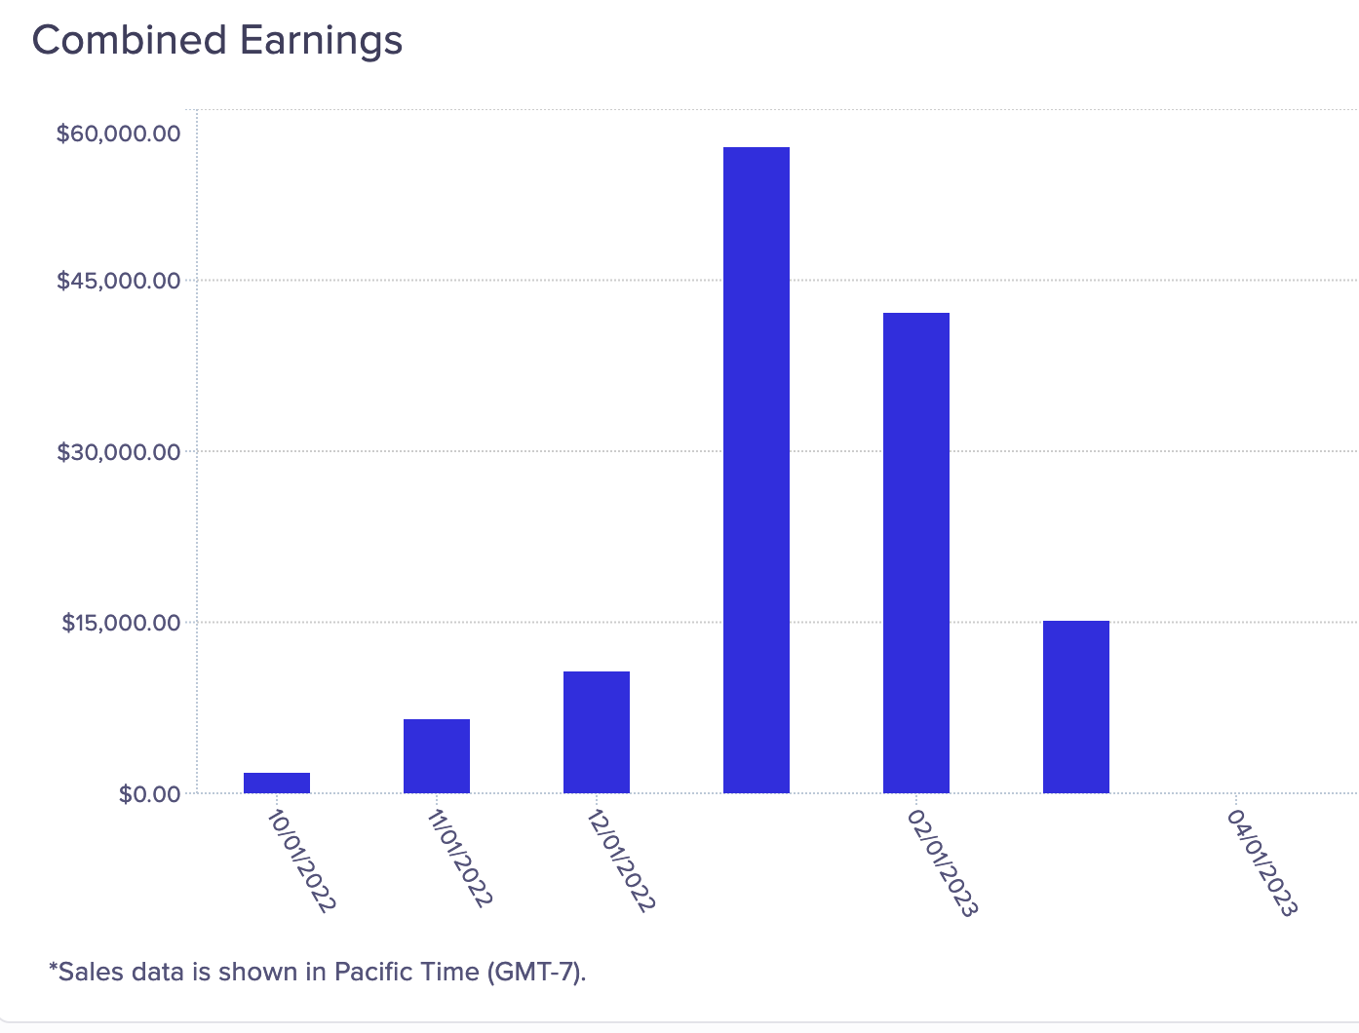

Set aside the 4-6 weeks to really dive in, absorb this stuff, and learn about the psychology of direct to consumer marketing. Give it the time and respect it deserves because you’re learning a new craft and skill set. Because there’s gold on the other side of the hill. No one can learn that overnight.
My Best Advice
COREY'S BEST DAY - $7,468
COREY'S BEST MONTH - $56,673

The answers are 99% always in the training. Just go back because you may have missed something the first time you watched it.

Accept you’re going to do things wrong and make mistakes. But so did every other person who’s now doing well. You can’t break anything so don’t worry and keep going.

“You win some, and you learn some. If you’re doing the work, it’s never a ‘loss’.”

Make sure you track everything so you know what changes you made and how it did. I didn’t and wound up wasting time and money forgetting I already ran the same versions multiple times.

Follow the Evolution testing Method exactly because it always works.

Feed yourself the right kind of information daily…books, podcasts, training calls…
Remove all negative thoughts so if you let those voices live in your head, then you’ve already lost.

The key is to continue believing in yourself, continue trusting the process, and continue taking that massive action and you will find success.

For me, Profit Singularity is the most valuable course I’ve ever purchased. It’s a masters class in marketing. It’s a full masters degree. Even if you’ve never been online or consider yourself a marketer, this is the BEST place to get started.

YouTube traffic is a massive, UNTAPPED ocean of money available there, traffic is super cheap, and it’s high converting.
IMPORTANT
To learn more about this all new system our students are using right now to earn $1000's in daily profits, join one of our free live training workshops (details are at the link below) :

https://goprofit.AI/FreeTraining

During the workshop you will learn about the entire business model and discover how you can deploy it into your own business immediately. We will also be taking your live questions on the call
VIN ZERBO

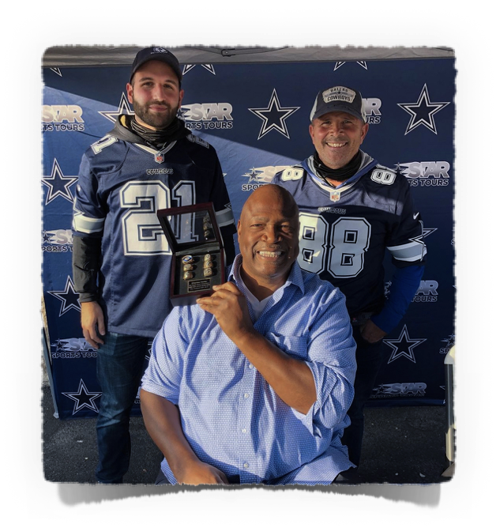
FROM STARVING ARTIST TO $78K IN MY FIRST MONTH!
CASE STUDY #9

Background
I’m Vin. I’m 32 and from New Jersey. I guess you could call me the Passionate Artist type. But I’m also practical because I knew I needed to find a business to make money to pursue the things I want rather than the traditional “Starving Artist” route.

I’ve been a musician since I was a kid. Like a lot of people, we formed a band and had the best time making music all of those years. We were on the cusp of signing a deal, but then the personalities of the other musicians came into play when things got real and unfortunately the band ended.

I had no idea where to go from there because making it as a band touring the country and even the world was all I thought about.

Since I had to make money and didn’t have a lot of other skills besides the drums and writing music, I got a sales job selling cars, music equipment and other things. I wasn’t very good at it.

Then I got a job with a bank located inside a grocery store trying to sell them bank products and credit cards while they’re shopping for food…it was terrible.

Then, I started looking into online opportunities…At first, I struggled with dropshipping because I only sold $100,000 in the first year at a 5% profit so that’s only 5 grand working my butt off for an entire year! Not sure how many people can live off of $400 a month profit?

I love the marketing and creative part of it, just wasn’t sure the right vehicle. I’m big into the Law of Attraction because that’s when the course was presented to me. It felt so fresh and different with the AI and I could only focus on the ads which is the part I loved to do.

I didn’t know it was going to be given to me on a silver platter.

The 80/20 Rule of affiliate marketing really resonated with me. You do the most crucial 20% for the business with the ads and you make the most amount of money from the sales (80%). You don’t need to run the actual business of the product, fulfillment, inventory, staff, etc.

I’m only a recent student, but I love where things are headed so far.

It wasn’t all sunshine and rainbows at first. To be honest, I had to confront my fears and to overcome self-doubt and self-belief to become successful. Most of us have a problem believing the answer even when we see it working for someone else. It’s not any more complicated than that if you can move through it.

$15,538 | Best Day - August 23, 2023
His Results
$63,967 | Best Week - ending August 22, 2023
$78,188 | First month of Sales running ads…

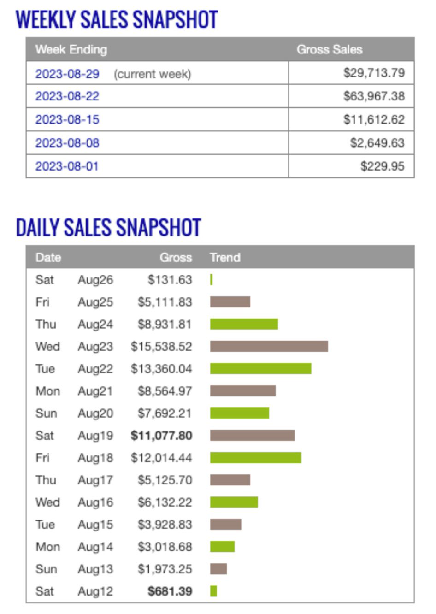



You can see went from $0 in Week 1, $230 in Week 2, $2,649 in Week 3, $11,612 in Week 4, $63,967 in Week 5 to this total → That’s the power of Google/YouTube ads and scaling your first Winner FAST

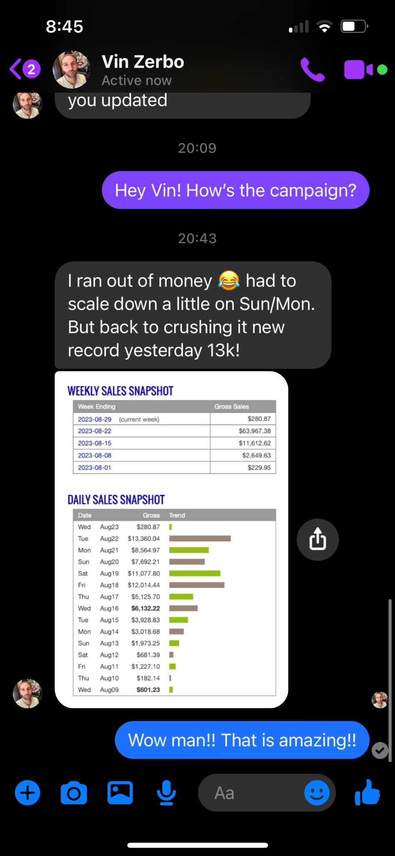
Got some love from Chris when I shared the great news of my $13k Best Day!

VIN'S BEST DAY - $15,538
VIN'S BEST WEEK - $63,967
VIN'S BEST MONTH - $78,188
My Best Advice
It’s just incredible, man. How many people are going to be experiencing this? Doing these types of things.

I’m supremely confident I can find another winner. I know I can keep doing it again. It’s not even a thought or a belief. I just know I’m going to do it next time.

When confidence turns into conviction with evidence…I don’t think there’s any better return that the program can give you.

Once you do all of the necessary, initial work to create ads and then go through the testing phase…once you are scaling that winner, I’m struggling to fill my calendar with things I need to do for my business. It takes 10 minutes to manage ROI.

Most of my time is calling banks and telling them, “Hey, this isn’t fraud. Please push this money through.” It’s a great problem to have.

Leverage both sides of your Brain…Try to take the creative hat off when you’re done with the video. When running ads, put the media hat on looking at the numbers and ask if it’s working. Don’t fall in love with your creations.

I’d argue that 90% of the people watching this have done significantly more complex stuff at their jobs. The opportunity is so great because it’s such a tight, narrow focus to get good at. It’s not easy, but it’s simple. Once you can do that, the return is so HIGH just for that one skill set.

It’s a gift once you achieve your first winner. Then you absolutely KNOW that you can recreate it again and again and it feels easier each time you do it.
IMPORTANT
To learn more about this all new system our students are using right now to earn $1000's in daily profits, join one of our free live training workshops (details are at the link below) :

https://goprofit.AI/FreeTraining

During the workshop you will learn about the entire business model and discover how you can deploy it into your own business immediately. We will also be taking your live questions on the call

Thanks for reading,
Chris Reader

